**Biogeochemical Cycles WebQuest & Human Impact Activity**

**Content Objective:** Students will be identify and explain three (3) different biogeochemical cycles (WATER, CARBON, NITROGEN) and how human activities are altering those cycles.

**Procedure:** Please answer all questions in complete sentences using the links found above each set of questions.

**The CARBON CYCLE:** <https://www.windows2universe.org/?page=/earth/Water/co2_cycle.html>

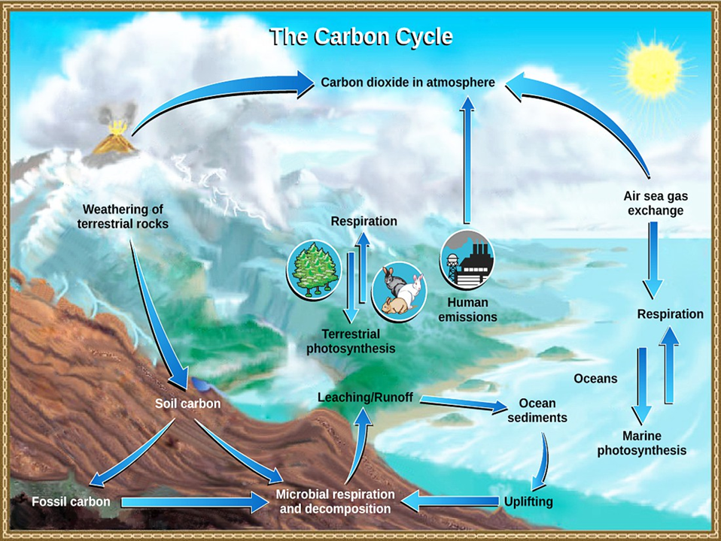

1. How does CARBON exist in the atmosphere?
2. In what TWO (2) ways does CARBON enter the atmosphere?
3. How are the oceans involved in the CARBON cycle?
4. How is the temperature of Earth partly controlled by CARBON?
5. What role do rocks have within the CARBON cycle?
6. Describe ONE (1) of the many paths a CARBON molecule can take through the CARBON cycle (Describe its path from start to finish, in as much detail as possible).
7. When CARBON enters the deep ocean, how long does it stay there?
8. Which organisms float in the ocean and take up CARBON dioxide as they grow?
9. Using, “Photosynthesis”, “Combustion”, Decomposition” and “Cellular Respiration”, please explain the CARBON cycle from start to finish in your own words.
10. How are humans changing the CARBON cycle? (Be as descriptive as possible, list & explain all possibilities)

**The NITROGEN CYCLE:** <http://www.physicalgeography.net/fundamentals/9s.html>

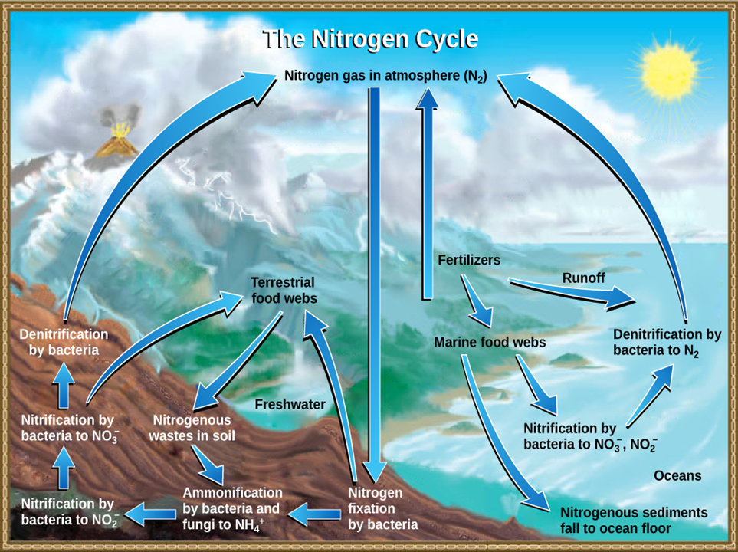

1. What are the TWO (2) conditions under which nitrogen will react with oxygen? (What is necessary for nitrogen in the air to combine with oxygen?)
2. What are the two (2) compounds that are formed when nitrogen combines with oxygen?
3. How does NITRIC ACID (HNO3) form?
4. Why is NITRIC ACID (HNO3) important?
5. Why is NITROGEN needed by plants and animals?

**The NITROGEN CYCLE Part 2**: <http://www.biology-pages.info/N/NitrogenCycle.html>

1. What percentage (%) of the air we breathe is NITROGEN?
2. Why do most plants not use the NITROGEN (N2) found in the atmosphere?
3. In what compounds can plants use NITROGEN?
4. How do animals get the NITROGEN they need?
5. What is NITROGEN fixation? (Describe how it happens)
6. How are humans changing the NITROGEN cycle? (Be as descriptive as possible, list & explain all possibilities)

**The WATER CYCLE:** <http://www.mbgnet.net/fresh/cycle/index.htm>

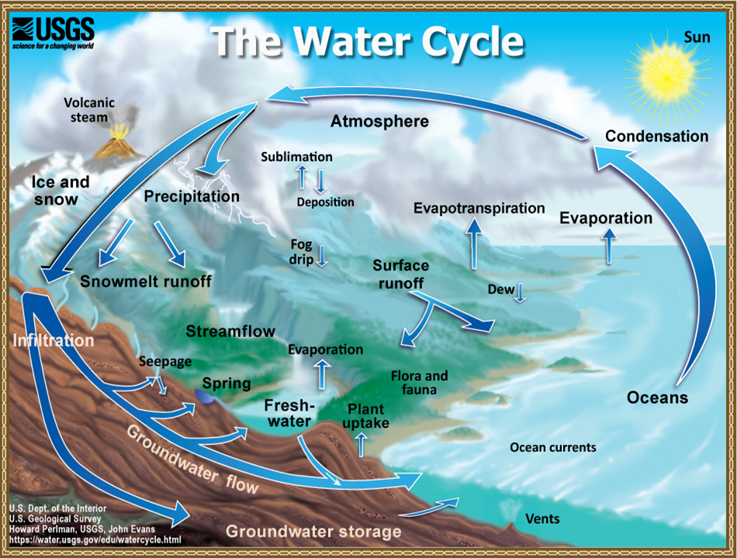

1. What is the WATER CYCLE?
2. What fraction of the Earth’s surface is covered in water?
3. What percentage of all the Earth’s water is in a form that is usable to humans and other land animals?
4. What is evaporation? How does it occur?
5. Why is evaporated water so clean?
6. What is condensation? How does it occur?
7. What is transpiration? How does it occur?
8. What is percolation? How does it occur?
9. Using, “evaporation”, “condensation” and “precipitation”, please explain the water cycle from start to finish in your own words.
10. Is the amount of water on Earth always changing or is it a constant amount? (Provide evidence in your answer)
11. How are humans changing the WATER cycle? (Be as descriptive as possible, list & explain all possibilities)

**ENRICHMENT RESOURCES:**

1. <http://www.geography4kids.com/files/cycles_intro.html>
2. <http://nca2014.globalchange.gov/report/sectors/biogeochemical-cycles>
3. <https://courses.lumenlearning.com/boundless-biology/chapter/biogeochemical-cycles/>
4. <https://www.britannica.com/science/biogeochemical-cycle>
5. <https://biologydictionary.net/biogeochemical-cycle/>