DNA Structure and Replication Review
Write the following questions on your own paper
and answer them. Cut out the pictures and color code and label as requested.

- What was the molecule named after?
- What molecules (monomer) is DNA composed of?
- What is the primary function of DNA?
- A nucleotide consists of? Draw it
- What scientists are credited with determining the structure of DNA?
- What is the base pair rule?
- If a strand of DNA has 30 % of thymine how much adenine, cytosine and guanine?
- What scientist discovered the base pair rule?
- What is the form of DNA called?
- What type of bond holds the strands together?
- What creates the sides or backbone of the DNA molecule?
- What kind of bond holds the sides together?
- What are chromosomes composed of?
- Where are chromosomes located in a cell?
- What is the first process of DNA replication?
- What does the enzyme Helicase do?
- Where is Helicase found?
- What does the enzyme DNA polymerase catalyze?
- Why is the process of DNA called semiconservative in nature?
- During the cell cycle when does DNA synthesis occur?
- Describe the DNA molecules that result from replication.
- What is the complimentary strand of the DNA molecule: AATCCGUC
- Cut out the diagrams and place in notebook. Label and color code

DNA structure: DNA replication:
Thymine, Adenine Cytosine, Guanine, DNA polymerase, helicase, replication fork
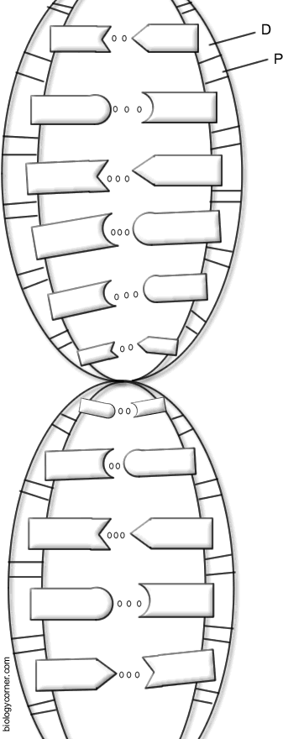
Hydrogen bond, covalent bond, old strand, new strand,
deoxyribose sugar, phosphate group
