**Homeostasis & Cellular Transport Study Guide**

**B2.3B**

1. What is diffusion?
2. 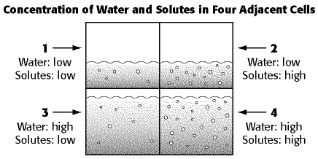
   1. In this system, solute molecules in cell 2 are most likely to do what?
   2. In this system, in which direction are water molecules in this system most likely to diffuse?
   3. In this system, Which cell is most likely to lose both water molecules and solute molecules as the system approaches equilibrium?
3. 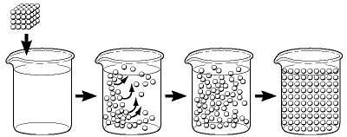
   1. The process show below is called?
4. Sugar molecules can enter cells through the process of?
5. The dispersal of ink in a beaker of water is an example of?

**B3.2C**

1. What is Homeostasis?
2. What is Exocytosis?
3. What is Endocytosis?
4. What are Cell Membrane Pumps?
5. What is Facilitated Diffusion?
6. What is Active Transport?
7. What is Hypertonic?
8. What is Hypotonic?
9. What is Isotonic?

**B2.5h**

1. What is Osmosis?
2. What is Pinocytosis?
3. What is Phagocytosis?
4. What is Passive Transport?



1. 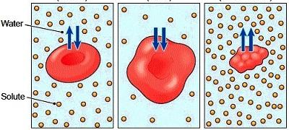
   1. Explain what is occurring in box one (1)
   2. Explain what is occurring in box two (2)
   3. Explain what is occurring in box three (3)