Station 1: Components of prokaryotic cells

There are some key ingredients that a cell needs in order to be a cell, regardless of whether it is prokaryotic or eukaryotic. All cells share four key components:
- The plasma membrane is an outer covering that separates the cell’s interior from its surrounding environment.
- Cytoplasm consists of the jelly-like cytosol inside the cell, plus the cellular structures suspended in it. In eukaryotes, cytoplasm specifically means the region outside the nucleus but inside the plasma membrane.
- DNA is the genetic material of the cell.
- Ribosomes are molecular machines that synthesize proteins.
Despite these similarities, prokaryotes and eukaryotes differ in a number of important ways.
A prokaryote is a simple, single-celled organism that lacks a nucleus and membrane-bound organelles. The main thing to keep in mind for now is that prokaryotic cells are not divided up on the inside by membrane walls, but consist instead of a single open space.
The majority of prokaryotic DNA is found in a central region of the cell called the nucleoid, and it typically consists of a single large loop called a circular chromosome. The nucleoid and some other frequently seen features of prokaryotes are shown in the diagram below of a cut-away of a rod-shaped bacterium.

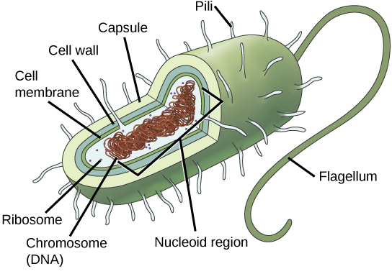

Station 2: Components of prokaryotic cells – Cont’d

Bacteria are very diverse in form, so not every type of bacterium will have all of the features shown in the diagram. Most bacteria are, however, surrounded by a rigid cell wall made out of peptidoglycan, a polymer composed of linked carbohydrates and small proteins. The cell wall provides an extra layer of protection, helps the cell maintain its shape, and prevents dehydration.

Many bacteria also have an outermost layer of carbohydrates called the capsule. The capsule is sticky and helps the cell attach to surfaces in its environment.

Some bacteria also have a specialized structures found on the cell surface, which may help them move, stick to surfaces, or even exchange genetic material with other bacteria. For instance, . Bacteria have rod-like structures known as pili, which come in different varieties. Some types of pili allow a bacterium to transfer DNA molecules to other bacteria, while others are involved in bacterial locomotion—helping the bacterium move.

flagella are whip-like structures that act as rotary motors to help bacteria move.

Station 3 All Bacteria are Prokaryotes – Where they live Size and Shapes of Prokayotes

Bacteria Basics - They are Alive!
Bacteria are the simplest of creatures that are considered alive. Bacteria are everywhere. They are in the bread you eat, the soil that plants grow in, and even inside of you. They are very simple cells that fall under the heading prokaryotic. That word means they do not have an organized nucleus. Bacteria are small single cells whose whole purpose in life is to replicate.
Most bacteria are 0.2 um in diameter and 2-8 um in length.
- Very small
- Need a microscope to see
- Can be found on most materials and surfaces
- Billions on and in your body right now

What Do Bacteria Look Like?
Very small. Very, very small. You might have seen pictures of some bacteria. Since we don't know what you have seen, we'll tell you there are three basic shapes. Spherical bacteria are in the shape of little spheres or balls. They usually form chains of cells like a row of circles. Rod shaped bacteria are look like the E. coli living in your intestine. You can imagine a bunch of bacteria that look like hot dogs. They can make chains like a set of linked sausages. Spiral shaped bacteria twist a little. Think about balloon animals for these shapes. It's like a balloon animal in the shape of a corkscrew.
The three basic bacterial shapes are
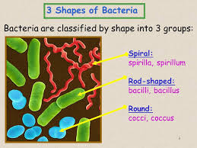
coccus (spherical),
bacillus (rod-shaped),
and spiral (twisted),

Station 4: What bacteria eat?

Bacteria feed on materials as varied as soybean oil, sugar, starch, sulfur, amino acids, iron, milk, meat and even wood compounds. Some types of bacteria are photosynthetic, making their own food from sunlight. Others absorb nutrition from the surface where they live.

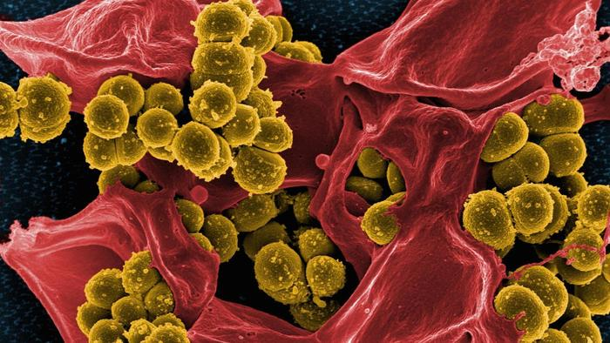

Bacteria exist as a single cell and there are thousands of species. The diet of bacteria is generally determined by their metabolic category. The process of bacteria breaking down food to get energy is called respiration. Phototrophic bacteria get their energy directly from the sun. Some bacteria feed on decaying matter and help break down environmental waste. Others get their food by breaking down chemicals in their surrounding environments. Some even consume harmful products such as oil, arsenic and nuclear waste. Bacteria do not consume food through chewing or swallowing in a mouth the way that other living organisms consume food. Instead, they absorb nutrients through channels in the walls of membranes and cells. Bacteria can feed alone or in groups that cluster together, forming chains, squares or various pairs.

Some make their own food from sunlight—like plants
Some are scavengers
Share the environment around them:
- Example: The bacteria in your stomach are now eating what you ate for breakfast
Some are warriors (pathogens)
They attack other living things
- Example: The bacteria on your face can attack skin causing infection and acne
Station 5. How Long They’ve Been Around
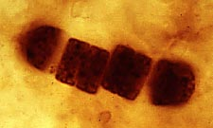
Like dinosaurs, bacteria left behind fossils. The big difference is that it takes a microscope to see them. And they are older.
Bacteria and their microbial cousins the archaea were the earliest forms of life on Earth. And may have played a role in shaping our planet into one that could support the larger life forms we know today by developing photosynthesis.
Cyanobacteria fossils date back more than 3 billion years. These photosynthetic bacteria paved the way for today's algae and plants. Cyanobacteria grow in the water, where they produce much of the oxygen that we breathe. Once considered a form of algae, they are also known as blue-green algae.
Bacteria are among the earliest forms of life that appeared on Earth billions of years ago. Scientists think that they helped shape and change the young planet's environment, eventually creating atmospheric oxygen that enabled other, more complex life forms to develop. Many believe that more complex cells developed as once free-living bacteria took up residence in other cells, eventually becoming the organelles in modern complex cells. The mitochondria (mite-oh-con-dree-uh) that make energy for your body cells is one example of such an organelle.

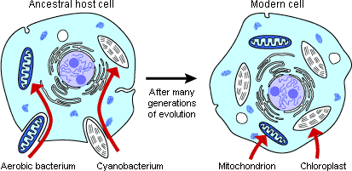

Station 6 How do Prokaryotes - Bacteria Reproduce?

Bacteria reproduce by binary fission. In this process the bacterium, which is a single cell, divides into two identical daughter cells. Binary fission begins when the DNA of the bacterium divides into two (replicates). The bacterial cell then elongates and splits into two daughter cells each with identical DNA to the parent cell. Each daughter cell is a clone of the parent cell.
When conditions are favourable such as the right temperature and nutrients are available, some bacteria likeEscherichia coli can divide every 20 minutes. This means that in just 7 hours one bacterium can generate 2,097,152 bacteria. After one more hour the number of bacteria will have risen to a colossal 16,777,216. That’s why we can quickly become ill when pathogenic microbes invade our bodies.
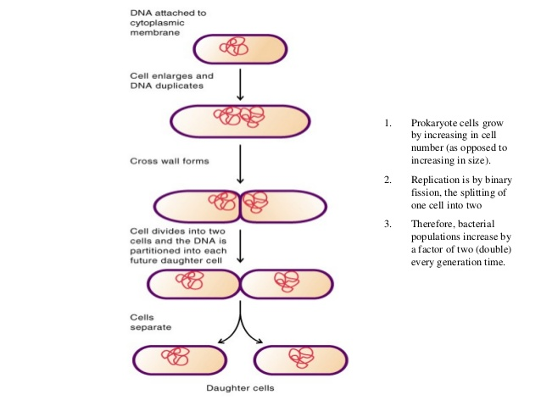

Station 7 Prokaryotes Archaea

Archaea
The Domain Archaea is also Prokaryotes. They can be spherical, rod, spiral, lobed, rectangular or irregular in shape. Some exist as single cells, others form filaments or clusters. Until the 1970s this group of microbes was classified as bacteria.
Many archaea have been found living in extreme environments, for example at high pressures, salt concentrations or temperatures, and have been nicknamed extremophiles. Their cell wall differs in structure from that of bacteria and is thought to be more stable in extreme conditions, helping to explain why some archaea can live in many of the most hostile environments on Earth.
Examples of archaea habitats are boiling hot springs and geysers such as those found in Yellow Stone Park, USA and ice such as the Artic and Antarctic oceans which remain frozen for most of the year.
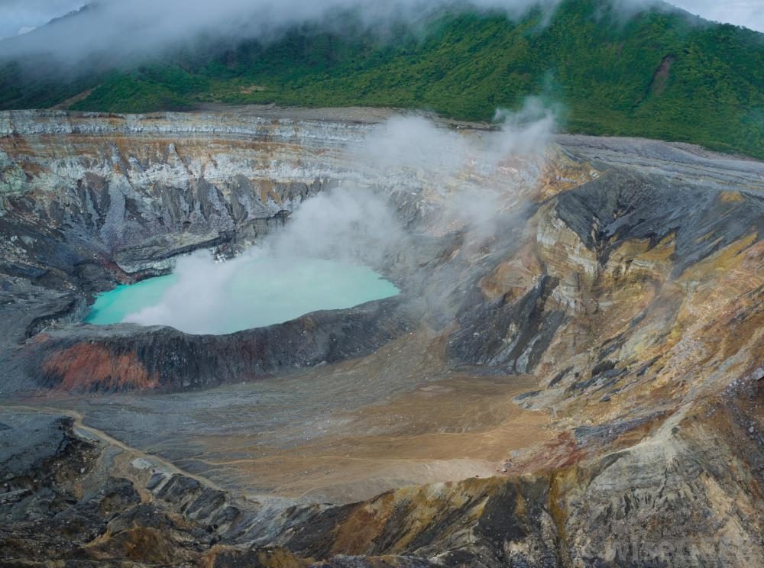
- Thermophiles Archaea can thrive inside volcanic lakes – very hot conditions

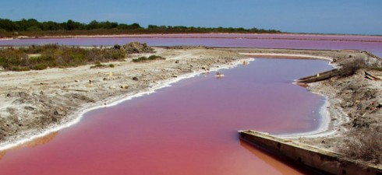

- Halophiles Archaea that thrive in very salty conditions

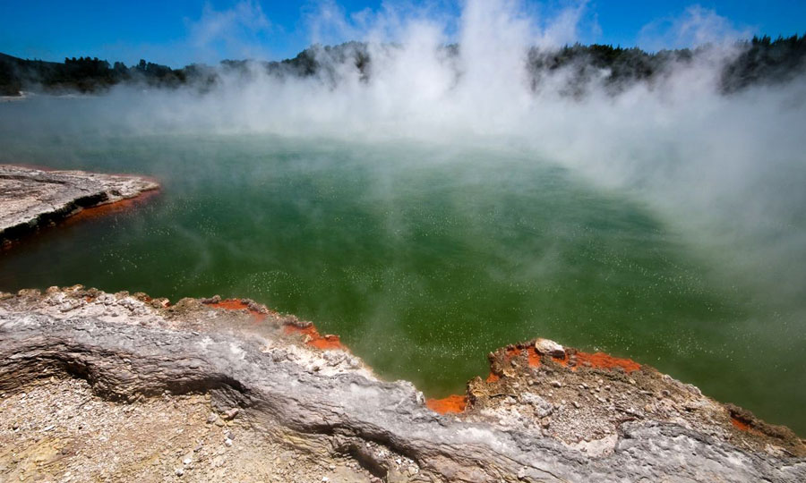

- Methanogens are Archaea that give off methane gas

Station 8: Good Bacteria
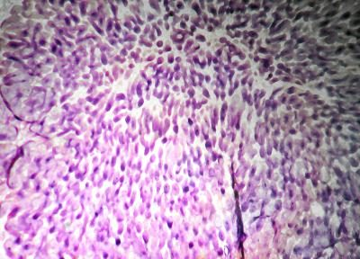

Bacteria aren’t all bad, in fact you couldn’t survive
without some bacteria! Good bacteria in your gut,
help digest your food and fight invading microbes.
Good bacteria are used in making some of the dairy products you like to eat and also some types of medicines! Bacteria are some of the best decomposers – they break down dead and decaying organic matter, from leaves to insects.

Best of all, bacteria are being used to clean up oil spills to keep your environment healthy too.

Your gut is a very busy place! It processes food, turning your dinner into nutrients that your body’s cells use for energy and growth. In your gut, friendly bacteria like GI Jake help with digestion and also help to fight microbes to make sure you stay healthy.
Probiotics-- often called "friendly" or "good" bacteria-- are live, lactic-acid producing microorganisms that are similar to those found in the human digestive tract. These beneficial bacteria are associated with numerous health benefits. They are also widely used in clinical nutrition and complementary alternative medicine. Experts at the National Institutes of Health note that probiotics show some promise in the treatment of diarrhea, irritable bowel syndrome, tooth decay and skin disease.
Probiotics are found in commercial supplements, as well as fermented foods like yogurt.
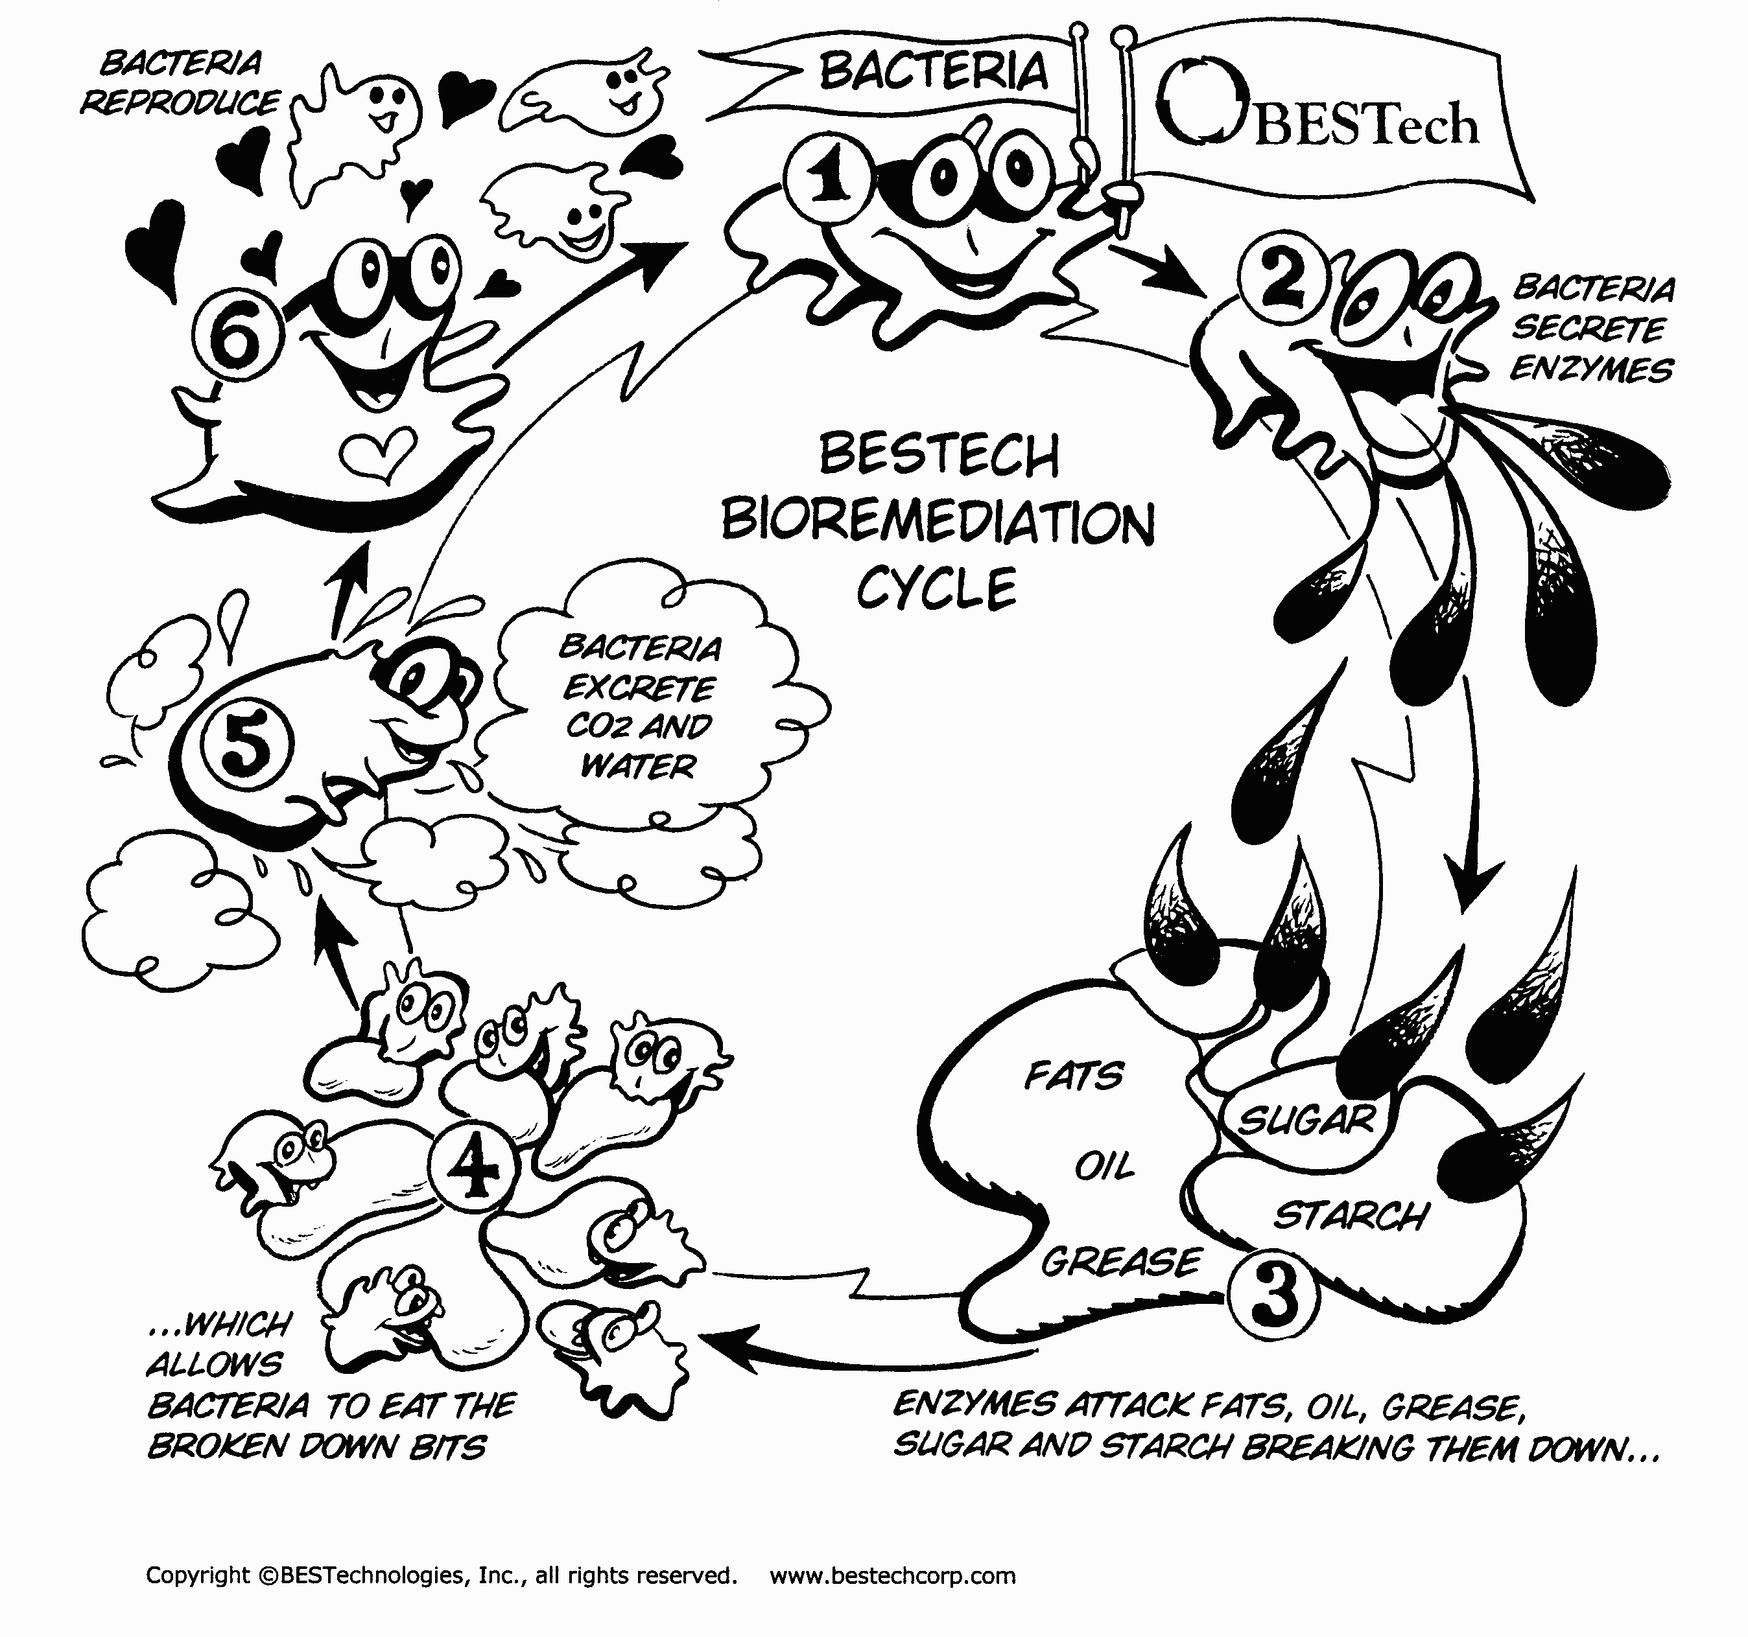
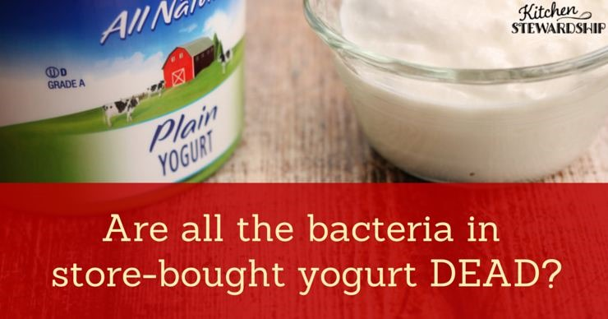
Station 9 Bad Bacteria – Pathogens and Antibiotics
Bacteria get a lot of bad press because some of them are really bad! There are plenty of good bacteria but these don’t make the news so often because they just get on with their jobs and don’t cause any trouble. In fact, without good bacteria we would have a lot of trouble surviving because they manage to keep you safe from a lot of the bad bacteria!
Although they are small, bacteria are very clever and they have learnt to live everywhere! Bacteria live in the air, in the ground, in water, in and on plant and animals, even on and inside you! Bacteria get a lot of attention because some of them, a small amount, can make you sick or even kill you! They can also cause some really annoying illnesses like sore ears, nose, throat and eyes. Some infections can spread right inside your body and give you more serious diseases such as respiratory infections like pneumonia!
The drugs that treat a lot of diseases caused by bacteria are called antibiotics. There are micro-organisms that defend themselves by making antibiotics that kill other micro-organisms. The problem was that bacteria are really very clever. The bacteria had adapted to the antibiotic, they are drug-resistant. New antibiotics are very difficult to find – the best way to make sure that all bacteria don’t become drug-resistant is to:
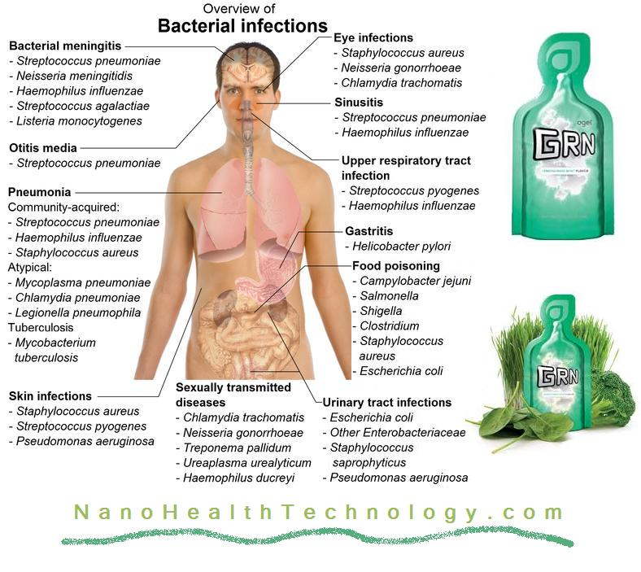
- only take antibiotics when you really need them
- always finish the course of treatment that your doctor gives you, even if you begin to feel better
- never take antibiotics from someone else or antibiotics that are out of date
- remember – antibiotics do not work on viruses so there is no point in taking them! Taking antibiotics when you don’t need them because the can reduce the amount of good bacteria in your body and make you even more likely to get another infection!
Name ________________________ Hour _____
Prokaryotic Cell Stations
Station 1.
- What are the four key components that all cells share?

- What is a prokaryote?

- Where is the DNA in a prokaryotic cell found?
- Label the diagram

Station 2
1. What is the function of the follwoing
Structure | Function
Cell wall
Capsule
Pili
flagella
Station 3
- How big are bacteria?
- Where can you find bacteria?

- What are the different shapes of bacteria?
Station 4:
- What do bacteria eat? (Are they heterotrophs? Or Autotrophs? Or both?)

- How do bacteria absorb nutrients?

Station 5:
- How old are bacteria?

- What are they given credit for changing on the Earths environment?

- How did more complex cells develop?

Station 6
- How do bacteria divide?
- Describe this process in your own words.

- How fast do bacteria divide?

Station 7
- What are Archaea?

- Where do they live, be specific?

- Why are they called extremophiles?

Station 8:
- List 4 things that good bacteria do?

- What are Probiotics?

- What are they similar to?

- What ailments are they used to treat?

Station 9:
1, Could we survive without bacteria?
2. What are some illnesses they can cause?

3. What drugs treat a lot of diseases caused by bacteria?

4. What has bacteria done over the years that has decreased the affect of antibiotics?

5. What can you do to stop bacteria from becoming drug resistant?

