Putting it all Together
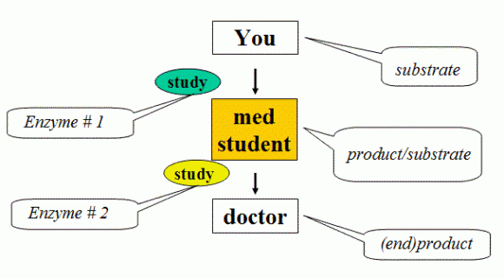
<>
Enzymes play a critical role in every function of the body. Most are proteins. We have enzymes to thank for how we are able to live our everyday lives. From the digestion of our food to the function of our brains to the ability to breathe, enzymes maintain the function and upkeep in our bodies. Enzymes are essential to sustain life. They work together cooperating with vitamins and minerals and act as a catalyst to accelerate chemical reaction because most chemical reactions in biological cells would occur too slowly. Enzymes don't only act as a catalyst. When the body has an abundance of enzymes, it can protect itself and repair the damage from almost all degenerative disease disorders! Without enzymes, we age more quickly, get disease earlier in life, and acquire physical impairments and mental retardation as our bodies degenerate. Neither a human being nor an animal can live without enzymatic function. As it were the leading part of the life activities and it is the source. If we take supplements in the correct form, most people would assume that the nutrients are being utilized to give the body the support it needs. Wrong! Without the assistance of digestive enzymes, many of the nutrients from the supplements are going to be used just for energy by the metabolic enzymes to clean up the bloodstream. It will not support the body's normal daily needs, creating another cause of deficiencies. More than 5,000 enzymes are known. Since we know each enzyme does one job, that means that 5,000 enzymes do 5,000 different jobs. A lack of enzymes in the body, makes the blood dirty, and it is the base of many kinds of diseases. There are a few things that you need to remember about enzymes to keep the upkeep of your body at its peak:
- It has been clinically proven that the more enzymes you take the more quickly your body can restore, repair and strengthen itself.
- The combination of digestive enzymes, vitamins, ionic minerals and clean water gives your body the support it desperately needs.
- Fat is the best source of energy, fully digested fat is good fat.
- The source of most health problems can be traced directly back to improperly digested foods
We have a choice, to add to the body's ability to protect or repair, or to continually and slowly drain the body's energy and enzyme reserves. Your choice will be a determining factor in your long-term health.
Name _________________________________ Date __________

Answer the following questions.
- What macromolecule are enzymes made from?
- What do enzymes do in our everyday life?
- How do enzymes work?
- Why do we need them?
- What would happen if we were without enzymes?
- How many enzymes are there?
- What does a lack of enzymes do?
- How do enzymes affect your body?
- What is the best source of energy?
- What is the source of most health problems?

