Name: _________________________________________

Date: ___________ Hour: ______

**PROTEINS**

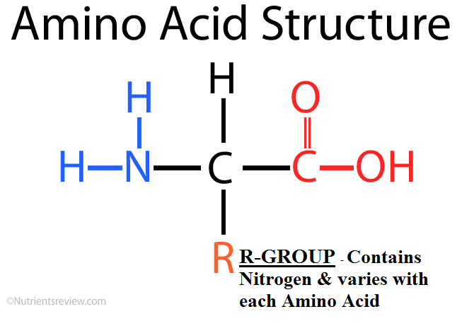

**PROTEINS** (also known as **POLYPEPTIDES**) make up the majority of the structures in plants & animals, are responsible for our immune system & act as enzymes to speed up chemical reactions. Proteins are made of monomers called **AMINO ACIDS** (aka **PEPTIDES**). Amino Acids are composed (made up of) Carbon (C), Hydrogen (H), Oxygen (O) & Nitrogen (N). The **STRUCTURE** of a protein **DICTATES/DETERMINES** the proteins **FUNCTION**. The bonds between the Amino Acids that are formed through CONDENSATION (DEHYDRATION) REACTIONS are known as **PEPTIDE BONDS** and for this reason proteins are called Polypeptides (many peptide bonds).

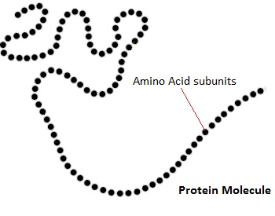 Every Amino Acid is composed of Carbon, Hydrogen, Oxygen & Nitrogen. All Amino Acids have the same structure (composed of Carbon, Hydrogen & Oxygen) except for a section called the **R GROUP**. The R group is the portion of the Amino Acid that contains Nitrogen. The structure of the R GROUP dictates the protein’s function. There are 20 different R Groups so there are 20 different Amino Acids. Each Amino acid has different properties that interact with each other when they are joined together in a protein. This is why the structure or shape of the protein dictates its function.

Proteins are damaged or **DENATURED** (to make nonfunctional) when their temperature or their pH is changed. Increased temperatures & pHs change the structure of a protein, therefore altering its function.

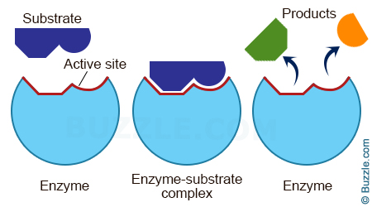**ENZYMES** are composed of protein molecules and they act as biological catalysts (**CATALYST** – increases the rate of a chemical reaction). Without enzymes life’s processes including the breakdown of food would happen too slowly to sustain life. Enzyme reactions depend on a physical fit between the enzyme molecule and its specific substrate (the reactant being catalyzed (speed up)). The **ACTIVE SITE** of the enzyme is a shape or fold in the enzyme that only allows the substrate to bind with the enzyme. Each enzyme speeds up a specific substrate. An enzyme can be damaged/denatured when their temperature or their pH is changed.

1. What are the functions of proteins? How are they determined? __________________________________________

_______________________________________________________________________________________________

_______________________________________________________________________________________________

2. Please describe the composition of a Protein molecule: ________________________________________________

_______________________________________________________________________________________________

3. Please recreate the structure of an Amino Acid below (include the R-Group label)

4. Please recreate an enzyme binding to its substrate below (include the active site & make the shape specific)

5. What does it mean to DENATURE a protein? Please provide an example of when you have denatured a protein.

_______________________________________________________________________________________________

_______________________________________________________________________________________________

_______________________________________________________________________________________________

_______________________________________________________________________________________________

6. What is the relationship between a Dehydration (Condensation) Reaction, an Amino Acid & a Protein? __________

_______________________________________________________________________________________________

_______________________________________________________________________________________________

7. What is the relationship between a Hydrolysis Reaction, an Amino Acid & a Protein? ________________________

_______________________________________________________________________________________________

_______________________________________________________________________________________________