Name: _________________________________________

Date: ___________ Hour: ______

**Nucleic Acids**

Nucleic Acids include DNA, RNA & ATP. DNA (Deoxyribonucleic Acid), RNA (Ribonucleic Acid) & ATP (Adenosine Triphosphate) are composed of Carbon (C), Hydrogen (H), Oxygen (O), Nitrogen (N) & Phosphorus (P)

**DNA/RNA/ATP = CHONP**

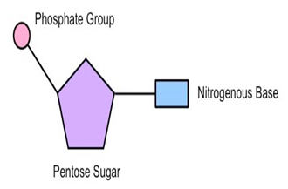

DNA & RNA carry the genetic information in a cell. DNA or Deoxyribose nucleic acid contains all of the instructions for making every protein needed by a living thing. RNA copies and transfers this genetic information so that proteins can be made.

**Nucleotide**

ATP is the primary energy source for all living things.

The monomers that make up nucleic acids are called **NUCLEOTIDES**.

Nucleotides are composed of a phosphate group attached to a 5-Carbon sugar & a Nitrogenous base.

* In DNA the sugar is deoxyribose & the N-Bases are Adenine (A), Guanine (G), Cytosine (C) & Thymine (T)
  + DNA – The Twisted Ladder
    - A bonds to T
    - G bonds to C
* In RNA the sugar is ribose & the N-Bases are Adenine (A), Guanine (G), Cytosine (C) & Uracil (U)
  + RNA – The Single Strand Spiral Staircase
    - A bonds to U
    - G bond to C

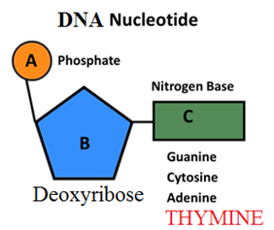

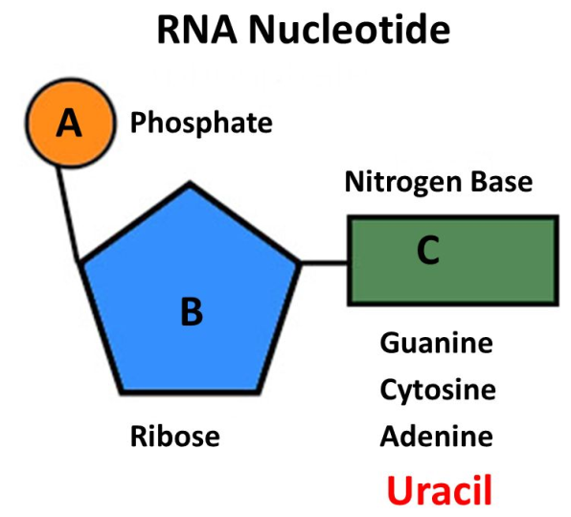

**ATP Nucleotide**

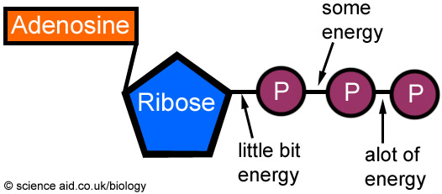

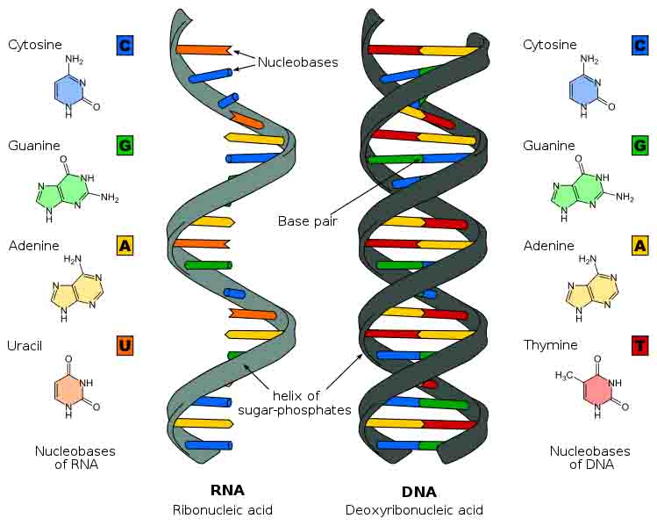

1. What are the functions of DNA, RNA & ATP? ______________________________________________________

_______________________________________________________________________________________________

_______________________________________________________________________________________________

_______________________________________________________________________________________________

2. Please describe the composition of a Nucleic Acid ____________________________________________________

_______________________________________________________________________________________________

_______________________________________________________________________________________________

3. Please recreate the structure of a Nucleotide below (include all labels)