Name: _________________________________________

Date: ___________ Hour: ______

**LIPIDS**

**FATS** are also known as **LIPIDS** in the world of Biology. Lipids (fats) are vital to the survival of all living things. Lipids are used for cell membranes, long term energy storage and insulation (against extreme temperatures). Lipids are large nonpolar (won’t dissolve in water) molecules. Lipid polymers include TRIGLYCERIDES, PHOSPHOLIPIDS, WAXES, PIGMENTS & STEROIDS.

Lipids can be produced as **WAX** coverings on plant leaves that prevent dehydration and on the feathers of aquatic birds that keep them dry in the water. Lipids produce the **PIGMENT** chlorophyll in plants. In humans the **STEROIDS,** estrogen, testosterone, cholesterol and adrenaline are all produced from lipids. When lipid molecules are broken down in the human body, they produce the greatest amount of energy.

Most lipids are composed of Fatty Acids. **FATTY ACIDS & GLYCEROLS** are considered the MONOMERS of Lipids. Fatty Acids are unbranched carbon chains composed of a **HYDROPHILIC** (POLAR) HEAD (WATER LOVING) & a **HYDROPHOBIC** (NONPOLAR) TAIL (WATER FEARING).

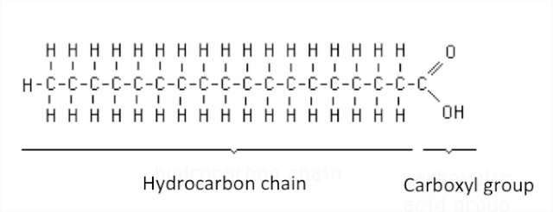

**HYDROPHOBIC (WATER FEARING) TAIL**

**HYDROPHILIC (WATER LOVING) HEAD**

In **SATURATED FATTY ACIDS**, the carbon atom is bonded to four (4) other atoms. In **UNSATURATED FATTY ACIDS**, the Carbon atoms are bonded to three (3) other atoms.

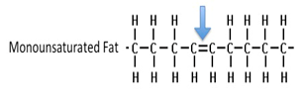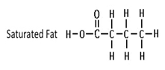

**LIQUID at room temperature**

**SOLID at room temperature**

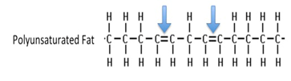

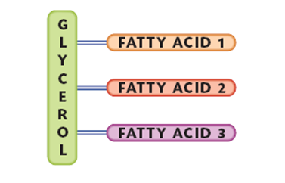

**TRIGLYCERIDES** are composed of three molecules of fatty acids joined to one molecule of GLYCEROL.

**Phospholipids** make up the cell membrane. Phospholipids are composed of two (2) fatty acids, a glycerol and a phosphate group. Phospholipids are Polar at one end and nonpolar at the tail. The cell membrane is composed of a Phospholipid Bilayer (Bilayer = Two (2) Layers).

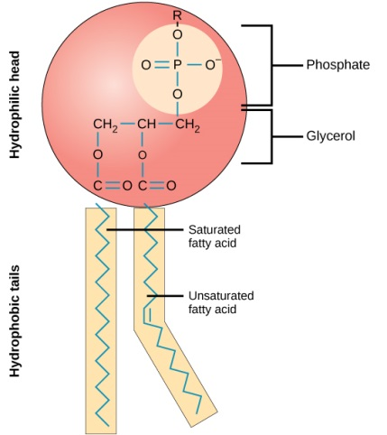

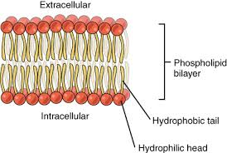

1. What are the three (3) functions of Lipids? __________________________________________________________

_______________________________________________________________________________________________

______________________________________________________________________________________________.

2. What are the two (2) Monomers of LIPIDS? _________________________________________________________

_______________________________________________________________________________________________

3. What are the five (5) Polymers of Lipids? ___________________________________________________________

_______________________________________________________________________________________________

_______________________________________________________________________________________________

4. Please recreate the structure of a Phospholipid below (include all labels (including hydrophilic Head & hydrophobic Tail))

5. Describe the composition of Lipids: _______________________________________________________________

_______________________________________________________________________________________________

_______________________________________________________________________________________________