Name: _________________________________________

Date: ___________ Hour: ______

**Introduction to Biochemistry**

**The Building Blocks**

* The six (6) most common elements in organic (living) molecules are Carbon (C), Hydrogen (H), Nitrogen (N), Oxygen (O), Phosphorus (P) & Sulfur (S). These six (6) elements make up over 95% of your body weight
* All compounds can be classified into two (2) broad categories → ORGANIC or INORGANIC
  + **ORGANIC COMPOUNDS** contain Carbon (C)
  + INORGANIC COMPOUNDS do NOT contain Carbon (C)
* **Carbon (C) is very unique**
  + Carbon is the ORGANIC element & makes life possible
  + Carbon has four (4) valence elections
    - Four (4) valence electrons = Four (4) Bonds
  + Carbon can form single (1) bonds, double (2) bonds & triple (3) bonds to itself & other elements
  + Carbon can form ring & chain structures
* **MONOMERS** are some of the structures formed by Carbon (C)
  + **Monomers** are simple molecules; Monomers include the following…
    - **Carbohydrate Monomer =** Monosaccharide (simple sugar)
    - **Protein Monomer =** Amino Acid (Peptides)
    - **Lipid Monomer** = Fatty Acid
    - **Nucleic Acid Monomer** = Nucleotide
* Long chains of monomers link together to form **POLYMERS**
  + **Polymers** are macromolecules (large molecules) composed (made of) repeated, linked units
  + **Dehydration Reactions** (also known as a **Condensation Reaction**) form polymers
    - During a **Dehydration (Condensation) Reaction**, water (H2O) is **PULLED OUT** of the monomers and they are then bonded together to form polymers
  + 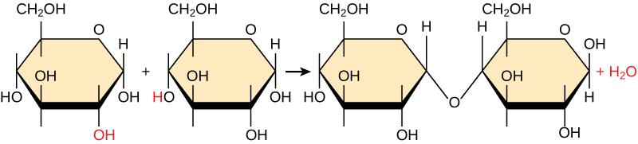
  + **Hydrolysis Reactions** break down polymers into their monomer counterparts
    - During a **Hydrolysis (Cut Using Water) Reaction**, water (H2O) is **ADDED** to the Polymer and it is broken apart into monomers
  + Image result for hydrolysis reaction
* There are four (4) types of macromolecules (polymers): Carbohydrates, Proteins, Lipids & Nucleic Acids
* Heterotrophs must get these biological macromolecules from our food which we break down into monomers through digestion
  + This makes the molecules small enough to cross cell membranes. Our cells use monomers as energy sources or to build the carbohydrates, proteins, lipids and nucleic acids that our body needs

1. What are the six (6) most common elements found in living things (B2.2B)?



2. Why is Carbon unique (provide the 4 reasons found in the text)?_________________________________________

_______________________________________________________________________________________________

_______________________________________________________________________________________________

_______________________________________________________________________________________________

3. When polymers are built, the process is called a Dehydration (Condensation) Reaction. Why are the words

“Dehydration/Condensation” used? __________________________________________________________________

_______________________________________________________________________________________________

4. Why does a cell (or your body) need to break down polymers into monomers (Give a minimum of two (2) reasons)?

_______________________________________________________________________________________________

_______________________________________________________________________________________________

_______________________________________________________________________________________________

5. What is the relationship between monomers, polymers & Dehydration (Condensation) Reactions?______________

_______________________________________________________________________________________________

6. What is the Relationship between monomers, polymers & Hydrolysis Reactions?____________________________

_______________________________________________________________________________________________

7. How can Carbon join to other carbon atoms in chains & rings to form large & complex molecules (B2.2A)? ______

_______________________________________________________________________________________________

_______________________________________________________________________________________________

_______________________________________________________________________________________________