Name: _________________________________________

Date: ___________ Hour: ______

**Carbohydrates**

Carbohydrates are sugars, starches and glycogen which are used for short and long term energy storage in cells and structural molecules in cell walls & exoskeletons. Carbohydrates are made of only Carbon, Hydrogen & Oxygen (often abbreviated CHO). They are found in vegetables, fruits, grains, oats, pastas, breads, nuts & seeds.

**CARBOHYDRATES** are also known as **POLYSACCHARIDES (POLY = MANY, SACCHARIDE = SUGAR)**. They are often referred to as polysaccharides because they are made of monomers called **MONOSACCHARIDES (MONO = ONE)**. Monosaccharides or simple sugars contain Carbon, Hydrogen & Oxygen in a ratio of 1 Carbon : 2 Hydrogen : 1 Oxygen. Monosaccharides include GLUCOSE, Galactose & Fructose. Glucose comes from photosynthesis & is converted into either Galactose or Fructose by plants. Two simple sugars come to make **DISACCHARIDES (DI = TWO).**

* **Monosaccharides** include: Glucose, Galactose & Fructose
  + 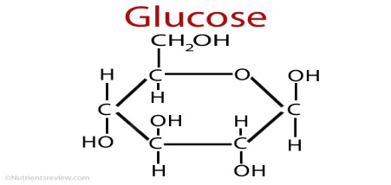
  + Chemical Equation of GLUCOSE = C6H12O6
* **Disaccharides** include: Lactose (Milk Sugar) & Sucrose (Table Sugar)
* **Polysaccharides** include: Cellulose, Chitin, Starch & Glycogen

Plants store glucose as STARCH which is simply long chains of glucose with a few side branches. Animals store glucose as GLYCOGEN which is those same long chains but with many more branches. CELLULOSE makes up plant cell walls & is three chains of glucose twined together like a rope (the rope is stuck together with Hydrogen bonds). CHITIN, which makes up the exoskeleton of insects and crustaceans, is a long chain of glucose with one amino acid attached to each end.

* Polysaccharides made of GLUCOSE…
  + **STARCH** used for energy in PLANTS
  + **CELLULOSE** used for structure (cell walls, bark) in PLANTS
  + **GLYCOGEN** used for energy in ANIMALS
  + 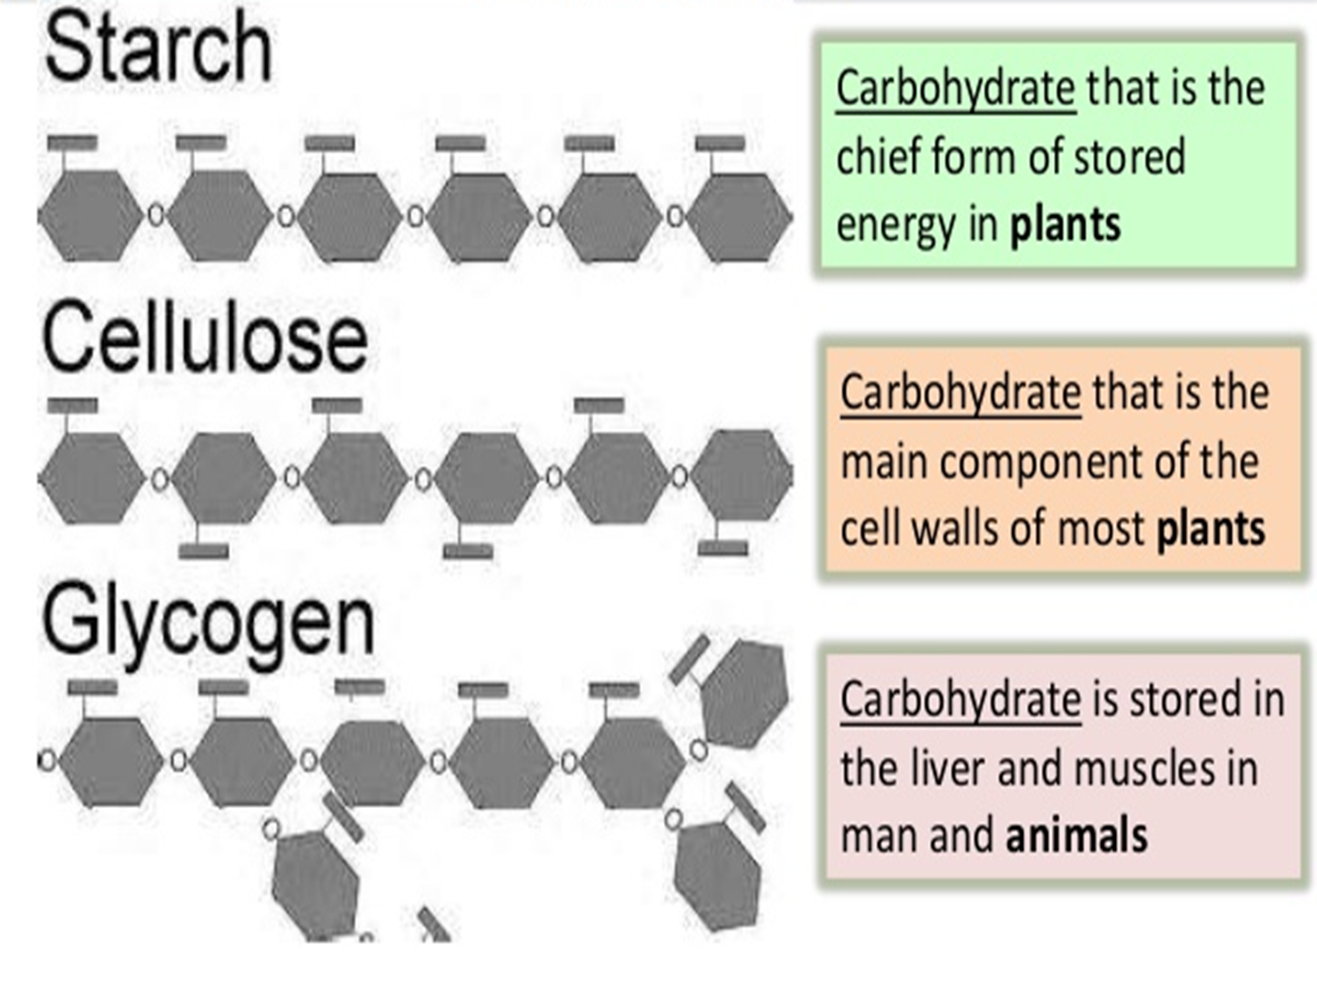**CHITIN** used for structure in INSECTS & CRUSTACEANS

1. What are the monomers that make up carbohydrates called? ____________________________________________

2. Using the Thinking Map below, Compare & Contrast, MONOSACCHARIDE, DISACCHARIDE& POLYSACCHRIDE

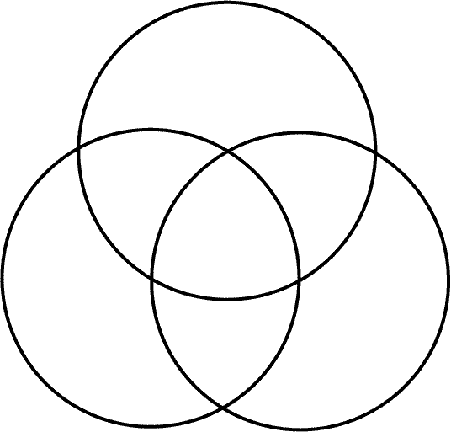

3. What are the TWO (2) functions of carbohydrates in living organisms? ___________________________________

_______________________________________________________________________________________________

_______________________________________________________________________________________________

4. Draw Glucose & provide its chemical equation in the space below.

5. Describe the structure of the following carbohydrates, Starch, Cellulose & Glycogen_________________________

_______________________________________________________________________________________________

_______________________________________________________________________________________________

_______________________________________________________________________________________________

6. What is the function of the POLYSACCHARIDES STARCH & GLYCOGEN? ____________________________

_______________________________________________________________________________________________

_______________________________________________________________________________________________

_______________________________________________________________________________________________