Station 1: Ecosystem Recycling – The Water Cycle

As energy and matter flow through an ecosystem, matter must be recycled and reused. Substances such as water, carbon, nitrogen, calcium and phosphorus each pass between the living and nonliving worlds through four (4) different **BIOGEOCHEMICAL CYCLES** (WATER cycle, CARBON cycle, NITROGEN cycle & PHOSPHORUS cycle)

Water is crucial to life. Cells contain 70-90 percent water and water provides the environment in which most of life’s chemical reactions occur. The availability of water is one of the key factors that regulates the productivity of terrestrial (growing on the ground) ecosystems. Bodies of water, such as lakes, rivers, streams and oceans, contain a substantial percentage of Earth’s water. The atmosphere also contains water – in the form of WATER VAPOR. In addition, some water is found below ground. Water in the soil or in underground formations of porous rock is known as **GROUND WATER**.

The movement of water between these various reservoirs is known as the WATER CYCLE. Three (3) important processes in the water cycle are EVAPORATION, TRANSPIRATION and PRECIPITATION.

* 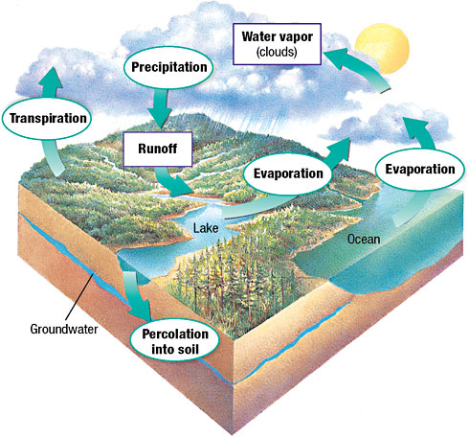**EVAPORATION** adds water as vapor to the atmosphere. Heat causes water to evaporate from bodies of water, from the soil and from bodies of living things.
* Most water that evaporates from terrestrial (growing on the ground) ecosystems passes through plants in a process called **TRANSPIRATION**.
  + In transpiration, plants take in water through their roots and they release it (along with CO2) through their leaves.
  + Animals drink or obtain water in their food and release it when they breathe, sweat of excrete.
* **PRECIPITATION** removes water from the atmosphere. The amount of water in the atmosphere is dependent on abiotic factors, such as temperature and air pressure. Once the atmosphere becomes saturated with water vapor, precipitation occurs in the form of rain, snow, sleet, hail or fog.

1. How are substances passed through the living (biotic) & nonliving (abiotic) worlds?

2. In a complete sentence, please state all of the BIOGEOCHEMICAL CYCLES.

3. In your own words please describe the water cycle (include the ground water, evaporation, transpiration & precipitation).

Station 2: Ecosystem Recycling – The Carbon Cycle

Photosynthesis and cellular respiration form the basis of the short-term CARBON CYCLE.

* In Photosynthesis, plants and other autotrophs (produce their own food) use carbon dioxide (CO2), along with water and solar energy, to make carbohydrates (Starch & Cellulose)
* Both autotrophs and heterotrophs use oxygen to break down carbohydrates during cellular respiration
* The by-products (waste products) of cellular respiration are carbon dioxide & water
* Decomposers release carbon dioxide into the atmosphere when they break down organic compounds.

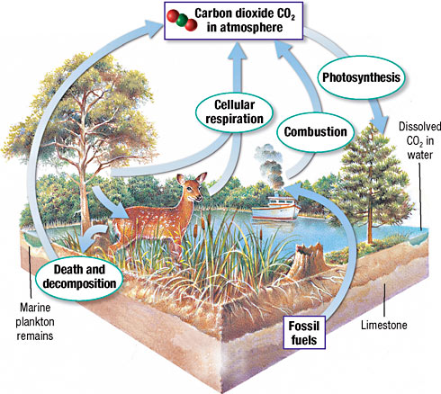

**The Human Influence on the Carbon Cycle**

In the last 150 years, the concentration of atmospheric carbon dioxide has risen more than 30 percent (30%). Humans contribute to this increase by burning fossil fuels (Gasoline, Coal, Natural Gas) and other organic matter. Our industrial society depends on the energy released by the burning of fossil fuels (Gasoline, Coal, Natural Gas).

Fossil fuels are the remains of organisms that have been transformed over millions of years through decay, heat and pressure into energy-rich molecules. Burning them releases the energy in these molecules but it also releases Carbon Dioxide. When large areas of forests are burned each year to clear land for agriculture (farming), less vegetation remains to absorb carbon dioxide from the atmosphere through photosynthesis.

1. How is Carbon Dioxide (CO2) released into the atmosphere? (use the information form the text and look over the picture).

2. What types of organisms remove Carbon Dioxide (CO2) from the atmosphere?

3. What affect are humans having on the amount of Carbon Dioxide (CO2) in the atmosphere?

Station 3: Ecosystem Recycling – The Nitrogen Cycle

All organisms need nitrogen to make proteins and nucleic acids. The complex pathway that nitrogen follows in an ecosystem is called the NITROGEN CYCLE.

* 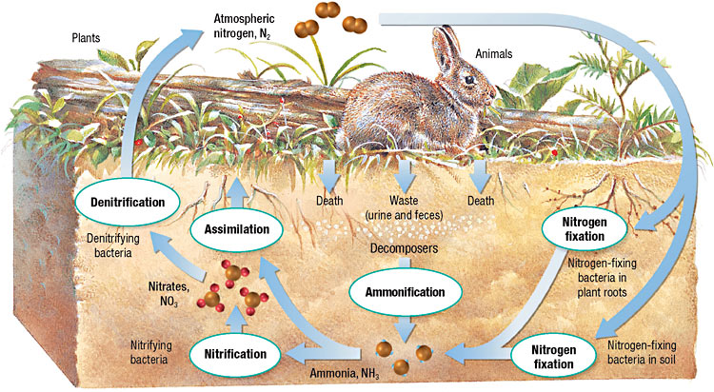Nitrogen gas, N2, makes up about 78 percent (78%) of the atmosphere, however most plants can only use nitrogen in the form of **NITRATE**. The process of converting N2 gas to Nitrate is called **NITROGEN FIXING**.
* Most organisms rely on **NITROGEN-FIXING BACTERIA** to transform nitrogen gas (N2) into a usable form
* These bacteria live in the soil and inside the swellings on the roots of some kinds of plants, such as beans, peas, clover and alfalfa (ALL HIGH IN PROTEIN)
* These plants supply carbohydrates for the bacteria and the bacteria produce usable nitrogen for the plant
* Additional nitrogen is released into the soil, increasing its ability to grow more plants (acts as a fertilizer)

Recycling Nitrogen

The bodies of dead organisms contain nitrogen, mainly as proteins and nucleic acids (Urine and dung also contain nitrogen). Decomposers break down these materials and release the nitrogen they contain as ammonia, NH3, which in soil becomes ammonium NH4+. This process is known as **AMMONIFICATION**. Through this process, nitrogen is again made available to other organisms.

Soil bacteria take up ammonium and oxidize it into nitrites in a process called **NITRIFICATION**. The erosion of nitrate-rich rocks also release nitrates into the ecosystem. Plants use nitrates to form AMINO ACIDS (the building blocks of proteins).

Nitrogen is returned to the atmosphere through **DENITRIFICATION**. Denitrification occurs when anaerobic (anaerobic means they do not need oxygen) bacteria break down nitrates and release nitrogen gas into the atmosphere.

Plants absorb the nitrates from the soil and animals obtain the nitrogen through eating the plants and other organisms that eat plants. This is how your body receives the **proteins** and **nucleic acids** it needs for muscles and DNA/RNA.

1. Explain the symbiotic relationship (they can’t live without each other) between Nitrogen-Fixing Bacteria & beans, peas, clover and alfalfa plants

2. Why are Nitrogen-Fixing Bacteria vital to our survival?

3. Why is nitrogen so important to us?

Station 4: Ecosystem Recycling – The Phosphorus Cycle

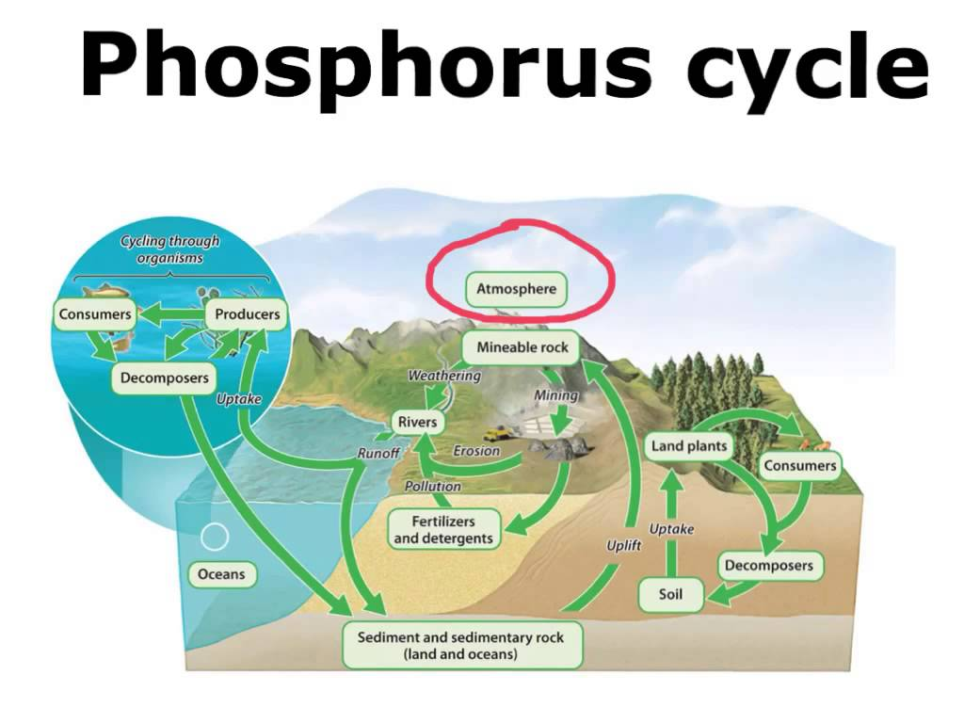Phosphorus is an element that is an essential material needed by animals to form bones, teeth and parts of molecules such as DNA and RNA. Plants get the phosphorus they need from soil and water, whereas animals get their phosphorus by eating plants or other animals.

The phosphorus cycle is the movement of phosphorus from the environment to organisms and then back to the environment. This cycle is slow and does not normally occur in the atmosphere because phosphorus rarely occurs as a gas.

When rocks erode, small amounts of phosphorus dissolve in the soil and water. Plants absorb the phosphorus in the soil through their roots.

Phosphorus is also added to soil and water when excess phosphorus is excreted in wastes from organisms and when organisms die and decompose.

Phosphorus applied as fertilizer also washes off the land and into streams and groundwater.

1. Why is Phosphorus important to us?

2. How do plants obtain the phosphorus they need?

3. How do human beings obtain the phosphorus they need?