Mutations Notes
What are mutations?
- Changes in the nucleotide sequence of DNA
- May occur in somatic cells (aren’t passed to offspring)
- May occur in gametes (eggs & sperm) and be passed to offspring
Are Mutations Helpful or Harmful?
- Mutations happen regularly
- Almost all mutations are neutral
- Chemicals & UV radiation cause mutations
- Many mutations are repaired by enzymes
- Some type of skin cancers and leukemia result from somatic mutations
- Some mutations may improve an organism’s survival (beneficial)
Types of Mutations
Chromosome Mutations
- May Involve:
  - Changing the structure of a chromosome
  - The loss or gain of part of a chromosome
- Five types exist:
  - Deletion
  - Inversion
  - Translocation
  - Nondisjunction
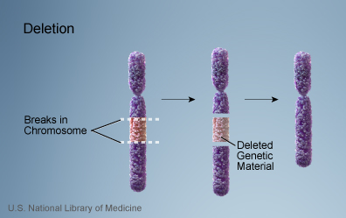
  - Duplication
Deletion
- Due to breakage
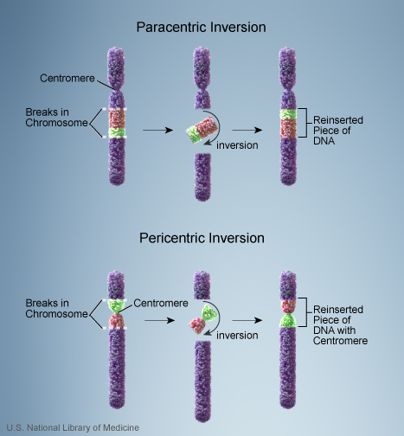
- A piece of a chromosome is lost
Inversion
- Chromosome segment breaks off
- Segment flips around backwards
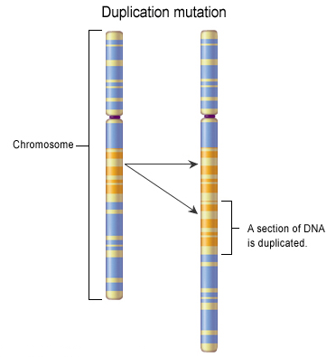
- Segment reattaches
Duplication
- Occurs when a gene sequence is repeated
Translocation
- Involves two chromosomes that aren’t homologous
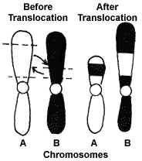
- Part of one chromosome is transferred to another chromosomes
Nondisjunction
- Failure of chromosomes to separate during meiosis
- Causes gamete to have too many or too few chromosomes
- Disorders:
  - Down Syndrome – three 21st chromosomes
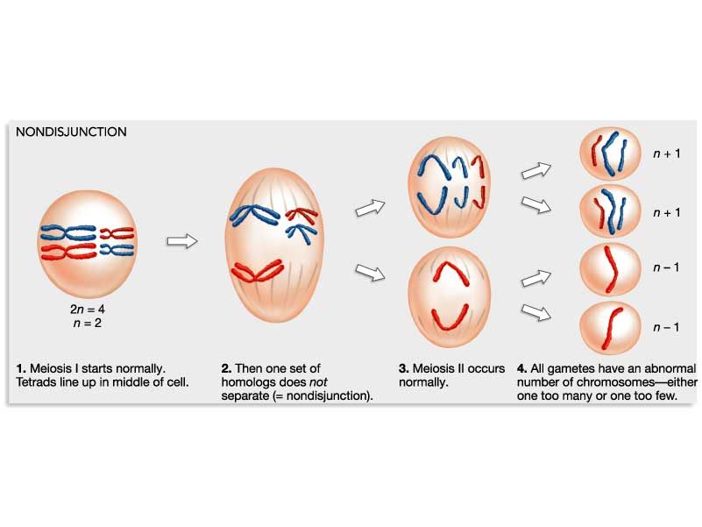
  - Turner Syndrome – single X chromosome
  - Klinefelter’s Syndrome – XXY chromosomes

Gene Mutations
- Change in the nucleotide sequence of a gene
- May only involve a single nucleotide
- May be due to copying errors, chemicals, viruses, etc.
Types of Gene Mutations
- Include:
  - Point Mutations
  - Substitutions
  - 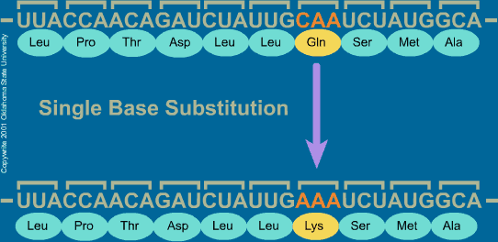
  - Insertions
  - Deletions
  - Frameshift
Point Mutation
- Change of a single nucleotide
- Includes the deletion, insertion, or substitution of ONE nucleotide in a gene
- Sickle Cell disease is the result of one nucleotide substitution
- Occurs in the hemoglobin gene
- 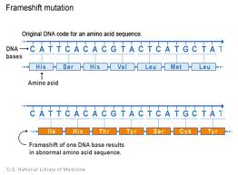
Frameshift Mutation
- Inserting or deleting one or more nucleotides
- Changes the “reading frame” like changing a sentence
- Proteins built incorrectly
- Original:
  - The fat cat ate the wee rat.
- Frame Shift (“a” added):
  - The fat caa tet hew eer at.

