**Explorations Through Time - Life Has a History**

<http://www.ucmp.berkeley.edu/education/explotime.html> - Go to "Life Has a History" ' Level 2

1. How many different species of living things exist today? ___________________  
2. Which group of animals has the largest number of species? _______________________  
3. How many mammal species exist today? ______________

4. Number the organisms from 1 (most abundant) to 8 (least abundant)  
____ Mammals ____ Molluscs___ Roundworms ____ Arthropods ____ Flatworms

5. What is biodiversity (click on the purple links for definitions): _______________________________

6. 470 Million Years Ago (click circle for a "closer look" at the period)  
What was the name of the period? ________________________  
What was the dominant predator? ____________________________  
What was the first arthropod? ________________________

7. 160 Million Years Ago  
What was the name of the period? _____________________________  
What large marine reptile existed? _____________________________

8. How old is the earth? _______________________  
9. Fill in the blanks of the timeline

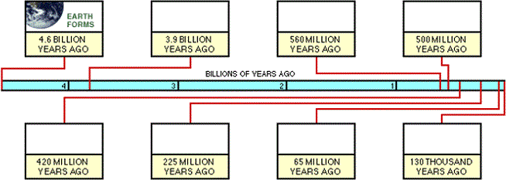

10. The best source of evidence for determining events in earth's history is ______________  
11. What is a paleontologist? __________________________

12. Identify three fossils from the image. Name them and point to them with an arrow

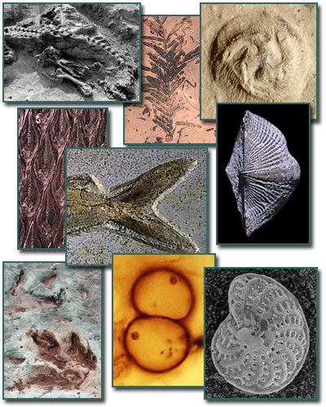

13. What features are found in therapods? _____________________________________  
14. What is a cladogram? ________________________________________  
15. What is divergence? _____________________________________

16. To which animal are the crane and eagle most closely related? _______________________  
17. What other data (besides physical features) do scientists use to find if organisms are related? List 3 things. _______________________________________18. What birds on the Galapagos islands were adapted to different regions? ________________  
19. The beaks of the birds vary with what? ___________________________________  
20. What would happen if the environment changed and only plants with larger, harder seeds survived.How do you think that might affect the population of Geospiza fortis finches? _____________________________________  
21. What is geographic isolation? _____________________________________________  
22. Identify the extinct creature. _________________________________________   
23. Name two animals that have gone extinct since humans have been present? ________________________

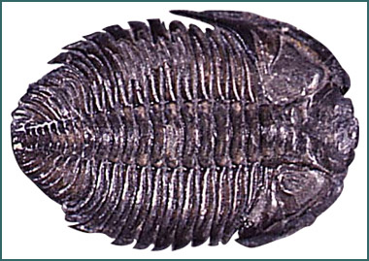

**Focus Questions**

**Name:**_________________ **Class:**_________________

**Directions:** Answer the following questions as you navigate through *Getting Into the Fossil Record*.

**1. What kinds of questions can the fossil record help us to answer?**

**2. Describe the difference between a body fossil and a trace fossil.**

**3. Why are organisms that are buried rapidly more likely to fossilize than those that are buried slowly or not at all?**

**4. Describe two ways an organism can become a fossil without being buried in sediment.**

**5. How does the environment affect the formation of fossils?**

**6. Describe three factors that could prevent an organism from long ago from ever turning up in a fossil collection today.**

**7. How are geologic maps useful to paleontologists?**

**8. In your own words, explain why the fossil record is not complete.**

**BONUS: You have been hired by National Geographic Magazine to journey to Inner Mongolia in search of fossils. You have the good fortune to find a site filled with many fossilized leaves, teeth, bones, eggs and even footprints from a variety of creatures. Amidst this treasure trove of ancient life you find no trace of insects. Your research partner concludes that no insects lived here at that time. What other hypothesis might you suggest to your partner?**