**Human Genetics**

Review of Mendel’s Principles

* Genes are passed parents 🡪 offspring; get one allele from each _____________
* During Meiosis, the alleles for a gene segregate from each other.
* During Meiosis,__________________independently assort with each other.
* Exceptions to Mendel’s principles
* Sometimes, there is no ____________________or recessive gene, or the trait is controlled by many alleles or genes.

**Incomplete Dominance**

* In Incomplete Dominance, every genotype has its own phenotype. (One allele not completely dominant over the other.) Third phenotype that is a ______________ of the parental traits. (2 alleles produce 3 phenotypes.)
* Result: Heterozygous _______________________ somewhere in between homozygous phenotype1. Incomplete Dominance

Examples:

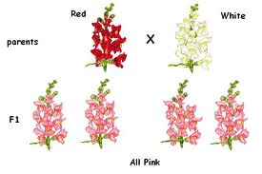

* Trait: Flower Color

Expressions: Red x White 🡪 ________________________

RR= Red; Rw= pink; WW=white

* straight hair, wavy, curly

**Codominance**

In codominance, neither allele are __________________________; both are expressed. A cross between organisms with two different phenotypes produces offspring with has both phenotypes of the _____________________traits shown.

* 2. Codominance

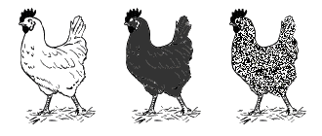

* Both alleles contribute to the phenotype.
  + Example: In come chickens

Black Chicken x White 🡪 _____________________________________

* YOU tell me which type of dominance____________________________
* Type of Dominance?______________________________________
* Type of Dominance?_____________________________________

**Multiple Alleles**

* In a population, alleles can come not just in two but in many variations
* **Multiple alleles** = when three or more ___________________ of the same gene exist in a population – like blood types
* Brings diversity to genes that are governed by one gene
* In humans, ________________________________ has multiple alleles.  IA and IB are codominant and i (type O blood) is recessive.
* Remember: each individual will only have ________________alleles for a trait but there are several alleles to choose from

**Polygenic Inheritance:**

* Most traits however are determined by many genes – called Polygenic Inheritance –like height, eye color and skin color
* **Polygenic Inheritance**
* **the inheritance of a genetic character that is determined by the interaction of _________________________________genes**
* **each having a small additive effect of the character**
* **Creates _____________________________– like the continuous variation in skin color – many different hues**
* Creates a bell curve effect – most traits in living things cluster around what is average rather than what is extreme

**X-Linked Inheritance in Humans (sex linked)**

* X-linked **disorders are caused by genes that lie on the ____________________________________________**
* Are more common in _____________________ than females
* Females that are heterozygous for the trait are called **carriers XAXa**
* Why do men suffer more from this disorder?
  + **they only have one X chromosome** – they have no back up
  + women have two X chromosomes - two chances to inherit the normal allele