Write the following questions in your interactive notebook and answer them:

- What is the monomer or subunit of a DNA molecule?
- What type of bond is present between the sugar and the phosphate on a DNA molecule?
- The DNA bases are held together by what type of bond?
- If a DNA molecule had the sequence of ATTCG , what would be its compliment strand?
- What is produced during transcription?
- Where does transcription take place
- What are the differences between DNA and RNA
- What is created during translation?
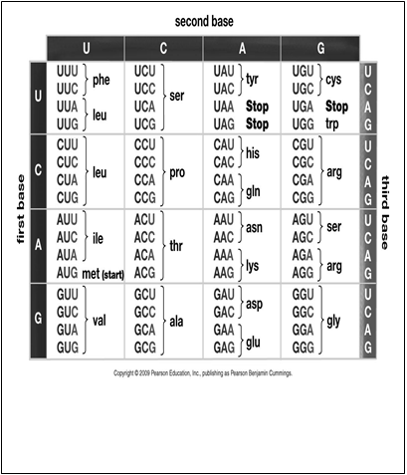
- What is the function of mRNA?
- What does a mRNA molecule look like?
- Where does translation take place?
- What is the function of a tRNA molecule?
- What does a tRNA molecule look like?
- What is a codon?
- What is an anticodon?
- What is formed by linking together amino acids?
- What kind of bond is formed when amino acid link together?
- Know the base pair rules for DNA and RNA
- Using the chart above find the amino acids for the following mRNA codons?

UAA AAA GUA CCU

