DNA Structure and Replication Review

Answer the following questions in full sentences on a separate sheet of paper.

- What molecules (monomer) is DNA composed of?
- What is the primary function of DNA?
- A nucleotide consists of?
- What scientists are credited with determining the structure of DNA?
- What is the base pair rule?
- What is the form of DNA called?
- What type of bond is between the nitrogen bases?
- What creates the sides or backbone of the DNA molecule?
- What kind of bond holds the sides together?
- What are chromosomes composed of?
- Where are chromosomes located in a cell?
- What is the first process of DNA replication?
- What does the enzyme Helicase do?
- Where is Helicase found?
- What does the enzyme DNA polymerase do?
- Why is the process of DNA called semiconservative in nature?
- During the cell cycle when does DNA synthesis occur?
- Describe the DNA molecules that result from replication.
- What is the complimentary strand of the DNA molecule: AATCCGUC
- Label the following on this sheet.

Thymine, Adenine Cytosine, Guanine, Hydrogen bond, covalent bond,
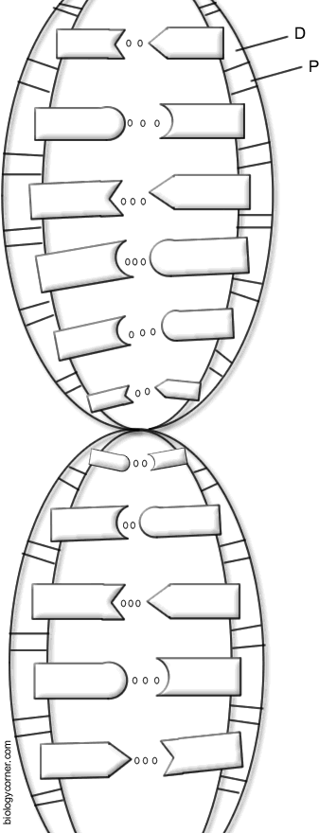
deoxyribose sugar, phosphate group

