1

**Griffith’s Experiments**

In 1928, British medical officer Frederick Griffith was studying a bacterium called Streptococcus Pneumoniae (S. Pneumoniae) . Some types or strains of this bacterium can cause the lung disease **PNEUMONIA** in mammals. Griffith was trying to develop a vaccine against a disease-causing or **VIRULENT** strain of bacterium.

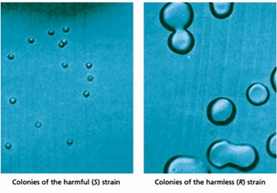As shown in the picture below, each virulent bacterium is surrounded by a capsule made of polysaccharides that protects it from a body’s defense system. The bacteria in a virulent strain grow smooth-edged colonies when grown in a petri dish and are called the **S strain**. In contrast, a second strain of S. pneumonia does not cause pneumonia and lacks a capsule. The second strain is called the **R strain** because it grows into rough colonies.

**1. What is a virulent?**

**2. What are virulent bacterium capsules made of?**

**3. What type of edges did the colonies of the S strain possess?**

2

**Griffith’s Mice**

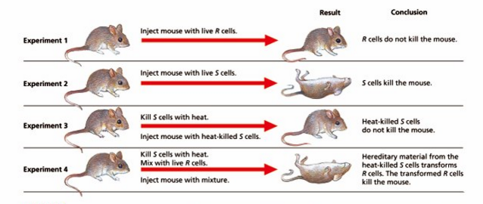Griffith used the two (2) strains of S. pneumoniae bacteria in a series of four (4) experiments. In experiments 1 and 2, Griffith injected either live R or live S strain cells into mice. He found that only S strain cells killed mice. In experiment 3, he injected heat-killed S strain bacteria into mice and found that the mice survived. In his fourth experiment, he injected mice with both heat-killed S strain cells & live R strain cells and found that the mice died.

Griffith concluded from his four (4) experiments that heat-killed virulent bacterial cells release a hereditary factor that transfers the disease-causing ability to live harmless cells. This type of transfer of genetic material form one cell to another cell or from one organism to another organism is called **TRANSFORMATION**.

**1. What strain cells killed mice?**

**2. What is a transformation?**

**3. How did dead S strain bacteria result in the death of mice?**

3

**Avery’s Experiments**

In the early 1940s, American researcher Oswald Avery and his colleagues set out to test whether the transforming agent in Griffith’s experiment was protein, RNA or DNA.

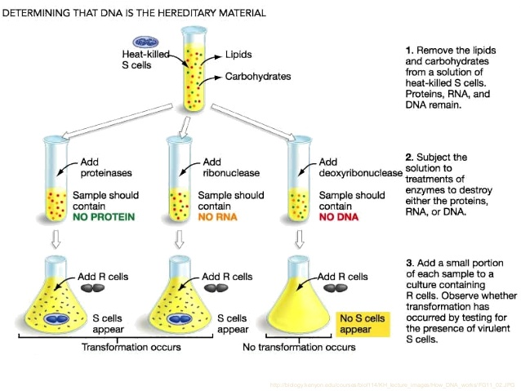The scientists used specific **enzymes** to destroy each of the three molecules (protein, RNA or DNA) in heat-killed S strain cells. They used a protease enzyme to destroy protein in heat-killed S strain cells in the first experiment, an enzyme called RNase to destroy RNA in the second experiment and an enzyme called Dnase to destroy DNA in the third experiment. They then separately mixed the three experimental batches of heat-killed S strain cells with live R strain cells and injected mice with the mixtures.

Avery and his group found that the cells missing protein and RNA were able to transform R strain cells into S strain cells and kill the mice. The cells missing DNA did not transform R strain cells into S strain cells and therefore the mice survived.

It was concluded that DNA is responsible for transformation in bacteria.

**1. What was the independent variable in Avery’s experiment (what they controlled)?**

**2. What was the dependent variable in Avery’s experiment (what they measured)?**

**3. What cells were unable to transform into S strain cells? Why do you think they couldn’t transform?**

4

**Hershey-Chase Experiment**

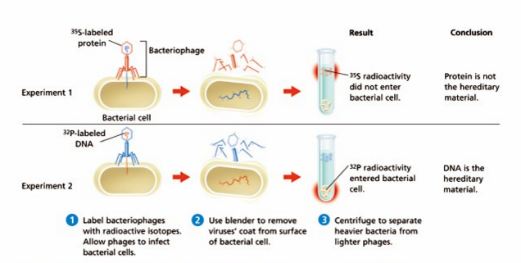In 1952, two (2) American researchers, Martha chase and Alfred Hershey, set out to test whether DNA or protein was the hereditary material viruses transfer when viruses enter a bacterium. Viruses that infect bacteria are called **bacteriophages**, or just phages.

**Step 1:** Hershey and Chase used radioactive isotopes to label the protein and DNA in the phage. They used radioactive Sulfur to label the protein and radioactive phosphorus to label the DNA. Then, they allowed the protein-labeled and DNA-labeled phage to separately infect Escherischia coli (E. Coli) bacteria.

**Step 2:** They then removed the phage coats from the cells in a blender

**Step 3:** They then used a centrifuge to separate the phage from the E.Coli.

They found that all of the viral DNA and a small amount of protein had entered E.Coli cells. They concluded that DNA is the hereditary molecule in viruses.

**1. What are bacteriophages?**

**2. Draw a picture depicting a bacteriophage.**

**3. How did the Hershey and Chase experiment produce evidence that DNA, and not protein, is the hereditary material in viruses?**

**5**

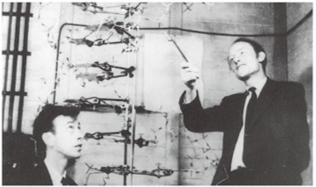**DNA Double Helix**

In the 1950s, a young American student, James Watson, teamed up with young British biology Francis Crick at Cambridge University in England to try to determine the structure of DNA.

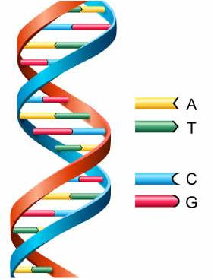They found that DNA is made of two (2) chains that wrap around each other in the shape of a **DOUBLE HELIX**, a shape similar to a winding spiral staircase.

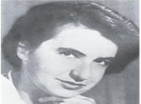Watson and Crick relied on other scientists’ work to develop their DNA model. Part of that work was X-ray diffraction photographs taken of DNA crystals by Rosalind Franklin & Maurice Wilkins.

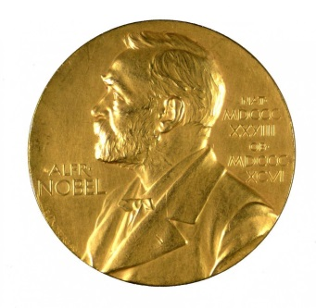In 1962, Watson, Crick and Wilkins received the Nobel Prize in Medicine for their work on DNA. Rosalind Franklin died in 1958, preventing her from being named in the award but an important genetics institute in Cambridge now bears her name and her contribution to the advancements in DNA’s structure are recognized around the world.

**1. Describe the structure & shape of DNA.**

**2. Copy the picture above depicting DNA & its codons (A,T,C,G)**

**3. What did Rosalind Franklin & Maurice Wilkins do that helped Watson and Crick describe the structure and shape of DNA.**

**6**

**DNA Nucleotides**

DNA is a nucleic acid (polymer) made of two (2) long chains (also called strands) of repeating subunits called nucleotides (monomer). Each **NUCLEOTIDE** consists of three (3) parts: a five-Carbon sugar, a phosphate group and a nitrogenous base.

1. **Five-Carbon Sugar** – Deoxyribose
2. **Phosphate Group** – Phosphorus (P) atom bonded to four oxygen (O) atoms
3. **Nitrogenous base** – Nitrogen (N) atoms and Carbon (C) atoms and is a base (accepts Hydrogen ions)

**Phosphate Group**

**Five-Carbon Sugar**

**Nitrogenous Base**

**A** = Adenine

**G** = Guanine

**C** = Cytosine

**T** = Thymine

**Deoxyribose**

**1. Deoxyribose Nucleic Acid, also known as DNA, is a polymer composed of thousands of what type of monomer?**

**2. What is a nucleotide?**

**3. Please copy the image above of a Nucleotide.**

**7**

**DNA Bonds**

The DNA double helix is similar to a spiral staircase. The alternating sugar and phosphate molecules form the side **“HANDRAILS”** of the staircase. Nucleotides along each strand are connected by covalent bonds between the sugar of one nucleotide and the phosphate group of the next nucleotide.

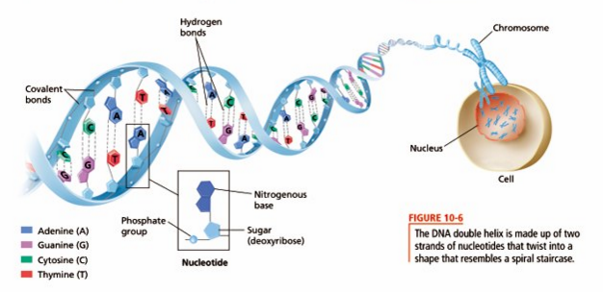Each full turn of the DNA helix has 10 nucleotide pairs.

The nitrogenous bases face toward the center of the DNA molecule. The bases on one strand of DNA form HYDROGEN BONDS with the bases on the other stand. Nitrogenous bases are bonded in pairs between the two (2) strands by two (2) or three (3) hydrogen bonds. The base pairs form the **“STEPS”** of the staircase. The base pairs are of uniform width because, in each pair one base has a two-ring (2) structure and the other base has a single-right (1) structure.

Hydrogen bonds between the bases help hold the two chains of the DNA double helix together

**1. What are the “handrails” in the DNA double helix staircase?**

**2. What are the “steps” in the DNA double helix staircase?**

**3. What bonds are responsible for holding the DNA double helix together?**

**8**

**DNA Bases**

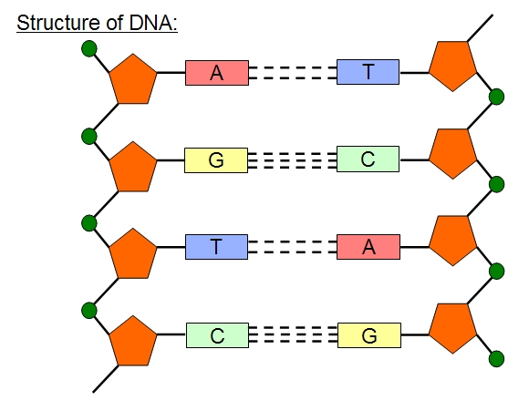The sugar and phosphate group are identical in all DNA nucleotides. However, the nitrogenous base may be any one (1) of four (4) different kinds – THYMINE (T), ADENINE (A), CYTOSINE (C) or GUANINE (G).

Thymine always pairs with Adenine.

**A -- T**

Cytosine always pairs with Guanine.

**C -- G**

Nitrogenous bases that have a double ring of Carbon and Nitrogen atoms, such as Adenine & Guanine are called PURINES.

Nitrogenous bases that have a single ring of Carbon and Nitrogen atoms, such as Cytosine & Thymine are called PYRIMIDINES. 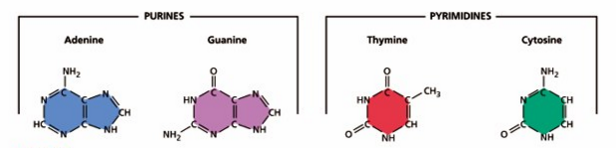

1. **What are the names and abbreviations of the four different kinds of nitrogenous bases?**
2. **What are purines? What are Pyrimidines?**
3. **How do the nitrogenous bases pair with one another?**

**9**

**Base Pairing**

In 1949, American biochemist Erwin Chargaff observed that the **PERCENTAGE OF** **ADENINE EQUALS THE PERCENTAGE OF THYMINE** and the **PERCENTAGE CYTOSINE EQUALTS THAT OF GUANINE** in the DNA of a variety of organisms.

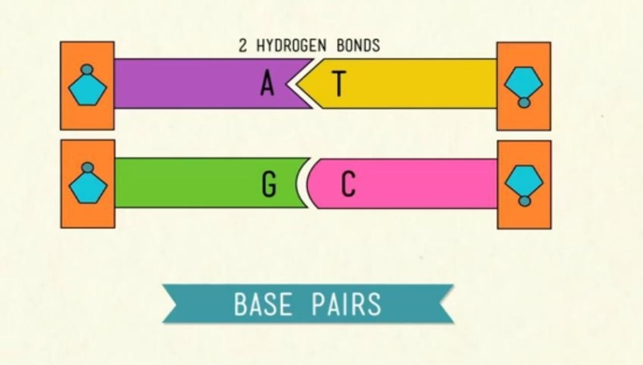DNA follows **BASE-PAIRING RULES** in that Cytosine only pairs with Guanine and Adenine pairs with thymine. These pairs of bases are called **COMPLEMENTARY BASE PAIRS**. Each complementary base pair contains one double-ringed purine and one single-ringed pyrimidine. The order of nitrogenous bases on the nucleotides in one chain of the DNA molecule is complementary to the order of bases on the opposite chain.

* If a DNA chain has the sequence ATTC, then the other chain must have the complimentary sequence TAAG.

The order of nitrogenous bases on a chain of DNA is called its **BASE SEQUENCE**.

Complementary base pairing is important in DNA structure and function for two (2) reasons.

1. The hydrogen bonds between the base pairs help hold the two (2) strands of a DNA molecule together
2. The complementary nature of DNA helps explain how DNA replicates before a cell divides.

One (1) strand of a DNA molecule can serve as a template for making a new complementary strand.

**1. What are base-pairing rules? (Include *COMPLEMENTARY BASE PAIRS* in your answer)**

**2. If one strand of DNA has the base sequence *ATTAGCGATTA*, what will the complementary base sequence be?**

**3. What two (2) reasons make complementary base pairing important in DNA structure & function?**