**Group 1: Complete the following:**

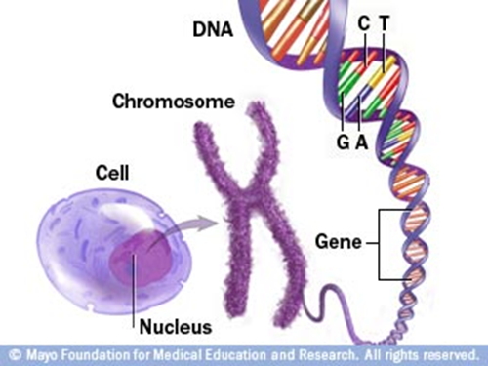

***Read page 151***

1. What is DNA?
2. How long is DNA?
3. Define Chromosome
4. What are histones and what do they maintain?
5. **Draw the diagram >>>>>>**

**Group 2: Complete the following:**

***Read page 152***

1. What is a chromatid?
2. **Draw figure 8-2 and label**
3. What is the centromere?
4. What is chromatin?

**Group 3: Complete the following:**

***Read page 153***

1. Describe the DNA in a prokaryote cell.
2. Describe how the number of chromosomes differs between species.
3. **Draw table 8-1 pg. 152**
4. How many chromosomes does a garden pea have? Dog?

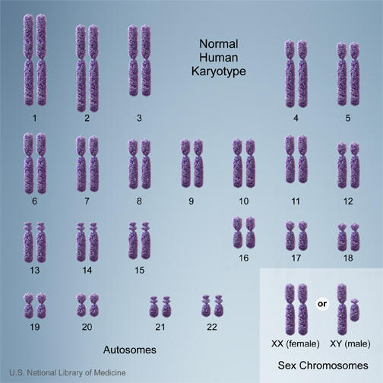

**Group 4: Complete the following:**

***Read page 152***

1. What are sex chromosomes?
2. What are the sex chromosomes in humans?
3. What are autosomes?
4. How many autosomes are in humans?
5. **Draw the diagram below**

**Read page 152-153**

1. What are homologous chromosomes?
2. How does each organism get homologous chromosomes?
3. How are homologous chromosomes similar?
4. What is a karyotype?

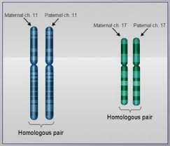

1. **Draw the diagrams:**



***Read page 153***

1. What are diploid cells?
2. What type of cells are diploid?
3. What is haploid?
4. What type of cells are haploid?
5. What happens when an egg and sperm combine?

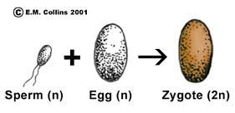

**(n) = haploid**

**(2n) = diploid**

**Zygote = new organism**