MITOSIS COLORING HOMEWORK

READ: Many, many years ago (actually probably around 13 years ago) you were made of just one cell. Just one tiny cell that people needed a microscope to see. Then one day that cell underwent mitosis, which means cell division. Everything inside that cell was copied (the nucleus, the mitochondria, the vacuoles, all the DNA, etc.) so that when the cell split, both the new cell and the old cell would have everything they needed to survive. These two cells then each underwent mitosis so that these two became four cells, and those four cells became eight, and then sixteen cells, and then thirty-two cells and so on. Eventually, there enough cells so that a beautiful bouncing baby was born Your cells continued going through mitosis making more and more cells. That’s why you are bigger today than when you were born. You have more cells (but NOT bigger cells) than when you were a baby. Elephants have more cells than you do but the cells they have are about the same size as yours.

Louis Pasteur taught us that everything has to come from somewhere; every living thing has to have parents of some kind. All living things are made of cells and all cells come from other cells (kind of makes you wonder where the very first cell came from then doesn’t it?!?). So as you can see, mitosis is the basis of all life!

Mitosis is a process that can be broken down into 4 steps. These steps are called Prophase, Metaphase, Anaphase, and Telophase. A phase called interphase is not actually part of mitosis, but is the resting phase that the cell is in when it is not dividing.

Interphase. Most of the time, a cell is not actually dividing. Instead it spends most of its time just resting and performing cell activities like cellular respiration, osmosis, and for plant cells, photosynthesis. During interphase, DNA and other cell materials are copied. While in interphase, the DNA is shaped like uncoiled strands that look like spaghetti. When it is in this shape, it is called chromatin. When DNA is loosely packed like this it is much easier for the cell’s machinery to copy.

Prophase. This is the first step of mitosis. The nuclear membrane (membrane around the nucleus) breaks apart. Chromatin condenses into rod-like structures called chromosomes. Take a look at the other side of this paper and find something inside any of the cells that looks like a big fat X. This is a chromosome that has been copied. One half of the X is the original chromosome and the other half is the copy.

Another thing that happens during Prophase is that the centrioles move to opposite sides of the cell and spindle fibers form across the cell. We’ll find out what these do later…

Metaphase. During this stage of mitosis the chromosomes line up in the middle of the cell, right along the equator. Each chromosome attaches itself to a spindle fiber.

Anaphase. The centrioles act like fishermen and start to reel in their fish (the chromosomes) using the spindle fibers as line. During anaphase the twin copies of the chromosomes get separated and each copy moves to opposite sides of the cell.

Telophase. Now that the chromosomes are separated, two new cells are formed. The spindle fibers disappear; the chromosomes uncoil and become spaghetti-like chromatin again. The nuclear membrane reappears and finally the cytoplasm divides to form two new daughter cells which are identical to each other. In a plant cell, a cell wall forms between the two new cells.

Questions: Answer these questions by following the directions in each one and using the pictures on the other side of this page. The questions do not necessarily go in order.

- Outline the cell membrane of the cells in these colors:
Prophase cells—red
Metaphase cells—green
Anaphase cells—yellow
Telophase cells—orange
Interphase cells—purple

- What is the name for the resting period between cell divisions? __________________________________. Color the word brown.
- In interphase, the DNA is in the form of loose threads called ___________________________. Color the word and pictures blue.
- Condensed DNA is called _______________________________. Color the word and these structures in metaphase cells green.
- During metaphase the chromosomes line up along the middle of the cell called the _______________________. Write the answer in the top left corner on the other side of this paper.
- During what stage do the chromosomes pull apart? ___________________________. Color the word yellow.
- Another name for cell division is ______________________________. Color the word blue.
- What structure reappears during telophase? _____________________________________________Outline this structure in the telophase cells with red.
- During which stage does the DNA copy itself? ____________________________________. Draw an orange star next to this word.
MITOSIS

INTERPHASE

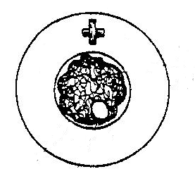
Centriole
Chromatin

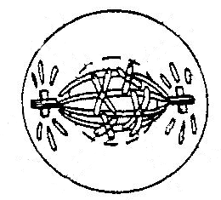
PROPHASE
Chromosomes

METAPHASE
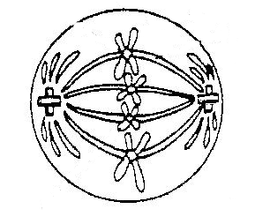
Chromosomes

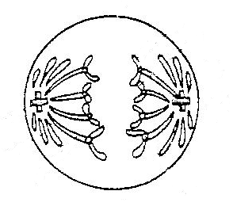

ANAPHASE

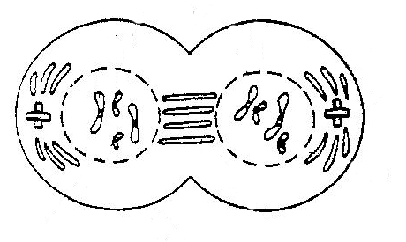
Nuclear Membrane

TELOPHASE

2 NEW DAUGHTER CELLS ARE FORMED

