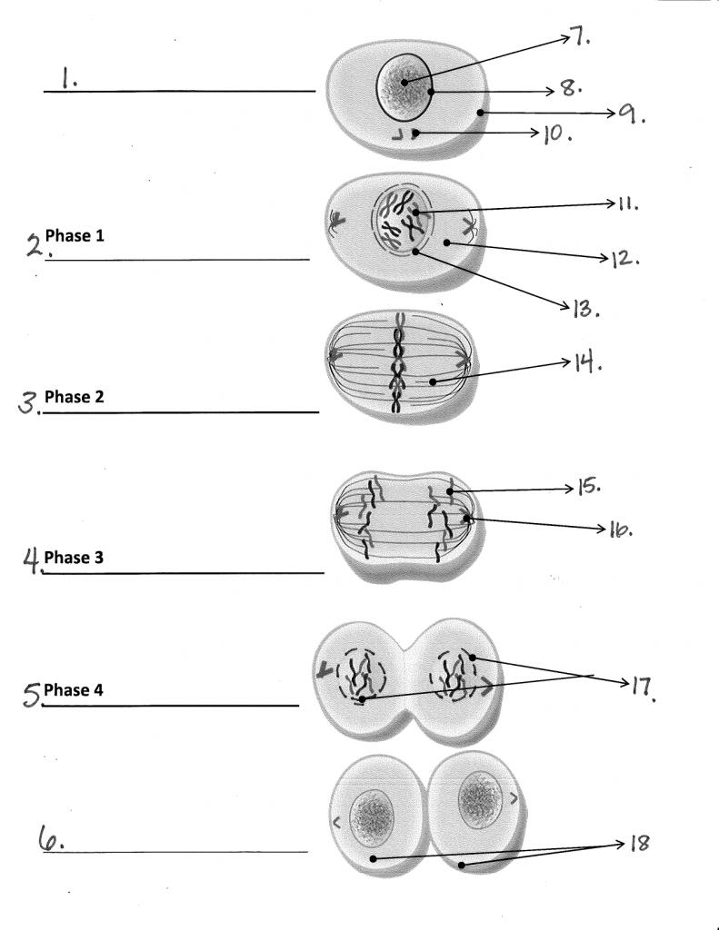

Name ____________ Hr ___

Please identify and describe #1 -6. Below each line describe what is occurring Identify 7-18.

Answer the following:

1. What did our lab on counting stages on a root tip tell us about mitosis?
2. A process by which a cell’s nucleus divides is called _____________
3. What are two things that are different between plant cell mitosis and animal cell mitosis?