***Station 1:***

***Read the information below. Write out the questions and answer them on your own paper.***

**Mitochondria - Turning on the Powerhouse**

Mitochondria are known as the powerhouses of the cell. They are **organelles** that act like a [**digestive system**](http://www.biology4kids.com/files/systems_digestive.html) which takes in nutrients, breaks them down, and creates energy rich molecules for the cell called Adenosine TriPhosphate = ATP **= energy**

Mitochondria can be found in both animal and plant cells. The biochemical processes of the cell are known as **cellular respiration**. Many of the reactions involved in cellular respiration happen in the mitochondria. Mitochondria are the working organelles that keep the cell full of energy.   
  
Mitochondria are small organelles floating free throughout the cell. Some cells have several thousand mitochondria while others have none. [**Muscle cells**](http://www.biology4kids.com/files/systems_muscular.html) need a lot of energy so they have loads of mitochondria. Neurons (cells that transmit nerve impulses) don’t need as many. If a cell feels it is not getting enough energy to survive, more mitochondria can be created. It all depends on the needs of the cell.

Animal Cell

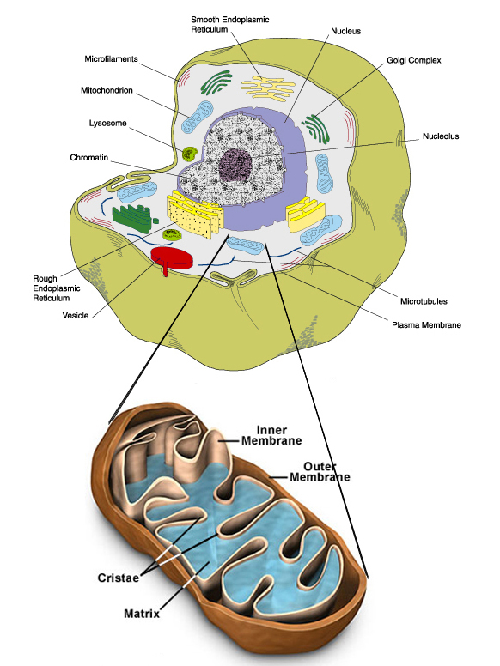

***Questions:***

1. **What is cellular respiration?**
2. **What does it produce?**
3. **Where does it occur?**

***Station 2:***

***Read the information below. Draw the diagram and label it. Write out the questions and answer them on your own paper.***

**Mitochondria Structure**

Mitochondria are shaped perfectly to maximize their productivity. They are made of two membranes. The **outer membrane** covers the organelle and contains it like a skin. The **inner membrane** folds over many times and creates layered structures called **cristae**. The fluid contained in the mitochondria is called the **matrix**.   
  
The folding of the inner membrane increases the surface area inside the organelle. Since many of the chemical reactions happen on the inner membrane, the increased surface area creates more space for reactions to occur. If you have more space to work, you can get more work done.

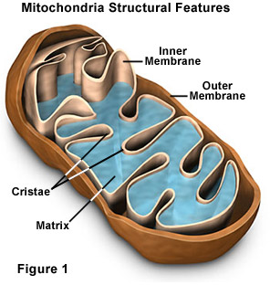

***Complete the following:***

***1. Draw the diagram on your own paper and label it.***

***Questions:***

1. ***What is the matrix?***
2. ***What are the cristae?***
3. ***Why do they claim that mitochondria are shaped perfectly to maximize their productivity?***

**Station 3:**

***Read the information below. Write out the questions and answer them on your own paper.***

**Overview of Respiration**

Cellular respiration is an almost universal process by which organisms utilize the sugars in their food to produce enough energy to perform all the necessary actions of living creatures

The general equation for cellular respiration is:

**C6H12O6 + 6 O2 🡪 6 CO2 + 6 H2O + 38 ATP**

**glucose + oxygen 🡪 carbon dioxide + water + ATP (energy)**

**We can divide cellular respiration into three metabolic processes: glycolysis, the Krebs cycle, and Electron transport chain. Each of these occurs in a specific region of the cell.**

1. Glycolysis occurs in the cytosol (liquid portion of cytoplasm)
2. The Krebs cycle takes place in the matrix of the mitochondria.
3. Electron transport chain is carried out on the inner mitochondrial membrane

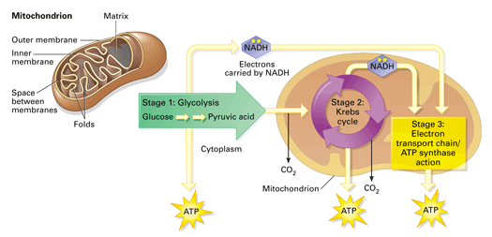

***Questions:***

1. **Write out the chemical equation for cellular respiration and identify its components**
2. **List the three processes of cellular respiration and identify where they take place.**

**Station 4:**

***Read the information below. Write out the questions and answer them on your own paper***

**Step 1 of cellular respiration: Glycolysis**

* **literally means "splitting sugars."**
* **It involves the breaking down of glucose molecules from carbohydrates into molecules of pyruvate (pyruvic acid), which will continue on to the Krebs Cycle.**
* **In the process, two molecules of ATP and two "high energy" electron carrying molecules are produced (2 NADH molecules).**
* **Glycolysis occurs in the cytosol of the cell and can proceed *regardless of the presence of oxygen. (Does not require oxygen)***

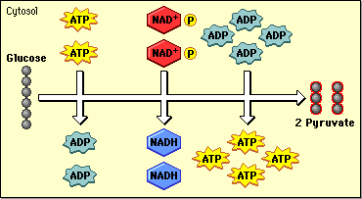

**Questions:**

1. **What is the first step in cellular respiration?**
2. **Where does it occur?**
3. **How many ATP molecules are produced? (net)**
4. **Does it require oxygen?**

**Station 5:**

***Read the information below. Write out the questions and answer them on your own paper***

**Step 2 of cellular respiration: Krebs Cycle**

**\*Occurs when oxygen is present!**

**Krebs cycle is an aerobic process, meaning it needs oxygen to function. It is the beginning of aerobic respiration**

**The Krebs cycle occurs in the mitochondrial matrix and generates a pool of chemical energy (ATP, NADH, and FADH2) from the oxidation of pyruvate, the end product of glycolysis.**

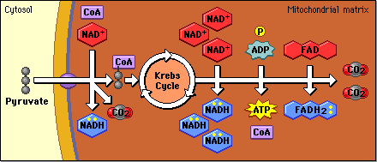

**Krebs cycle begins after pyruvate is converted to a slightly different compound called Acetyl CoA**

**Through a series of steps, several compounds capable of storing "high energy" electrons are produced along with two ATP molecules.**

**Carbon dioxide is also produced.**

**Questions:**

1. **What is the second step of cellular respiration?**
2. **Where does it occur?**
3. **What must be present?**
4. **How many ATP molecules does it produce?**

**Station 6:**

***Read the information below. Write out the questions and answer them on your own paper***

**Step 3 of cellular respiration: Electron Transport Chain**

**\*Occurs when oxygen is present!**

**The electron transport chain is an aerobic process, meaning it requires oxygen directly. It is the part of aerobic respiration.**

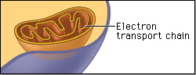

* The electron transport chain consists of a series of molecules, mostly proteins, embedded in the **inner mitochondrial membrane, the cristae.**
* **These molecules transfer electrons from one molecule to another.**
* It allows the release of a large amount of stored chemical energy. The electron transport chain produces **34 ATP.**
* It also produces water.

**Questions:**

1. **What is the third step of cellular respiration?**
2. **Where does it occur?**
3. **How many ATP molecules does it produce?**
4. **What must be present?**



**Station 7:**

***Read the information below. Write out the questions and answer them on your own paper***

**Anaerobic respiration – also know as fermentation**

**Occurs when No oxygen is available = can’t complete aerobic respiration**

Occurs when no mitochondria is available – like in bacteria

Can only make very little ATP – large animals cannot survive

Glycolysis proceeds normally, as in aerobic conditions, producing a net gain of 2 ATP and 2 pyruvate molecules.

When oxygen is not available, fermentation takes over…

In **fermentation** pyruvate molecules are turned into “waste” products, either ethyl alcohol or lactic acid is produced.

The pyruvate is not transported into the mitochondrion, **but remains in the cytoplasm**, where it is converted to waste products that may be removed from the cell.

This waste product varies depending on the organism. In yeast, the waste products are ethanol and carbon dioxide. This type of fermentation is known as alcoholic or ethanol fermentation.

**alcohol fermentation**

Yeasts are able to participate in fermentation because they have the necessary enzyme to convert pyruvic acid to ethyl alcohol.

Yeast is used both in bread and alcohol production. Alcohol fermentation is the process that yields beer, wine, and other spirits. The carbon dioxide given off during fermentation supplements the carbon dioxide given off during the Krebs cycle and causes bread to rise.

**glucose → ATP + CO2+ alcohol**

**lactic acid fermentation**

In skeletal muscles, the waste product is lactic [acid](http://www.diffen.com/difference/Acid_vs_Base). This type of fermentation is called lactic acid fermentation

When lactic acid builds up in your muscles it can cause soreness and stiffness

**glucose → ATP + lactic acid**

**Questions:**

1. **Where does anaerobic respiration occur?**
2. **How many ATP molecules does it produce**
3. **What are the two types of fermentation?**

