Station 1
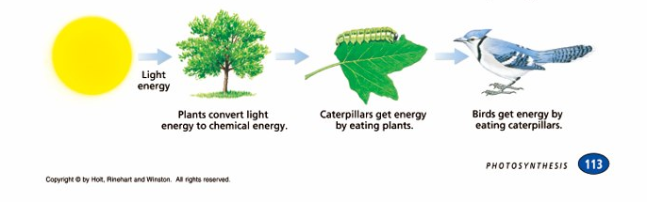

- What energy do all organisms depend on for food – life? The suns energy

- What is an autotroph? “Self-feeder” makes their own food

- What type of organic compounds do most autotrophs make? Glucose

- What is a heterotroph? Organisms that eat other organisms to get the nutrients they need

- What is a biochemical pathway?
When the products of one chemical reaction are the reactants for the next chemical reaction
Station 2
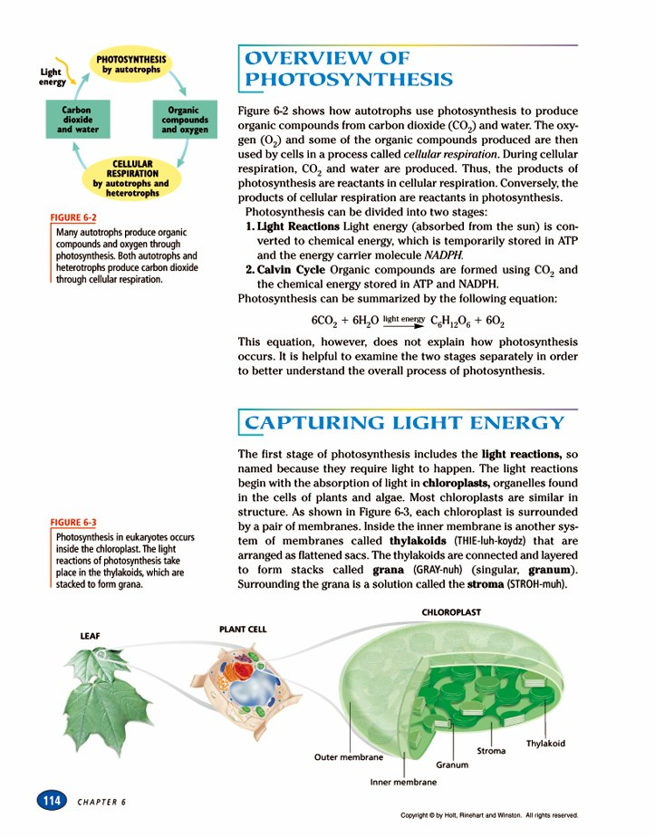

- Explain how are photosynthesis and cellular respiration connected?
The organic compounds produced by photosynthesis (glucose) and the oxygen are used by cellular respiration to produce energy. The carbon dioxide and water are used by photosynthesis to produce glucose and oxygen.
Biochemical pathway?????

- List the two stages of photosynthesis
Light reactions and the Calvin cycle

- What do the light reactions produce? ATP + oxygen

- What does the Calvin cycle produce? Glucose

- Write the equation for photosynthesis – identify each molecule.

6CO2 + 6H20 -----→ C6H12O6 + 6O2
Carbon dioxide Water glucose oxygen

Station 3

- Where does photosynthesis take place?
In the chloroplasts
2. Describe the following:
Thylakoids –thin pancake like structures – light reactions take place in their membrane

Granum – stacks of thylakoids

Stroma – liquid within the chloroplast – where Calvin cycle takes place

Station 4

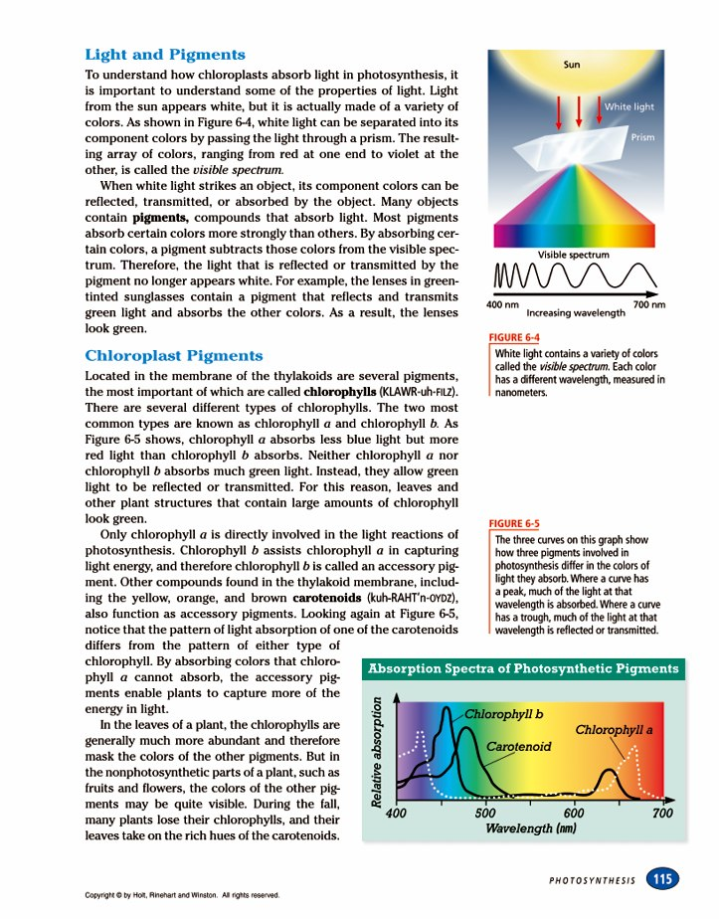

- What is white light? Light emitted from the sun

- Why do the leaves on a tree look green in the summer? The green light waves are reflected

- What is chlorophyll and what does it absorb?
Chlorophyll is the green pigment in a chloroplast and it has the ability to absorb the sun’s energy

- What does a peak on the graph above indicate?
Absorbed light waves

- Why do leaves change color in the fall?
In the fall the plant stop photosynthesizing and the chlorophyll pigment loses its dominance. That allows all the other pigments in the leaf to be expressed. That is why we see the yellows, oranges reds and other fall colors.

Station 5
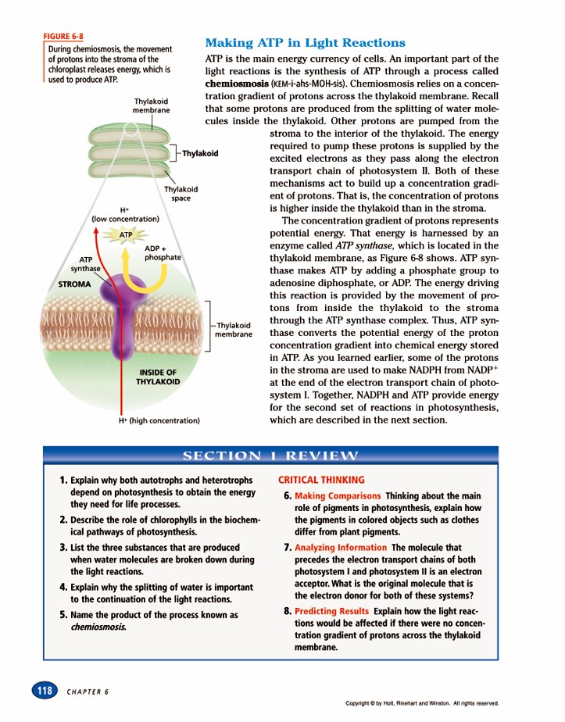
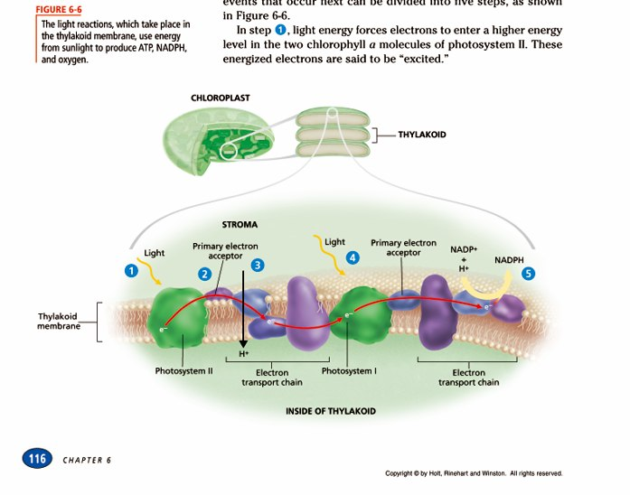

- Where do the light reactions take place? In the membrane of the Thylakoid

- What do they produce? ATP + oxygen

- What is chemiosmosis? The synthesis of ATP

- How is the energy used that is made in the light reactions?
To fuel the Calvin cycle

Station 6

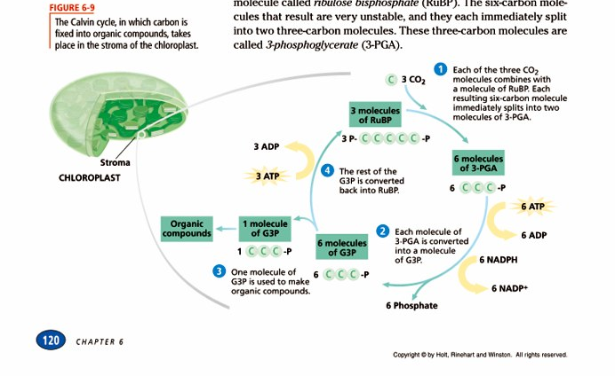

- What does the Calvin cycle produce? Glucose

- What is carbon fixation? When the carbon from carbon dioxide is bonded together to form glucose

- Where does the CO2 come from? Atmosphere

- Where does the Calvin cycle take place?
In the stroma

Station 7

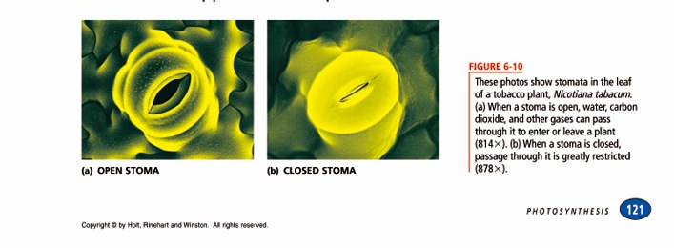

- What are stomata?
Openings like pores
- Where are they located?
Most are located on the underside of a leaf
- Why would they close? They close when it is hot and the plant is losing too much water

- How would this affect photosynthesis? With out a source of carbon dioxide from the atmosphere – no glucose would be produced

- Describe the C4 pathway and the CAM pathway – what do they allow?
Both pathways allow for these plants to photosynthesize when the temperatures are too high for the stoma to remain open

Station 8
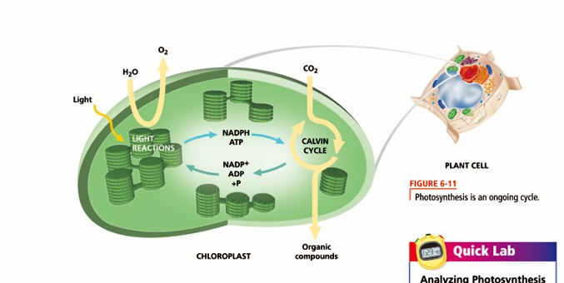

- Draw the diagram above.
- In a summary of 25 words describe photosynthesis.
Using the following words:
Light reactions, Calvin cycle, ATP, Glucose (organic compounds)
Water, light, carbon dioxide, stroma, thylakoids, starch, energy, autotrophs, heterotrophs, continuous cycle.

Please underline each word above in your paragraph.
Station 9
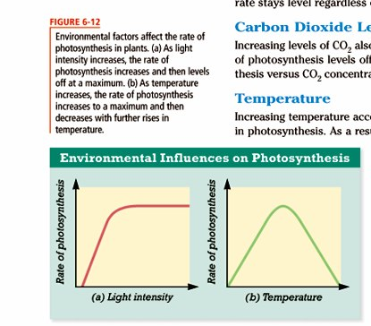

- List three factors that can affect the rate of photosynthesis.
Light intensity, temperature and carbon

- Describe what is happening in the graph on the left.
As the light intensity increases so does the rate of photosynthesis until it maxes out and then it remains constant
- Describe what is happening in the graph on the right.
Photosynthesis increases as the temperature increases until it gets too hot and the stoma of the leaf closes and the carbon dioxide is no longer available for photosynthesis

