Station 1

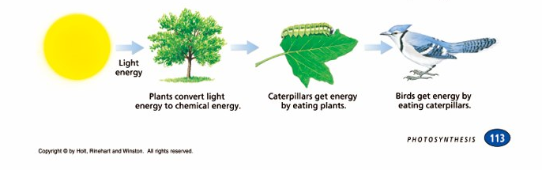

- What energy do all organisms depend on for food – life?
- What is an autotroph?
- What type of organic compounds do most autotrophs make?
- What is a heterotroph?
- What is a biochemical pathway?

Station 2

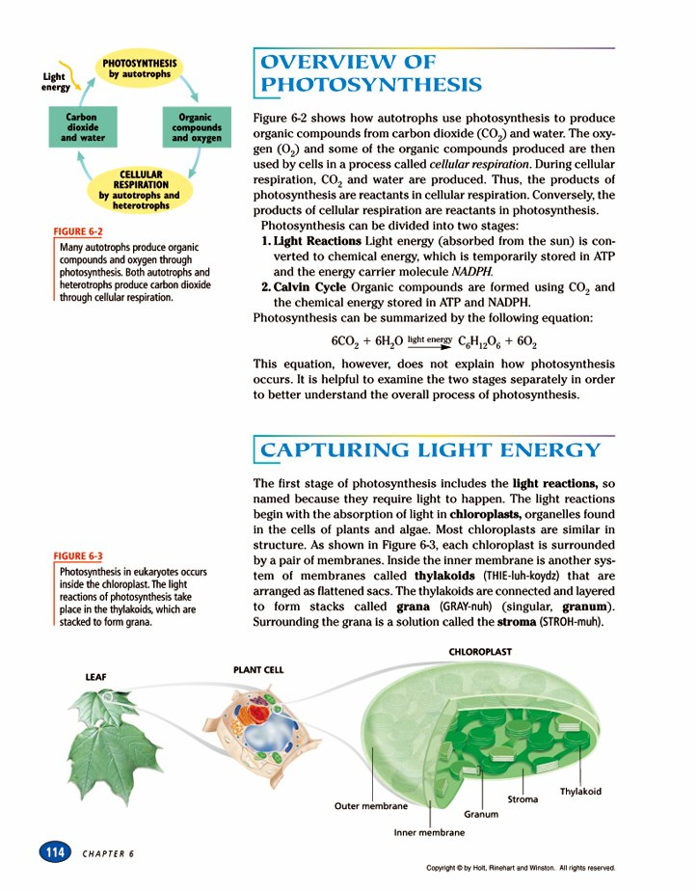

- Explain how are photosynthesis and cellular respiration connected?
- List the two stages of photosynthesis
- What do the light reactions produce?
- What does the Calvin cycle produce?
- Write the equation for photosynthesis – identify each molecule.

Station 3

1. Where does photosynthesis take place?
2. Describe the following:
Thylakoids
Granum
Stroma

Station 4

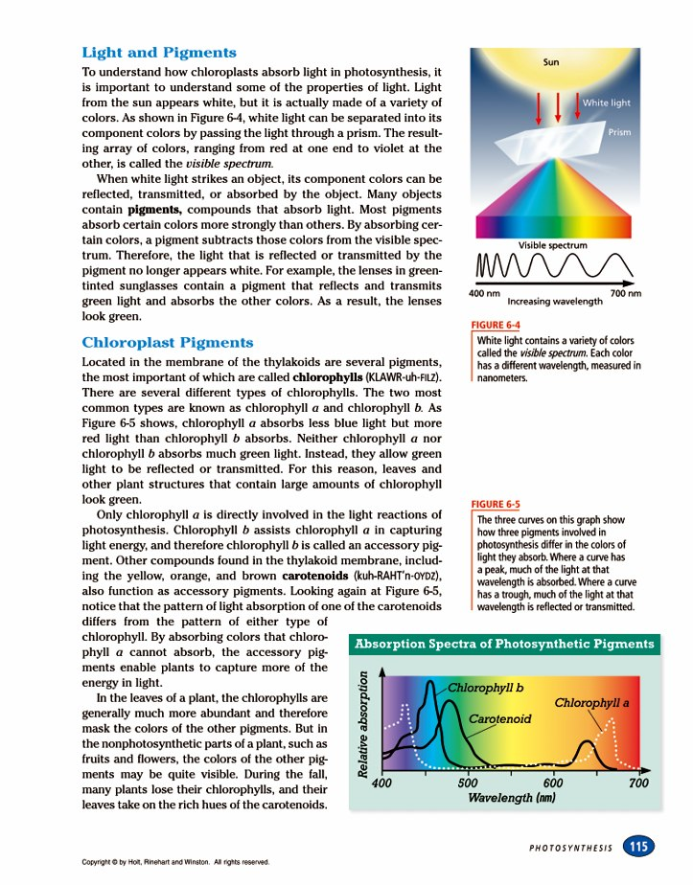

- What is white light?
- Why do the leaves on a tree look green in the summer?
- What is chlorophyll and what does it absorb?
- What does a peak on the graph above indicate?
- Why do leaves change color in the fall?

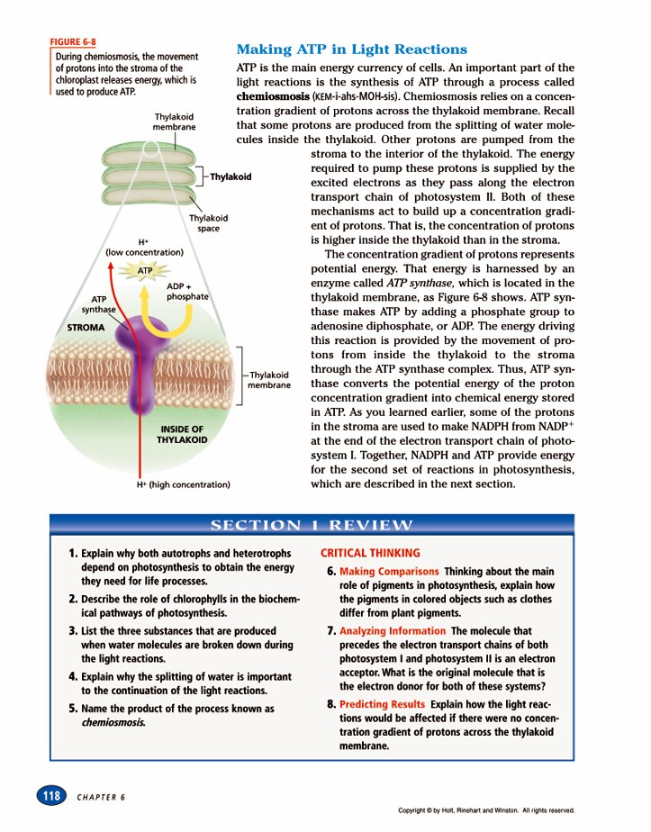
Station 5
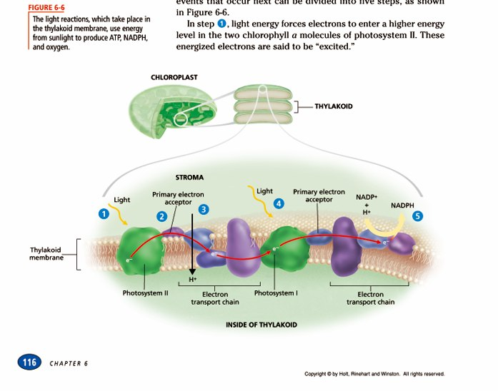

- Where do the light reactions take place?
- What do they produce?
- What is chemiosmosis?
- How is the energy used that is made in the light reactions?

Station 6

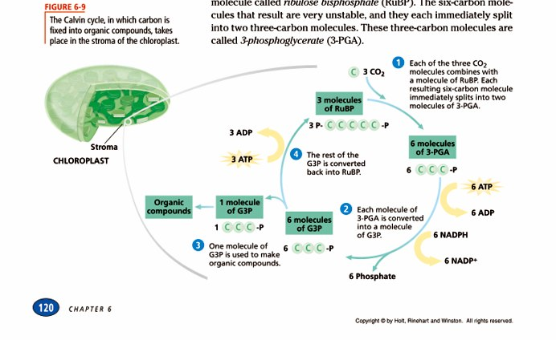

- What does the Calvin cycle produce?
- What is carbon fixation?
- Where does the CO2 come from?
- Where does the Calvin cycle take place?

Station 7

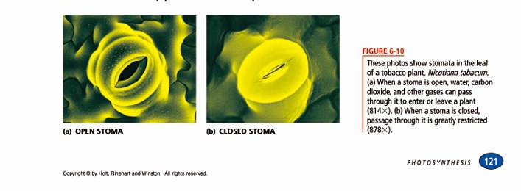

- What is a stomata?
- Where are they located?
- Why would they close?
- How would this affect photosynthesis?
- Describe the C4 pathway and the CAM pathway – what do they allow?

Station 8
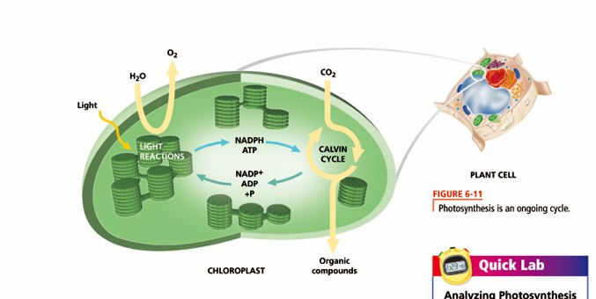

- Draw the diagram above.
- In a summary of 25 words describe photosynthesis.
Using the following words:
Light reactions, Calvin cycle, ATP, Glucose (organic compounds)
Water, light, carbon dioxide, stroma, thylakoids, starch, energy, autotrophs, heterotrophs, continuous cycle.

Please underline each word above in your paragraph.

Station 9
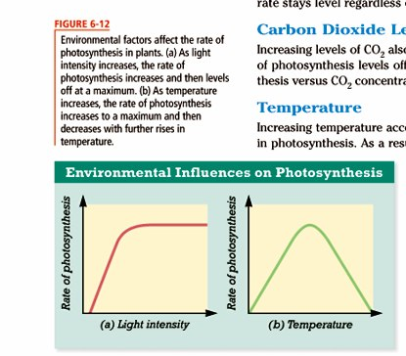

- List three factors that can affect the rate of photosynthesis.
- Describe what is happening in the graph on the left.
- Describe what is happening in the graph on the right.

