Cellular Respiration Review
Vocabulary:
Aerobic Cellular Respiration Electron Transport Krebs Cycle
Anaerobic Chloroplast Fermentation Lactic Acid
ATP Cristae Glycolysis Matrix
Mitocondria
Know the following concepts:
- Cellular respiration releases energy by breaking down ________.
- What are the stages of Cellular respiration?
- Where do these stages take place?
- What is released during cellular respiration?
- When is lactic acid produced?
- Cellular respiration uses one molecule of glucose to produce __________ATP
- What is the chemical equation for cellular respiration?
- What are the reactants? What are the products?
- What is the chemical equation for photosynthesis?
- What are the reactants? What are the products?
- Describe the relationship between photosynthesis and cellular respiration.
Biology Graphs: Carbon Dioxide and Oxygen
Carbon dioxide and oxygen are produced by two different reactions: carbon dioxide is produced during cellular respiration and oxygen is the product of photosynthesis. 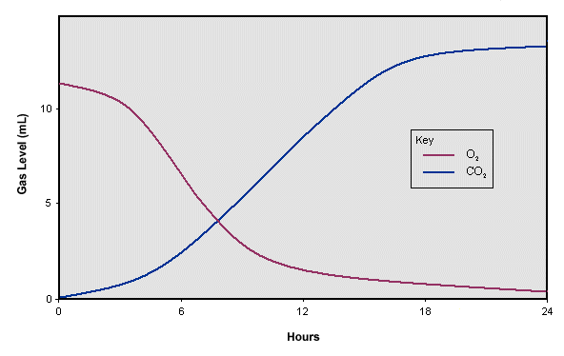
Cellular respiration uses up oxygen. Sugars power respiration producing carbon dioxide and water as waste products. Cells use sugars to keep things hopping. All sugars end in OSE so glucose, sucrose,
and fructose are all sugars
In this graph organisms were placed into a test tube along with a sugar and then the test tube was capped. The organism was monitored over a 24 hour period. After 24 hours all the sugar was gone.
Questions:
- What is happening in this graph?
- Why might the CO2 be increasing?

