Name__________________________

Microscope Labeling
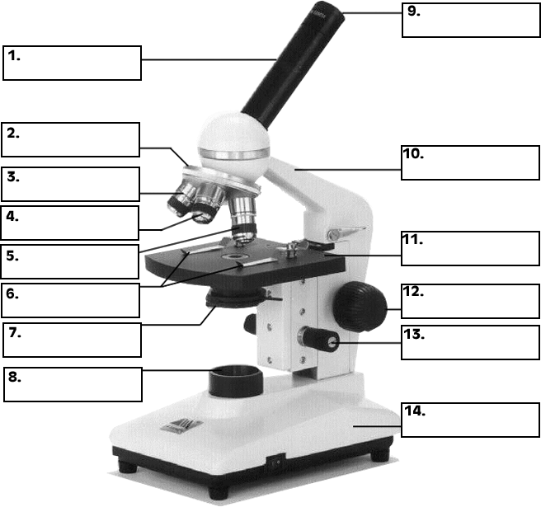

Total magnification

Objective | Magnification of ocular | Magnification of objective | Total Magnification
Scanner
Low
High

See also Microscope PPT for students to learn the parts and function of the microscope | Microscope labeling Key

