In your notebook: complete the following:
What is:
A cell
Cell theory

Describe the function of the following:
- Mitochondria
- Nucleus
  - Nuclear membrane
- Chloroplasts
- Ribosome
- Endoplasmic Reticulum
- Golgi Apparatus
- lysosomes
- Cell wall
- Cell membrane (plasma membrane)
- Vacuole
  - Role in plants
- Chromatin (chromosomes)
- Cell membrane
  - Phospholipid bilayer (draw and describe)

Describe the characteristics of the following:
- Eukaryotic Cell
- Prokaryotic cell
- 3 differences between plant and animal
Draw and complete in your notebook
Transport method | Definition | Diagram | Active or Passive transport
Osmosis
Diffusion
Endocytosis
Exocytosis
Facilitated Diffusion

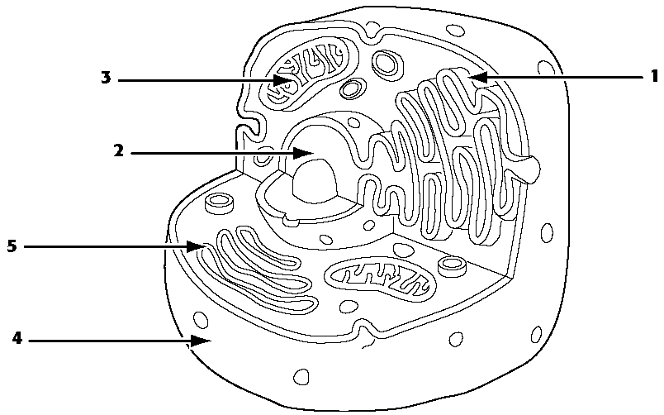
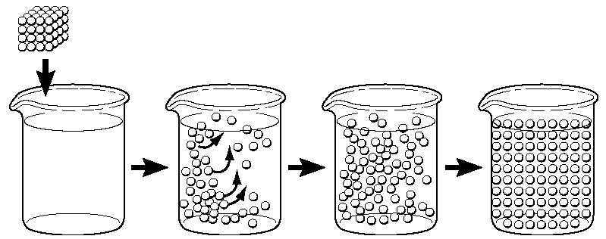

- Draw arrows to show what would happen to the cells.

10%
CO2
40 %
CO2
2% CO2

Outside: 10% CO2 30%CO2 4%CO2

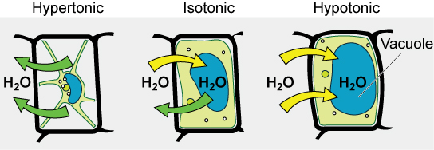

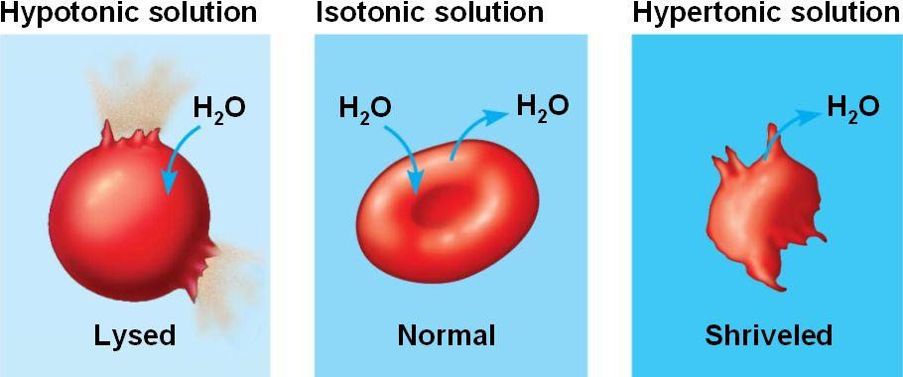

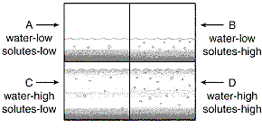
Based on the diagram above, explain what would happen to each square?

Square A:

Square B

Square C:

Square D:

