Smelly Balloons

Procedure:
- Smell each balloon and identify the odor. Record what you smell on your work sheet

1. Anise (black licorice)

2. pine

3. Cinnamon

- citrus

Procedure:
Answer the following questions:
  - How do smells get out of the balloon?
Diffusion
  - What does semi-permeable mean?
Allows some substances through but not others

  - How does the balloon compare with your cell membranes?
Both are semi permeable

Size of Molecule

Procedure: A test tube was filled with Iodine and a cellophane bag was filled with starch and placed in the test tube. Observe the results and answer the question below.

- Did starch and Iodine molecules mix? How do you know?
Because the starch turned black

- Which molecule moved through the membrane?
Iodine moved through the membrane – if starch moved out of the bag then the whole test tube would be black

- Why weren’t the molecules of the starch able to undergo diffusion?
They are a macromolecule and too large!

Procedure: Observe the diagram below and answer the questions
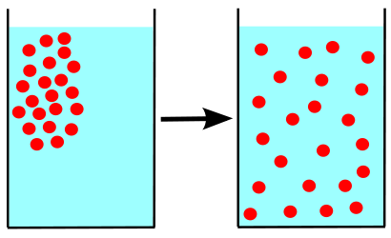
- Describe the movement of the molecules.
The molecules moved from an area of high concentration to an area of low until equally spaced

- What is this called?
Diffusion

- Does it require energy? NO

- Is this an example of active or passive transport?
Passive transport – no energy required

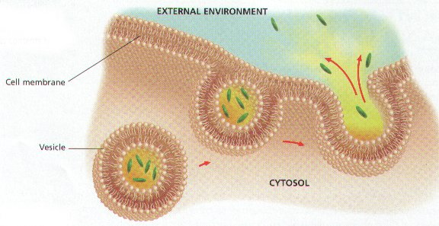

Procedure:
Observe the diagram above and answer the following questions:
- Describe what is occurring.
Large molecules that can not diffuse through the membrane are being removed from the cell

- What is this form of cell transport?
Exocytosis

- Does it require energy? YES

- Is this a form of active or passive transport?
Active transport – energy is required

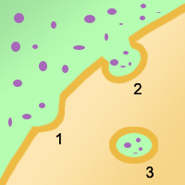
Procedure:
Observe the diagram above and answer the following questions.
- Describe what is occurring in the diagram.
Large molecules that can not diffuse through the membrane are being brought into the cell

- What is this form of cell transport?
Endocytosis

- Does it require energy? YES

- Is it a form of active or passive transport?
Active transport requires energy

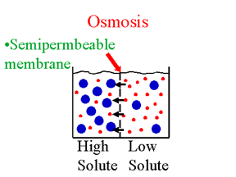

(Water molecules are red and solute molecules are blue)
Procedure:
Observe the image above and answer the questions.
- Describe the movement of the molecules.
Water molecules are moving from an area of high concentration to an area of low

- What is this form of cell transport called?
Osmosis

- Does it require energy? NO

- Is it a form of active or passive transport?
Passive transport no energy is required

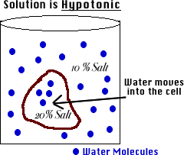

Procedure:
Observe the diagram above and answer the questions.
- What type of solution is this?
Hypotonic less solute more water

- What type of cell transport is this called?
Osmosis

- Does it require energy? NO

- What will happen to the cell inside this solution?
The cell will increase in size

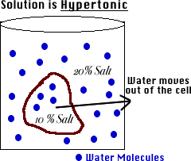

Procedure:
Observe the diagram above and answer the questions.
- What type of solution is this?
Hypertonic – more solute less water

- What type of cell transport is this called?
Osmosis

- Does it require energy? NO

- What will happen to the cell inside this solution?
The cell will decrease in size

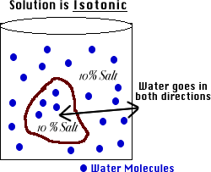

Procedure:
Observe the diagram above and answer the questions.
- What type of solution is this?
Isotonic – equal amounts of solutes

- What type of cell transport is this called?
Osmosis

- Does it require energy? NO

- What will happen to the cell inside this solution?
It will remain the same

Procedure:
Read the paragraph below and answer the questions:
Diffusion of substances and their absorption by the body is an important part of many of our body functions. The regulation and maintenance of a steady balance of substances in the body is referred to as homeostasis. The cell membrane is the most important part of the cell in regard to homeostasis of substances. In living organisms diffusion is sometimes complicated by the fact that the cell membrane will allow some substances to pass through it but not others. If a substance can pass through the membrane we say that the membrane is permeable to it. So the cell membrane is described as being selectively permeable. Water can almost always diffuse through the membrane although its dissolved solutes may not always do so. This may create concentration gradients (areas of high and low concentration) on either side of the membrane. This diffusion of water through a cell's selectively permeable membrane is termed osmosis.
The main direction in which the water flows is determined by the concentration gradient. The concentration gradient of solutions is indicated by use of the terms hypotonic, hypertonic, and isotonic.
The prefix hypo means "less than". The prefix hyper means "greater than". The prefix iso means "equal".

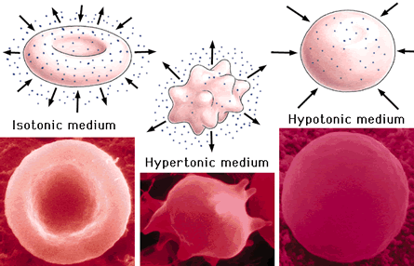
A B C

- What type of solution is cell A in? Isotonic
- What type of solution is cell B in? Hypertonic
- What type of solution is cell C in? Hypotonic
- What is homeostasis? The regulation and maintenance of a steady balance of substances in the body is referred to as homeostasis

