Name _________________________________ Date ________
Cells Alive- Internet Lesson ....................................................................
Part A. "HOW BIG IS A....
Instructions: Look at the objects that can be found on the head of a pink. Zoom in and out to determine which object is the smallest, then slowly zoom out so you can see how other objects compare.
1. If you zoom all the way in, what is the smallest object on the head of the pin? ______________
Zoom out a little farther, what is the hook shaped object you see? ________________________
2. Compare each of the following objects on the pin, circle the one that is larger.
a) baker's yeast or e. coli
b) lymphocyte or ragweed
c) red blood cell or staphylococcus
d) ragweed or dust mite
Part B: Label the image below.
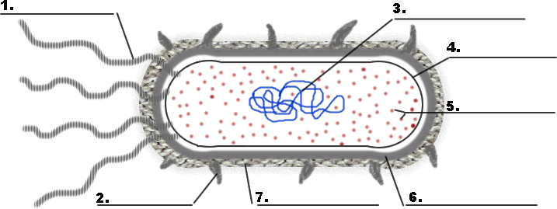
Part C: Go to the Animal Cell Model and click through each of the parts and read their descriptions. Use the information to answer the questions and make sketches of the cell organelles.
1. What do the mitochondrion do?
2. How big are the mitochondrion?
3. What is the function of the golgi apparatus?

4. What structure is found on the rough ER that is not found on the smooth ER?

5. Where is the nucleolus found?
6. What is the function of the nucleolus?

7. What is the function of the cytoskeleton?
8. What within the nucleus is responsible for providing the cell with its unique characteristics?

Sketches – sketch each organelle below;
11. Rough ER
12. Mitochondrion

13. Centrosome

14. Microtubules

Go to the Plant Cell Model
9. What structure takes up the majority of the center space within the plant cell? What is its primary function?
10. What part of the plant cell give it is green color? How many of these structures are visible on the plant diagram?
Part D: Comparing Cells
Use what you know about each type of cell (reference pictures if needed), and place a check in the box if the cell has that characteristic or structure.
 | Bacteria | Plant | Animal
Cell Wall
Cell Membrane
Nucleus
Cytosol
Central Vacuole
Chloroplast
Mitochondrion

