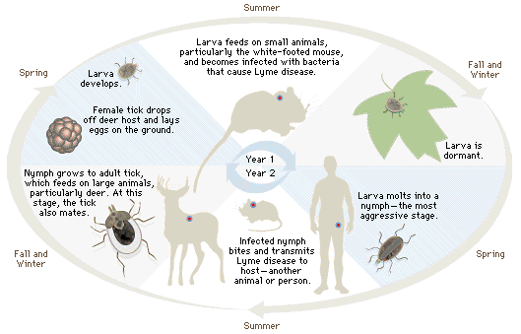

Lyme Bacterium Life Cycle

