Chapter 18 review

In your interactive notebook write out the questions and answer them. Cut out the diagrams and paste them in your notebook by the questions that relate to them.

- Define: community, population
- Describe interdependence and give an example
- What is an ecosystem composed of
- What are coal, oil and natural gas? How are they formed? What do they release when burned?
- Why do we use ecological models?
- How do humans affect the carbon cycle?
- In a food web, which organism receives energy from every
other type of organism?
- What occurs as you move from trophic level to trophic level?
What is the 10% rule?
- Refer to the marine food web:
What are the top consumers?
What is the producer?
What are herbivores?
What are carnivores?
What do the arrows represent in a food web:
- Use the diagram to the right: (energy pyramid)
How much energy is available to each trophic level?
What is the organism that eats plant eaters?
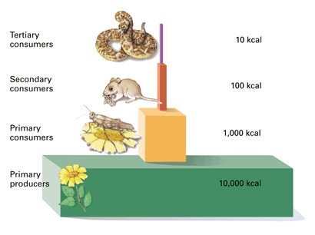
What limits the number of trophic levels in an ecosystem?
- Define biomass
- Most primary producers are?
- Define habitat
- Define niche
- What are biochemical cycles
- In the nitrogen cycle, plants use nitrates and nitrites to form?
- What is nitrogen a component of?
- Organisms that manufacture organic nutrients for an ecosystem are called?
- Precipitation and evaporation are components of what cycle?
- What happens to organisms when they die?
- Why are biochemical cycles so important?
- Describe each in a paragraph: the carbon cycle, water cycle, and nitrogen cycle

