[**Malcolm Lemmons**](https://www.huffingtonpost.com/author/malcolm-lemmons)**, Contributor**

Athlete, Author & Entrepreneur

College Athletes Getting Paid? Here Are Some Pros And Cons

03/29/2017 10:06 am ET **Updated** Mar 29, 2017

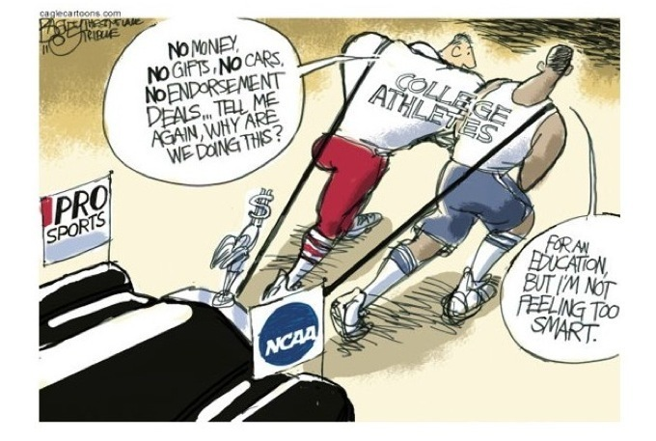

SOURCE: YOUTHVOICES.NET

During this year’s NCAA tournament, there has been obvious speculation about college athletes and the significant amount of revenue they have been bringing to their schools and the NCAA. This isn’t something new. This is something that has been a growing issue in recent years. Not just a regular issue at that, but a structurally racial issue on many levels. African Americans make up the majority of college athletes at the top levels in three major sports: men’s and women’s basketball (Division I) and the upper FBS level of the NCAA’s Division I, according to Travis Walton’s HuffPost article [“Black Americans Support Paying College Athletes. White People? Not So Much.”](http://www.huffingtonpost.com/entry/paying-college-athletes-racial-divide-poll_us_58caca9fe4b0ec9d29d9c12c) These also happen to be the highest revenue-generating sports in college athletics.

Race isn’t the only issue, but statistically it plays a huge part in the reason why many people oppose the fact that college athletes should be getting paid. According to the same article, “A majority ― 52% ― of black respondents are strongly or somewhat in favor of paying college athletes, while only 15% strongly or somewhat oppose the idea. Among whites, however, the numbers flip: Just 27% support paying those athletes, while 43% oppose it.”

If a majority of these college athletes, who are bringing in staggering amounts of money to these schools were white, would this even be a conversation?

Ed O’Bannon, a former professional basketball player, won a lawsuit in 2014 where the NCAA was ordered to pay $44.4 million in attorneys’ fees and another $1.5 million in costs to lawyers for the plaintiffs in the Ed O’Bannon class-action antitrust lawsuit against the NCAA.

FORMER UCLA BASKETBALL PLAYER ED O’BANNON JR. SITS IN HIS OFFICE IN HENDERSON, NEVADA. (AP PHOTO/ISAAC BREKKEN)

O’Bannon and 19 others sued the NCAA, claiming the organization violated United States antitrust laws by not allowing athletes to get a share of the revenues generated from the use of their images in broadcasts and video games. Many former collegiate players were compensated, but some felt it was inadequate and they were owed more.

In 2014, Shabazz Napier was quoted:

*“We do have hungry nights that we don’t have enough money to get food in. Sometimes money is needed. I don’t think you should stretch it out to hundreds of thousands of dollars for playing, because a lot of times guys don’t know how to handle themselves with money. I feel like a student athlete. Sometimes, there’s hungry nights where I’m not able to eat, but I still gotta play up to my capabilities.”*

Subscribe to The Morning Email.

Bottom of Form

All of this begs the question, that if the NCAA did choose to pay college athletes, what would be the advantages or disadvantages of doing so? Below are a few potential pros and cons of paying college athletes.

**Pros**

1. **Support their families**― Players would be able to actually afford a decent meal and possibly send some money back home. Many of these athletes come from urban, low-class families and often leave school early because of the unimaginable pressure to be the main provider for their family at a young age.
2. **Players may stay longer ―** To back up the last point, players wouldn’t have to leave school early and would still be able to pursue an education while taking care of their family back home. This would possibly increase graduation rates, allow fans to see their favorite players mature through college, and ensure coaches are preparing athletes as much as possible for the next level.
3. **Limits corruption from external influences**― Compensating athletes in college will limit the corruption involving agents, boosters and others. Over the years we have seen and heard scandals involving players taking money and even point-shaving. Wouldn’t paying them eliminate a lot of these issues?
4. **Giving them what they deserve right? ―**In Business Insider last week, there was an article that stated, “It is estimated that the University of Louisville has the most valuable players at $1.72 million per year based on the program’s $45.6 million in annual revenue. Overall, the average Division I player is worth $170,098 per year with the 351 Division I basketball programs taking in more than 4.5 million in revenue on average each year.” These athletes are bringing in incredible amounts of revenue to these schools ― why aren’t they receiving what is due? I mean the bottom line is, isn’t this what they deserve for their labor?

**Cons**

1. **Financial irresponsibility**― Amateur players receiving compensation just seems like a complete disaster. They don’t know how to manage their money, and there wouldn’t be anyone their to guide their financial decisions. Colin Cowherd states, “I don’t think paying all college athletes is great; not every college is loaded, and most 19-year-olds (are) gonna spend it—and let’s be honest, they’re gonna spend it on weed and kicks!”
2. **Unfair compensation between players**― How will players be compensated? Will each player receive the same amount? What about the top level talent? Should they receive more because they were All-Americans? In theory, wouldn’t it bring problems between players, due to one teammate potentially receiving more money?
3. **Athletes may never go to class ―** Let’s face it, if they give these kids money, they’ll never have any incentive to go to class. Many of them don’t want to go already, combined with the fact that some may be receiving grades without doing any work. Money will only add to this fact.
4. **Removes athletes competitive nature and passion for the game**― Players will take on a “pro mindset” where the only motive is money. They will lose that hunger and passion that we see in college. It will be traded for lackadaisical plays and half-ass efforts that we sometime see from pros.

As always, there are two sides to any argument. Even as a former college athlete, I am at a point in my life where I can understand each side. But I do find it interesting as to why so many are widely opposed to this idea. Is it racial? Is it because it’s unnecessary? Is it unfair?

Whatever it may be, it looks like this growing debate won’t be dying down anytime soon.