**Directions:** Question 1 is based on the accompanying documents. The documents have been edited for the purpose of this exercise.

In your response you should do the following.

* Support the thesis or a relevant argument with evidence from all, or all but one, of the documents.
* Incorporate analysis of all, or all but one, of the documents into your argument.
* Focus your analysis of each document on at least one of the following: intended audience, purpose, historical context, and/or point of view.
* Support your argument with analysis of historical examples outside the documents.
* Connect historical phenomena relevant to your argument to broader events or processes.
* Synthesize the elements above into a persuasive essay that extends your argument, connects it to a different historical context, or accounts for contradictory evidence on the topic.

1. **Explain how the economic changes between 1816 and 1848 impacted the social and political developments within the United States.**

**Document 1: President Andrew Jackson's Message to Congress, 1830**

It gives me pleasure to announce to Congress that the benevolent policy of the Government, steadily pursued for nearly thirty years, in relation to the removal of the Indians beyond the white settlements is approaching to a happy consummation…The consequences of a speedy removal will be important to the United States, to individual States, and to the Indians themselves. The pecuniary advantages which it promises to the Government are the least of its recommendations. It puts an end to all possible danger of collision between the authorities of the General and State Governments on account of the Indians. It will place a dense and civilized population in large tracts of country now occupied by a few savage hunters. By opening the whole territory between Tennessee on the north and Louisiana on the south to the settlement of the whites it will incalculably strengthen the southwestern frontier...It will relieve the whole State of Mississippi and the western part of Alabama of Indian occupancy, and enable those States to advance rapidly in population, wealth, and power. It will separate the Indians from immediate contact with settlements of whites; free them from the power of the States; enable them to pursue happiness in their own way and under their own rude institutions…and perhaps cause them gradually, under the protection of the Government and through the influence of good counsels, to cast off their savage habits and become an interesting, civilized, and Christian community.

**Document 2: *Boston Transcript* reports on the strike at Lowell Mills, 1834**

"We learn that extraordinary excitement was occasioned at Lowell, last week, by an announcement that the wages paid in some of the departments would be reduced 15 percent on the 1st of March. The reduction principally affected the female operatives, and they held several meetings, or caucuses, at which a young woman presided, who took an active part in persuading her associates to give notice that they should quit the mills, and to induce them to 'make a run' on the Lowell Bank and the Savings Bank, which they did. On Friday morning, the young woman referred to was dismissed, by the Agent...and on leaving the office...waved her calash in the air, as a signal to the others, who were watching from the windows, when they immediately 'struck' and assembled about her, in despite of the overseers.

"The number soon increased to nearly 800. A procession was formed, and they marched about the town, to the amusement of a mob of idlers and boys, and we are sorry to add, not altogether to the credit of Yankee girls....We are told that one of the leaders mounted a stump and made a flaming [Mary](http://www.netaxs.com/~kwbridge/feminist.html) [Wollstonecraft](http://www.columbia.edu/acis/bartleby/wollstonecraft/index.html) speech on the rights of women and the iniquities of the 'monied aristocracy,' which produced a powerful effect on her auditors, and they determined to 'have their way if they died for it.'"

**Document 3: *Democracy in America*, Alexis de Tocqueville, 1835**

Once a people begins to interfere with the voting qualification, one can be sure that sooner or later it will abolish it altogether. That is one of the most invariable rules of social behavior. The further the limit of voting rights is extended, the stronger is the need felt to spread them still wider, for after each new concession the forces of democracy are strengthened, and its demands increase with the augmented power. The ambition of those left below the qualifying limit increases in proportion to the number of those above it. Finally the exception becomes the rule; concessions follow one another without interruption, and there is no halting place until universal suffrage has been attained... In the United States, except slaves, servants, and paupers supported by the townships, there is no class of persons who do not exercise the elective franchise and who do not indirectly contribute to make the laws. Those who wish to attack the laws must consequently either change the opinion of the nation or trample upon its decision.

**Document 4: Campaign poster for William Henry Harrison and John Tyler, Presidential Race, 1840**

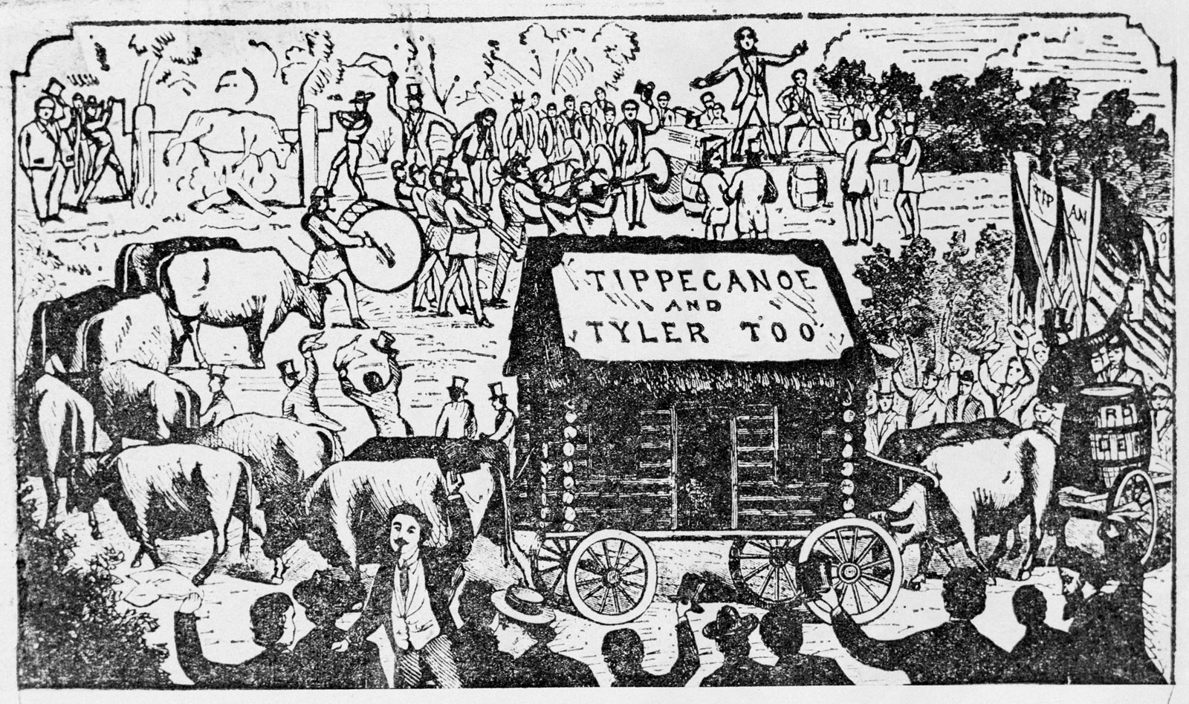

**Document 5: Lydia Maria Child, “Woman’s Rights,” 1843**

The nearer society approaches to divine order, the less separation will there be in the characters, duties, and pursuits of men and women. Women will not become less gentle and graceful, but men will become more so. Women will not neglect the care and education of their children, but men will find themselves ennobled and refined by sharing those duties with them; and will receive, in return, co-operation and sympathy in the discharge of various other duties, now deemed inappropriate to women. The more women become rational companions, partners in business and in thought, as well as in affection and amusement, the more highly will men appreciate *home*—that blessed word, which opens to the human heart the most perfect glimpse of Heaven, and helps to carry it thither, as on an angel’s wings…

**Document 6: James Henry Hammond, *Letter to an English Abolitionist*, 1845**

“Let us open these Holy Scriptures…You cannot deny that God especially authorized his chosen people to purchase “bondmen forever” from the heathen, as recorded in the twenty-fifth chapter of Leviticus, and that they are there designated by the very Hebrew word used in the tenth commandment. Nor can you deny that “BONDMAND FOREVER” is a “SLAVE”; yet you endeavor to hang an argument of immortal consequence upon the wretched subterfuge, that the precise word “slave” is notrto be found in the translation of the Bible…It is impossible, therefore, to suppose that Slavery is contrary to the will of God. It is equally absurd to say that American Slavery differs in form or principle from that of the chosen people…I think, then, I may safely conclude, and I firmly believe, that American Slavery is not only not a sin, but especially commanded by God through Moses, and approved by Christ through his apostles.”

**Document 7: Horace Mann, “Twelfth Annual Report to the Secretary of the Massachusetts Board of Education,” 1848**

I suppose it to be the universal sentiment of all those who mingle any ingredient of benevolence with their notions on Political Economy, that vast and overshadowing private fortunes are among the greatest dangers to which the happiness of the people in a republic can be subjected. Such fortunes would create a feudalism of a new kind;

Now, surely, nothing but Universal Education can counter-work this tendency to the domination of capital and the servility of labor. If one class possesses all the wealth and the education, while the residue of society is ignorant and poor, it matters not by what name the relation between them may be called; the latter, in fact and in truth, will be the servile dependents and subjects of the former. But if education be equably diffused, it will draw property after it, by the strongest of all attractions; for such a thing never did happen, and never can happen, as that an intelligent and practical body of men should be permanently poor. Property and labor, in different classes, are essentially antagonistic; but property and labor, in the same class, are essentially fraternal.

**Document 8: Samuel F.B. Morse, Imminent Dangers to the Free Institutions of the**

**United States, 1835.**

In our national infancy we needed the strength of numbers. . . . Now emigration is changed; naturalization has become the door of entrance not alone to the ever welcome lovers of liberty, but also for the priest-ridden troops of the Holy Alliance. . . . Now emigrants are selected . . . not for their affinity to liberty, but for their mental servitude, and their docility in obeying the orders of their priests. . . .

It may be, Americans, that you still doubt the existence of a conspiracy. . . . Do you wish to test its existence and its power? . . . Test it by attempting a change in the Naturalization Law.

Take the ground that such a change must be made, that no foreigner who comes into the country after the law is passed shall ever be allowed the right of suffrage.