1844-1877 Illustrated/Annotated Timeline

Your task: Create a timeline of events that occurred during the time period assigned. You may use any of the topics discussed in class, the textbook, or things that you researched. The goal here is to find events that you believe have had the biggest impact on the time period. Choose the events that have the most historical significance, and tell the story of period. You will need to include graphics or illustrations, and outside information to highlight the events.

Your timeline must include (This assignment may be done with a partner):
- Events between 1844-1877 (APUSH Period 5)
- A minimum of 12 specific events and graphic for each event.
- You will also need to include a description of an outside document that supports the event (ex. Lincoln/Douglas could use Lincoln’s House divided Speech or Freeport document. Also, could include Acts or laws passed)
- A 4-5 sentence caption that provides a description of the event and your explanation of why it is of important. You will need to defend your decision of why you included it. Do not just copy from the source
- Color throughout.
- Be free from spelling and grammatical errors
- Be neat, well planned, and shows effort was used

Example Event:
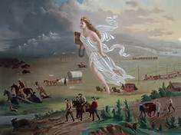 | Manifest Destiny, 1845  Manifest Destiny was the widely held idea that the United States had the right to extend their reach across the North American continent. Americans believed that God had ordained them with the ability and resources to obtain the western land, and that they were justified in doing so. As Americans extended the westward boundary the land they acquired symbolized an extension of their economic opportunity and hope. The American government encouraged westward movement with the passage of the Homestead Act of 1862, which granted land to any US citizen that was willing to farm the land for at least 5 years.

