**The Ferment of Reform and Culture (1790-1860)**

A new "sub-revolution" will emerged in America to attempt to improve the moral standings of the citizens. The change was to influence more religious values and social reforms. It was a time of reinvention in America socially, economically and culturally.

Here are the requirements: A Total of 12 Cards/ People

*Front:*

*Picture of the person*

*Name of the person*

*Date: Born-Died*

*Where are they from?*

*Back:*

*Brief bio- What are they famous for?*

*What were there significant works of art? (include description)*

*Picture*

***THE TWO CATEGORIES MUST BE SEPARATE AND CLEAR***

Here at the possible people (you must do the ones that are bolded):

|  |  |
| --- | --- |
| * Charles Grandison Finney * **Joseph Smith** * Brigham Young * Horace Mann * **Dorothea Dix** * **Elizabeth Cady Stanton** * **Susan B. Anthony** * James Fenimore Cooper * **Ralph Waldo Emerson** | * Henry David Thoreau * Walt Whitman * Henry Wadsworth Longfellow * Louisa May Alcott * **Emily Dickinson** * Edgar Allan Poe * Nathaniel Hawthorne * Herman Melville |

Brief Biography:

Ralph Waldo Emerson was an American poet, philosopher and essayist during the 19th century. He promoted and wrote in the American Transcendentalist style. Transcendentalism believes in the goodness of people and nature that societies led to corruption of people, and we are best when we are able to self-reflect and be independent.

[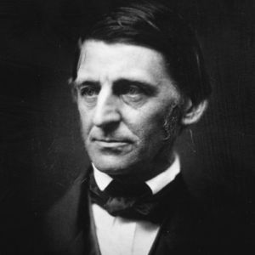](http://www.biography.com/people/ralph-waldo-emerson-9287153)

**Ralph Waldo Emerson**

May 25, 1803- April 27, 1882

Massachusetts

Influential Writings:

His most famous work was titled

“Self-Reliance”. The essay discussed Emerson’s ideas related to the need for each individual to avoid conformity and false consistency, and follow their own instincts and ideas. His beliefs and his idealism strongly influenced Henry David Thoreau and Walt Whitman.

A core belief of transcendentalism is in the inherent goodness of people and nature. Adherents believe that society and its institutions have corrupted the purity of the individual, and they have faith that people are at their best when truly "[self-reliant](https://en.wikipedia.org/wiki/Self-Reliance)" and independent.