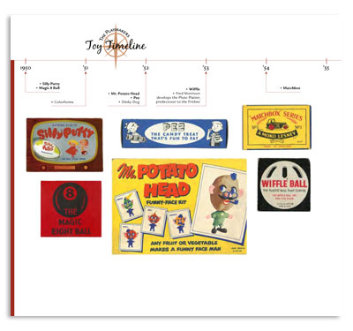
1750-1783 Illustrated/Annotated Timeline
Your task: Create a timeline of events that occurred from the French and Indian War up to the American Revolution. You may use any of the topics discussed in class, the textbook, or things that you researched. The goal here is to find events that you believe have had the biggest impact on the time period. Choose the events that have the most historical significance, and tell the story of period. You will need to include graphics or illustrations that highlighting some of the events.

Your timeline must include:
- Events between 1750-1783.
- A minimum of 15 specific events and graphic for each event.
- A 4-5 sentence caption that provides a description of the event and your explanation of why it is of important. You will need to defend your decision of why you included it. Do not just copy from the source
- Color throughout.
- Be free from spelling and grammatical errors
- Be neat, well planned, and shows effort was used

Example Event:
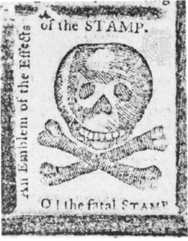 | Nov 1, 1765- Stamp Act  The Stamp Act was a direct tax placed on all printed goods that were sold in the colonies. The Stamp Act was significant because it was the event that pushed the colonialist past the breaking point and they started to feel they were being over taxed. They saw it as a violation of their rights as Englishmen and helped to ignite the revolutionary spirit. The Stamp Act Congress was a direct result of the Stamp Act which resulted in the first real strides of colonial unification.

