1. Answer a, b, and c.

1. Briefly explain ONE example of how social, political, or economic groups challenged the prominence of the industrial elite in American society during the period 1865-1898.
2. Briefly explain a SECOND way social, political, or economic groups challenged the prominence of the industrial elite in American society during the period 1865-1898.
3. Briefly explain ONE way business leaders justified or defended their status and privilege.

2. Answer a, b, and c.

As Manifest Destiny took hold of the nation, the US extended its boundaries.

1. How did the extension of borders create conflict with Mexicans and/or American Indians?
2. How did the U.S. government abrogate (revoke) the rights of Mexicans and/or American Indians during and after the period of Manifest Destiny?
3. How did Manifest Destiny lead to a change in representation in Congress leading to eventual civil war?

3. Answer a, b, and c.

1. Select one of the regions below and explain how improvements to transportation transformed its economy between 1800-1848.

New England

South

Middle Atlantic

West

1. Briefly explain ONE way that the lives of workers in that region changed as a result of these transportation improvements.
2. By contrast, choose another region from the list and explain why it was least impacted by transportation improvements.

“If anyone… had asked what I had yet discovered respecting General Jackson, I might have answered thus: “Andrew Jackson...was a patriot and a traitor.  He was one of the greatest of generals, and wholly ignorant of the art of war… The first of statesmen, he never devised, he never framed a measure...A most law-obeying citizen.  A stickler for discipline, he never hesitated to disobey his superior.  A democratic autocrat.  An urbane savage.  An atrocious saint.”  James Parton, preface to the Life of Andrew Jackson, 1860.

4. Using the excerpt above, please answer a, b, and c:

1. Briefly explain ONE way that President Andrew Jackson acted like a “patriot” or law-abiding citizen.
2. Briefly explain ONE way that President Andrew Jackson acted like an autocrat or a “traitor.
3. Briefly explain ONE development during (1824-1837) that led to this time period being called “The Era of Jackson.”

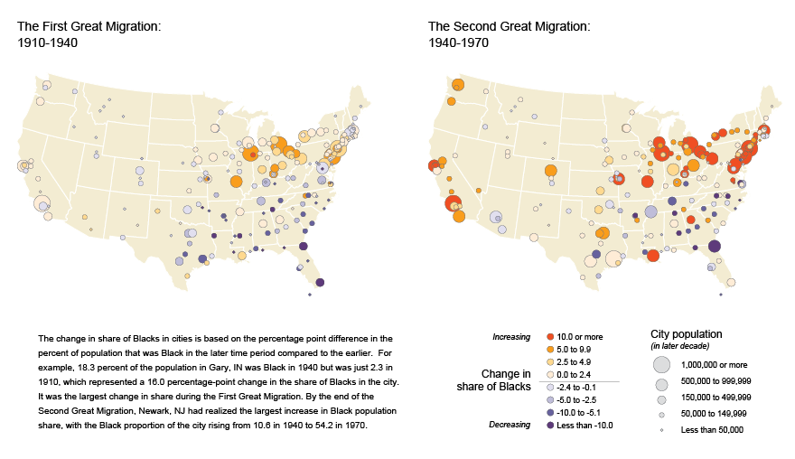

5.

1. **Briefly explain what caused the changes in migration patterns that occurred in the first great migration 1910-1940**
2. **Briefly explain what caused the changes in migration patterns that occurred in the second great migration 1940-1970**
3. **Briefly explain which migration pattern was more economically beneficial to African Americans**