Short Answer Response Questions: Answer each part of the question (P-E-A: Point, Evidence, Analysis)

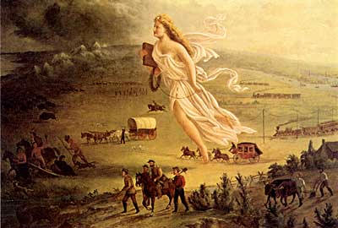

1. Use the image above and your knowledge of United States history to answer parts A, B, and C.

1. Explain the point of view reflected in the image regarding ONE of the following:

◆ Migration

◆ Technology

◆ American Indians

1. Explain how ONE element of the image expresses the point of view you identified in Part A.
2. Explain how the point of view you identified in Part A helped to shape ONE specific United States government action between 1845 and 1900.

2. Answer a, b, and c.

1. Briefly explain why ONE of the following best marks the beginning of industrialization in the United States.

• The market revolution in the first half of the 1800s

• The Civil War era in the middle of the 1800s

• The rise of big business in the second half of the 1800s

1. Provide ONE example of an event or development that supports your explanation in (a).
2. Provide specific historical evidence that explains why ONE of the other options is less convincing as the possible beginning of industrialization in the United States.

3. Answer a, b, and c.

1. Briefly explain ONE example of how immigrants gained access to new opportunities in the period from 1865-1898.
2. Briefly explain a ONE example of how immigrants gained access to new opportunities in the period from 1865-1898.
3. Briefly explain ONE way immigrants were restricted in politics, society, or the economy in the period from 1865-1898.

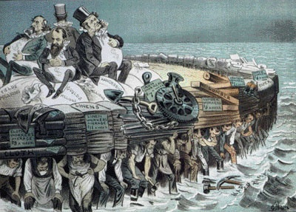

4. Using the 1883 image above, answer a, b, and c.

1. Briefly explain the point of view about the economy expressed by the artist.
2. Briefly explain ONE development in the period 1865 to 1910 that could be used to support the point of view expressed by the artist.
3. Briefly explain ONE development in the period 1865 to 1910 that could be used to challenge the point of view expressed by the artist.

5. Answer a, b, and c.

1. Briefly explain ONE example of how social, political, or economic groups challenged the prominence of the industrial elite in American society during the period 1865-1898.
2. Briefly explain a SECOND way social, political, or economic groups challenged the prominence of the industrial elite in American society during the period 1865-1898
3. Briefly explain ONE way business leaders justified or defended their status and privilege.

Long Response Questions: (Create a thesis and an outline to answer each question).

1. **AP 2006** For whom and to what extent was the American West a land of opportunity from 1865 to 1890?
2. **AP 2007** Explain how TWO of the following individuals responded to the economic and social problems created by industrialism during the late nineteenth and early twentieth centuries.

Jane Addams Andrew Carnegie Samuel Gompers Upton Sinclair

1. **AP 2003** Analyze the ways in which the farmers and industrial workers responded to industrialization in the Gilded Age (1865-1900).
2. **AP 2002** Identify and analyze the factors that changed the American city in the second half of the nineteenth century.
3. **AP 2001** How and why did transportation developments spark economic growth during the period from 1860-1900 in the United States?
4. **AP 1999** How were the lives of the Plains Indians in the second half of the nineteenth century affected by technological developments and government actions?