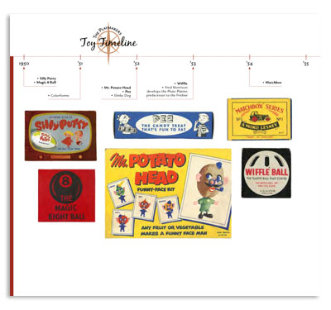
Due: Monday 11/16

Illustrated/Annotated Timeline

Your task: Create a timeline of events that occurred during WWI. You may use any of the topics discussed in class, the textbook, or things that you researched. The goal here is to find events that you believe have had the biggest impact on WWI. Choose the events that have the most historical significance, and tell the story of their impact on America. You will need to include graphics or illustrations that highlighting some of the events.

Your timeline must include:
- Events between 1914-1918.
- A minimum of 10 specific events.
- A 2-3 sentence caption that provides a description of the event and your explanation of why it is of important/ significant.
- Color throughout.
- Be free from spelling and grammatical errors
- Be neat, well planned, shows effort was used

Example Event:
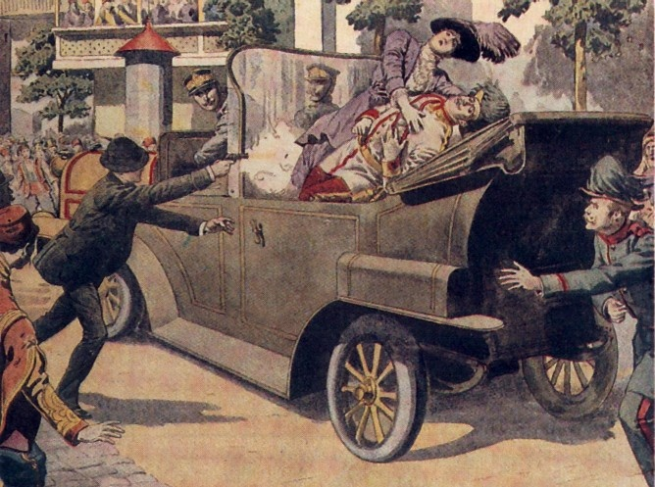 | Assassination of Franz Ferdinand, June 28, 1914  On 28 June 1914, Archduke Franz Ferdinand of Austria, heir to the Austro-Hungarian throne, and his wife, Sophie, were assassinated in Sarajevo by Gavrilo Princip. The assassination led to a diplomatic crisis that resulted in the Austria-Hungary empire declaring war on Serbia. Russia then came to the aid of Serbia because of the alliance system, and Germany aided Austria-Hungary, which resulted in the start of WWI. The US would eventually be pulled into the conflict in 1917, and fight against the German/ Austrian alliance.

