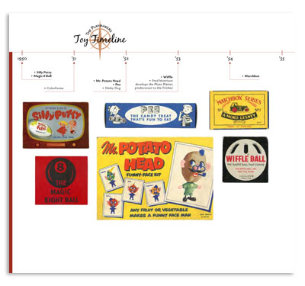
Extra Credit- Illustrated/Annotated Timeline

Due 6/8

Your task: Create a timeline of 10 events that affected the United States between 1945-2000. Include illustrations and captions that highlighting key information from anything we have discussed this semester. Your timeline should be neat and colored.

Your timeline must include:
- A basic timeline from 1945-2000.
- A minimum of 10 specific events.
- Include 2-3 sentence caption that explains each event along with the correct date (as close to possible)of when it occurred.
- A picture for/ of each event.
- Color throughout and be neat.

