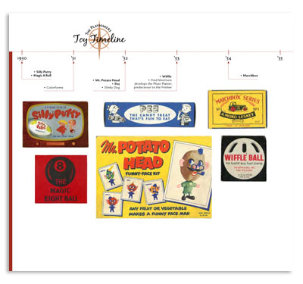
Illustrated/Annotated Timeline
Your task: Create a timeline of events that occurred in APUSH this semester. You may use any of the topics discussed in class, the textbook, or things that you researched. The goal here is to find events that you believe have had the biggest impact on the United States. Choose the events that have the most historical significance, and tell the story of America. You will need to include graphics or illustrations that highlighting some of the events.

Your timeline must include:
- Events between1450-1865.
- A minimum of 15 specific events.
- A 4-5 sentence a caption that provides a description of the event and your explanation of why it is of important. You will need to defend your decision of why you included it.
- Color throughout.
- Be free from spelling and grammatical errors
- Be neat, well planned, shows effort was used

Culminating Activity: Students are expected to present their timeline to the class. Presentations should be 5 min in duration and will take place on the day of finals.

Example Event:
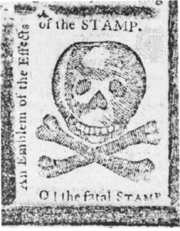 | Nov 1, 1765- Stamp Act  The Stamp Act was a direct tax placed on all printed goods that were sold in the colonies. The Stamp Act was significant because it was the event that pushed the colonialist past the breaking point. They saw it as a violation of their rights as Englishmen and helped to ignite the revolutionary spirit. The slogan of “No taxation without representation” was heard after the passage of the Stamp Act.

