Great Depression Political Cartoon Assignment

During hard times it is common to see political cartoons directed at the government or powerful individuals. Political cartoons are used to share one’s anger or dissatisfaction with policy or person for an audience to see. In order to make sure you fully understand the impact a political cartoons can have, your job will be to create a political cartoon that meets the following standards and addresses the following issues:

Standards and Issues-
- Cartoons should be relevant to the topic, and school appropriate
- Cartoons should fill up a majority of the paper given to you
- Cartoons must be colorful
- Cartoons must be Stock Market Crash, Great Depression or Dust Bowl related
- Cartoons must have at least one central image and enough writing to explain what’s going on

Guidelines-
In order to receive full credit, your Cartoons should meet the following requirements:
- The cartoons must use one of the central themes listed above (5 pts)
- It should be creative in its attempt to explain the purpose (5 pts)
- It needs to be colorful! ( 5 pts)
- Neatness and effort (5pts)

Political Cartoon Examples-

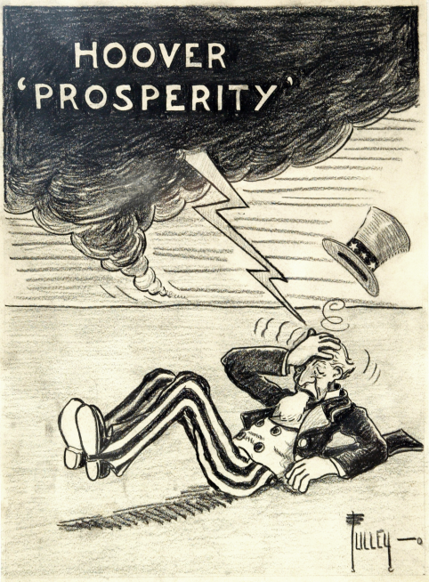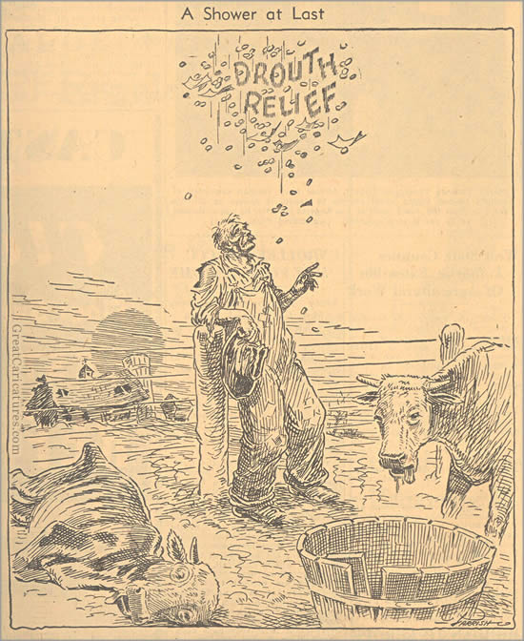

You can also look on pages 467, 481, and 485 for other examples

