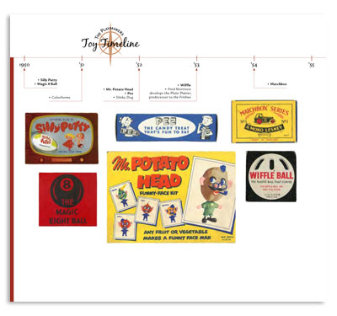
Illustrated/Annotated Timeline due 11/22

Your task: Create a timeline of any of the events that happen during the 1920’s. Include illustrations and captions that highlighting key information from chapters 12 and 13. Your timeline should be neat and colored.

Your timeline must include:
- The basic timeline of your historical period.
- A minimum of 10 specific events that you want to represent on your timeline.
- Include 2-3 sentence caption that explains each event along with the correct date of when it occurred.
- A picture for at least 5 of the events.
- Color throughout.

