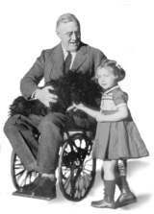

**Allied Powers**

**United States**

**Franklin Roosevelt**

**32**

**19**



**World War II**

**Birth/Death Date**

**Political Party**

**Describe their impact on the war**

**World War II**

**Franklin Roosevelt**

Jan 30, 1882 - Apr 12, 1945

**Allied Powers**

**U.S. President**

**Birth/Death Date**

**Democrat**

**Political Party**

**Describe their impact on the war**

**World War II**

**Birth/Death Date**

**Political Party**

**Describe their impact on the war**

**World War II**

**Birth/Death Date**

**Political Party**

**Describe their impact on the war**

**World War II**

**Birth/Death Date**

**Political Party**

**Describe their impact on the war**

**World War II**

**Birth/Death Date**

**Political Party**

**Describe their impact on the war**