Chapter 5-Political Parties
Key Vocabulary Terms

Directions: Please define the following words associated with the concept of Political Parties.
- Political Party-

- Candidate-

- Republican-

- Democrat-

- Independent-

- Primary-

- Caucus-

- Debate-

- Constituent-

- Party Platform-

*Use the following website to complete the activity: https://www.diffen.com/difference/Democrat_vs_Republican

Democrats

Philosophy
Economic Ideas
Social and Human Ideas
Stance on Military Issues
Stance on Same Sex Marriage
Stance on Abortion
Stance on the Death Penalty
Stance on Taxes
Stance on Government Regulations
Healthcare Policy

Democrats

Stance on Immigration
States in which the Democrats are Traditionally Strong
Symbol and Color | Symbol | Color
Year in Which the Democratic Party Was Founded
Democratic Party Website
Senate Leader
Chairperson
Famous Democratic Presidents
Number of Seats in the Senate
Number of Seats in the House
Governorships
Memberships

Republicans

Philosophy
Economic Ideas
Social and Human Ideas
Stance on Military Issues
Stance on Same Sex Marriage
Stance on Abortion
Stance on the Death Penalty
Stance on Taxes
Stance on Government Regulations
Healthcare Policy

Republicans

Stance on Immigration
States in which the Republicans are Traditionally Strong
Symbol and Color | Symbol | Color
Year in Which the Republican Party Was Founded
Republican Party Website
Senate Leader
Chairperson
Famous Republican Presidents
Number of Seats in the Senate
Number of Seats in the House
Governorships
Memberships

Presidential Biography: Republican President
Presidential Bio #1: __________________________________
- When and where was he born?
- What did he do in his early years as a child and a young adult?
- Who did he marry and how many children did he have?
- What was his occupation before he was elected President?
- When was he elected President of the United States?
- When was his term of office?
- Who was his vice president?
- What was one major event that took place during his term? (Include the results)
- What are two interesting or little known facts about this president?

Presidential Biography: Democratic President
Presidential Bio #2: __________________________________
- When and where was he born?
- What did he do in his early years as a child and a young adult?
- Who did he marry and how many children did he have?
- What was his occupation before he was elected President?
- When was he elected President of the United States?
- When was his term of office?
- Who was his vice president?
- What was one major event that took place during his term? (Include the results)
- What are two interesting or little known facts about this president?
Comparing the Candidates
2020 Primary Election

Directions: For this portion of the activity you will research President Trump and your choice of one of the candidates running for the 2020 Democratic nomination. For President Trump you can use the following website: http://www.diffen.com/difference/Donald-Trump-vs-Hillary-Clinton. For the Democratic candidates you can use a site like https://uproxx.com/culture/2020-presidential-candidates-beliefs/ and additional sites to complete your research.

Topics | President Donald Trump
Political Party
Alma Mater
Date and Place of Birth
Current Position of Employment
Campaign Website
Position on Immigration
Position on Healthcare
Position on Abortion
Tax Policies

Comparing the Candidates
2020 Primary Election

Economic Policies
Position on Minimum Wage
Position on Government Regulation
Position on Global Warming
Position on Gun Rights
Position on Marijuana Legalization
Position on Syria and ISIS
Spouse(s)
Religion
Running Mate |  | *Not yet decided

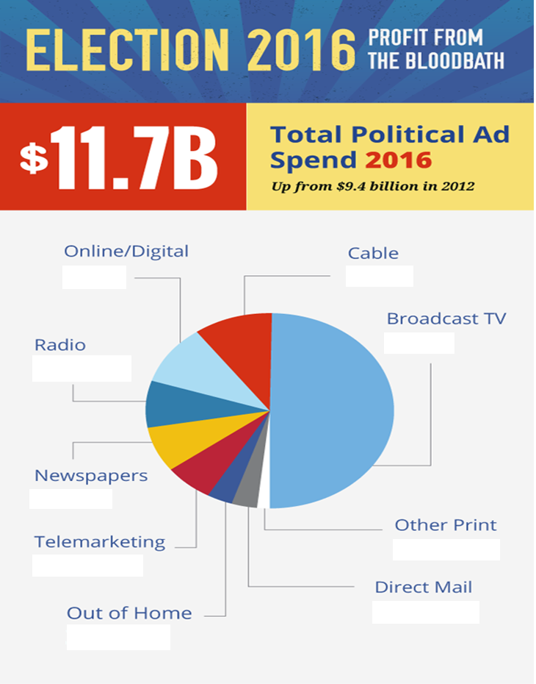
Go to the following website to fill in the pie chart: Please https://www.thestreet.com/story/13594342/1/tv-political-ad-spending-will-break-records-in-2016-and-these-broadcasters-will-cash-in.html

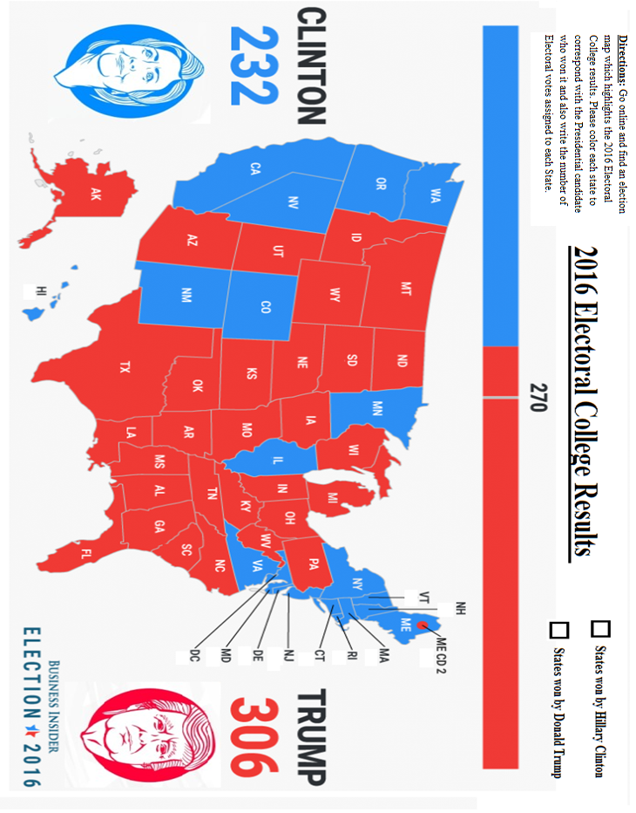
Minor Political Parties
 | Definition | Examples
Ideological Parties
Single-Issue Parties
Economic Protest Parties
Splinter Parties

Decide whether the following scenarios would be an example of an Ideological Party, Single-Issues Party, Economic Protest Party or Splinter Party then write the correct term in the space provided.

_________________________________ The “Free Choice Party” is formed by people intent on legalizing the use of marijuana for medical purposes.

_________________________________ A group of Democrats dissatisfied with the parties moderate nominee, decided to form a new “People’s Rights” party to block their more liberal leader, Henry J. Smith.

_________________________________ A group of angry Midwestern farmers and laborers form the “Working Peoples” party calling for higher tariffs, higher farm subsidies and congressional term limits

_________________________________ The “Socialist Justice Party” calls for a complete overhaul of the American political, economic and legal systems

_________________________________ The “Equality” party works for an end to affirmative action programs

