Chapter 4: Federalism
Section 2: The National Government and the 50 States (pg. 103-109)
Main Idea: As America continued to expand it was only a matter of time before new states would need to be admitted. The process for admittance is pretty straight forward and with the new wave of admitted states the federal government faced the challenge of providing financial assistance as well through various grant programs.

Identify the two things the framers created the Constitution to do in order to preserve unity between the states:

The Nations Obligations
Identify where most of the obligations placed on the National Government are listed:

Identify what the Constitution requires the National Government to do:

Identify and describe what it means for a nation to have a Republican Form of Government:

- Example of the principle in action:

Identify and describe what it means for a nation to protect its citizens from Invasion and Internal Disorder:

- Example of the principle in action:

Identify and describe what it means for a nation to maintain Respect for Territorial Integrity:

- Example of the principle in action:

Admitting New States

Territorial Expansion of the United States
(Please color each acquisition or secession a different color)
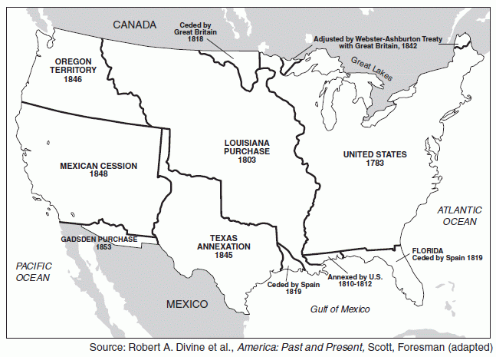

Congress and States
Identify who has the power to admit new States:

Describe what happens if a new State is attempting to be created from land comprised of previously established states:

Identify the amount of States Congress has admitted since our birth as a nation: (Hint: Don’t count the original thirteen states)

Identify how the following States received

- List which States were created from territory belonging to already existing States:

- List which States existed as independent republics prior to being admitted:

- List which territory became a state shortly after succeeding from Mexico:

- List the minimum amount of time the other thirty states had to wait prior to being admitted to the Union?

Admission Procedure
Define the term Enabling Act:

Define the term Act of Admission:

Discuss how the admission process for Alaska and Hawaii deviated from the standard admission procedure

Conditions for Admission
List two examples of conditions that were placed on states prior to their admission into the Union

Cooperative Federalism
Define the term Grants-in-aid Programs:

- List an early example of this principle in action:

Identify and describe what Categorical Grants are:

- Example of the principle in action:

Identify and describe what Block Grants are:

- Example of the principle in action:

Identify and describe what Project Grants are:

- Example of the principle in action:

Describe how state and local elections are financed:

