**11 Main Pros and Cons of American Imperialism-Reflection Activity**

**Directions:**

**Step One:** After reading the article titled ***11 Main Pros and Cons of American Imperialism,*** create a tree map in the space provided below that highlights the two strongest Pros and Cons you feel were included in the article. Under each example include a short explanation for why you feel that is a strong piece of evidence.

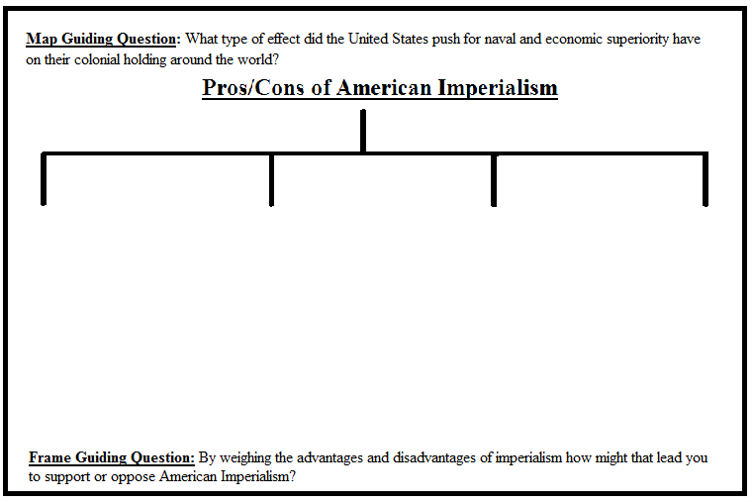

**Step Two:** After reading the article and creating your thinking map you will answer the following writing prompt on located the back of this paper. When answering the prompt please include either the two advantages or disadvantages (depending on which position you are taking) of imperialism in your writing as your textual evidence.

**Writing Prompt:** In your opinion should America continue to expand their imperialistic power to other nations as a means of support or should it retract its naval/military bases and give these colonies a chance to operate as independent sovereign governments?