The 'Real' Forrest Gump: Sammy L. Davis
Military.com | By Peter Collier
Sammy Davis took some ribbing in the Army because he shared a name with the famous entertainer. Much later, long after his military days were over, he would again gain acclaim among his old comrades, this time as the "real" Forrest Gump.
Davis enlisted in the Army directly out of high school in 1965. Volunteering for the artillery because his father had been an artilleryman in World War II, he was assigned to the 4th Artillery. Soon after completing training, he asked to be sent to Vietnam.
Early on November 18, 1967, his unit of 11 guns and 42 men was helicoptered into an area west of Cai Lay to set up a forward fire-support base -- Firebase Cudgel -- for American infantrymen operating in the area.
Shortly after midnight the next morning, Private First Class Davis's Battery C came under heavy mortar attack. Almost simultaneously, an estimated fifteen hundred Vietcong soldiers launched an intense ground assault, failing to overrun the Americans only because a river separated the two forces.
Davis's squad was operating a 105 mm howitzer that fired eighteen thousand beehive darts in each shell. When he saw how close the enemy had come, Davis took over a machine gun and provided covering fire for his gun crew. But an enemy recoilless rifle round scored a direct hit on the howitzer, knocking the crew from the weapon and blowing Davis sideways into a foxhole.
Convinced that the heavily outnumbered Americans couldn't survive the attack, he decided to fire off at least one round from the damaged artillery piece before being overrun. He struggled to his feet, rammed a shell into the gun, and fired point-blank at the Vietcong who were advancing five deep directly in front of the weapon; the beehive round cut them down.
An enemy mortar round exploded nearby, knocking Davis to the ground, but he got up and kept firing the howitzer. When there were no more rounds left, he fired a white phosphorus shell, and then the last round he had -- a "propaganda shell" filled with leaflets.
At this point, he heard yelling from the other side of the river and realized that GIs had been cut off there. Despite the fact that he didn't know how to swim, he got in the water and paddled across on an air mattress from the American camp; other GIs followed him.
Scrambling up the bank, he found three wounded soldiers, one of them suffering from a head wound that looked fatal. He gave them all morphine and provided covering fire as another GI helped the most gravely wounded soldier across the river, then pulled the other two through the water on the air mattress to the fire base.
He eventually made his way to an American howitzer crew and resumed the fight. Sometime before dawn, he was seriously wounded in the back and buttocks by friendly fire.
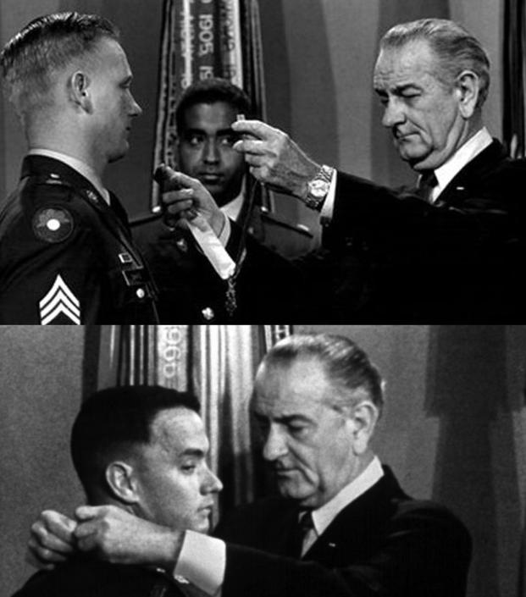
Sammy L. Davis receives his Medal of Honor (top), an image that would be repurposed for a similar moment in the movie Forrest Gump (bottom).
While he was in the hospital, Davis heard that he was to be sent home. He petitioned General William Westmoreland to be allowed to stay with his unit. Permission was granted, although Davis was still so hobbled by his wounds that he was taken off the line and made a cook.
On November 19, 1968, exactly one year and one day after the nightlong firefight at Cai Lay, Davis received the Medal of Honor from President Lyndon Johnson.
Years later, footage of LBJ putting the medal around Davis's neck appeared in the movie Forrest Gump (with Tom Hanks's head substituted for Davis's), and Gump's fictional Medal of Honor citation was loosely based on Davis's real one.

Source: https://www.military.com/history/real-forrest-gump-sammy-l-davis.html

