How a Bill Becomes a Law Activity

Directions: For this activity we are going to imagine that our class represents the two houses of Congress (The House of Representatives and the Senate). Together with a few of your fellow representatives you are going to create a bill addressing a problem facing students at Fordson High School. Once you have crafted your bill it will be presented to each house for a vote before being placed on the President’s (Mr. Murray) desk for approval or veto. It is important that the issue you choose is relevant and that your group is persuasive since it must pass by a majority vote in the both our House and Senate.

*Included below is a sample template for how you will create your bill.

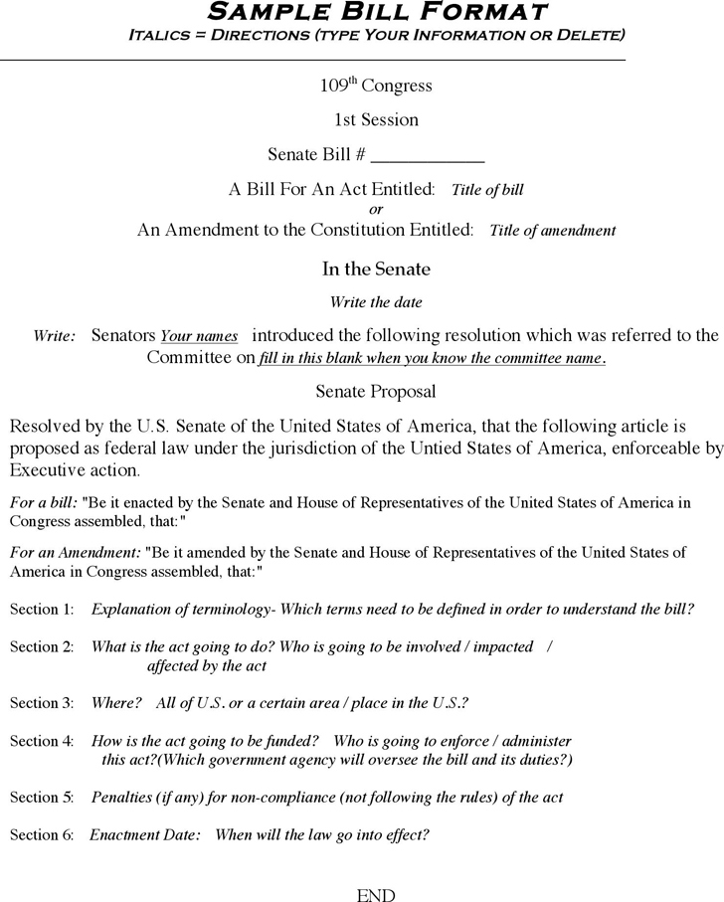

S. ______

97th Congress
1st Session

IN THE SENATE OF FORDSON HIGH SCHOOL

__________________________________________ introduced the following bill, which was read twice and referred to the Committee on __________, 2019.

A BILL

______________________________________________________________________________

______________________________________________________________________________

S. ______

97th Congress
1st Session

IN THE SENATE OF FORDSON HIGH SCHOOL

__________________________________________ introduced the following bill, which was read twice and referred to the Committee on __________, 2019.

A BILL

To amend section _______ of title _____, Fordson High School’s student rules and
regulations for student conduct (commonly known as known as _____________
_______________________________), to provide for _______________________
____________________________________________________________________,
and other purposes.

HR. ______

97th Congress
1st Session

IN THE HOUSE OF REPRESENATIVES OF FORDSON HIGH SCHOOL

__________________________________________ introduced the following bill, which was read twice and referred to the Committee on __________, 2019.

A BILL

______________________________________________________________________________

______________________________________________________________________________

HR. ______

97th Congress
1st Session

IN THE HOUSE OF REPRESENATIVES OF FORDSON HIGH SCHOOL

__________________________________________ introduced the following bill, which was read twice and referred to the Committee on __________, 2019.

A BILL

To amend section _______ of title _____, Fordson High School’s student rules and
regulations for student conduct (commonly known as known as _____________
_______________________________), to provide for _______________________
____________________________________________________________________,
and other purposes.

