Herbert Hoover and the Great Depression
Digital History-Activity

Reading Reflection exercise:

- Using the reading source Digital History: Herbert Hoover and the Great Depression evaluate the reasoning behind Hoover’s actions during the early stages of the Great Depression, i.e. cite his reasons while also explaining their strengths and weaknesses.

- Does it seem that Hoovers’ policies were likely to end the Depression?
Explain your reasoning and use textual evidence to support your position.

- Based on the reading and your prior knowledge regarding the events of the Great Depression which is the best description of Herbert Hoover the president?

  - He was a misguided and perhaps narrow minded man, unable to see that his own policies added to the causes of the great Depression and could not end it.
  - He was an unlucky man who happened to be elected president just as the depression began and he can certainly not be blamed for the problems he inherited.
  - He is unfairly judged when we measuring him against the present-day understanding of the factors that led to the Great Depression, since he truly believed American’s would recover.

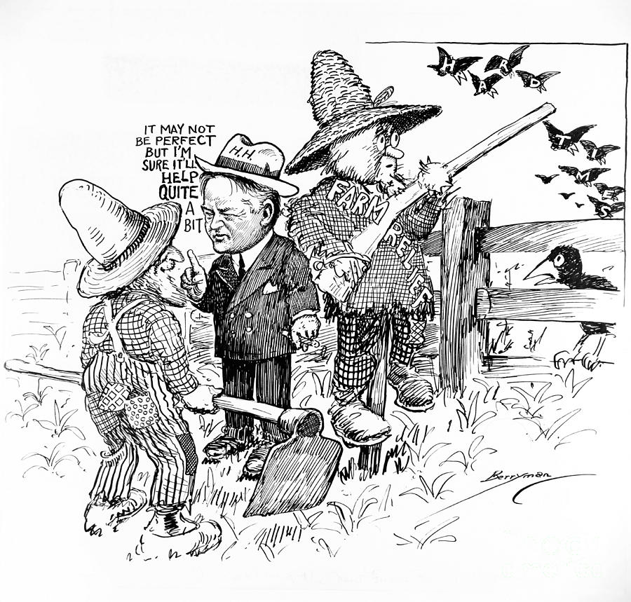
- Based on the political cartoon above describe the effect Herbert Hoover reluctant attempt to help American farmers had on the farming industry?

