Women’s Suffrage-DBQ
Document A
This photograph of women protesting for the right to vote provides a primary source document of women that expressed their desire for suffrage.
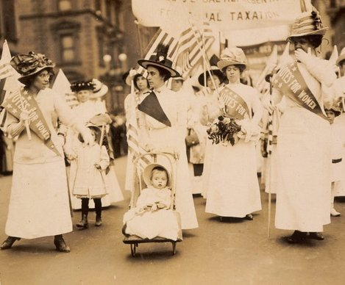
Suffrage Parade in New York City, 1912
- Identify the risks these women are taking by demonstrating in this parade.

- Based on historical tendencies explain whether an event like this would have a positive or negative effect on the women's suffrage movement? *Support your reasoning

Document B
Election Day 1909
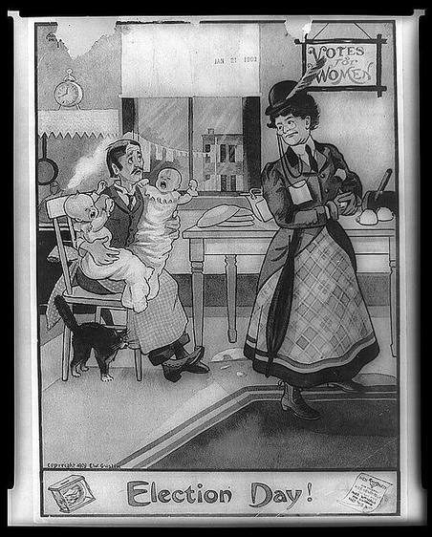
An illustration demonstrating the negative side of how some felt women gaining the right to vote would result in.
1.) Based on this illustration what can you infer the artist is trying to express regarding the subject of women's suffrage?
2.) Examine the husband pictured in the political cartoon and describe why he has a look of despair on his face why he watches his wife leave to vote on Election Day.
3.) Compare both visual images (Document A and B), how does the subject of each image differ in terms of their potential outcome on the Women’s Suffrage Movement?

Document C
Taunton Daily Gazette (Published 1920)
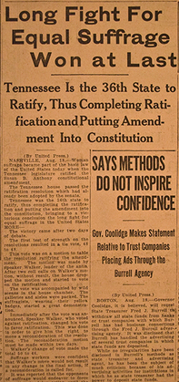
A newspaper article published after the 19th Amendment is ratified; demonstrating a bias on the topic by the article's author.
1.) Based on how the article's title is phrased what can we infer would most likely be the author's feelings toward the Women’s Suffrage Movement?
2.) Compare and contrast the subject matter contained in Document A and B, how does this document (Document C) differ in terms of its content and message?

Document D
Women’s Suffrage Prior to the Passage of the 19th Amendment
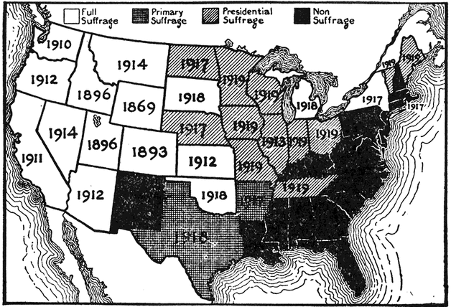
A map representing where states stood on the subject of women's suffrage prior to the passage of the 19th Amendment.
1.) Based on the map interpret why a correlation exists between location and negative attitudes toward women's suffrage?
2.) Based on historical data identify the motives behind the decision of certain states to grant women suffrage prior to it becoming a federal law?
3.) Imagine you’re part of the majority of citizens living in the black states (non-suffrage states) how would you feel about the passage of the 19th Amendment?

Document E
A portion of a speech given by Elizabeth Cady Stanton, who was a major leader in the women's suffrage movement. This gives insight into a prominent figure's view on what it means to gain the right to vote.
"With violence and disturbance in the natural world, we see a constant effort to maintain an equilibrium of forces. Nature, like a loving mother, is ever trying to keep land and sea, mountain and valley, each in its place, to hush the angry winds and waves, balance the extremes of heat and cold, of rain and drought, that peace, harmony, and beauty may reign supreme. There is a striking analogy between matter and mind, and the present disorganization of society warns us that in the dethronement of woman we have let loose the elements of violence and ruin that she only has the power to curb. If the civilization of the age calls for an extension of the suffrage, surely a government of the most virtuous educated men and women would better represent the whole and protect the interests of all than could the representation of either sex alone."
"The Destructive Male": An excerpt of a speech by Elizabeth Cady Stanton in 1868

- What is the underlying theme behind this excerpt from Elizabeth Cady Stanton's speech?

- Can you distinguish the difference between the focus of this document and the others in terms of the date it was written and the message it is trying to convey?

- What can you predict based on the pervious documents and your prior knowledge might
be the reaction of male voters after hearing this speech?

Document F
The Trial of Susan B. Anthony (1874)
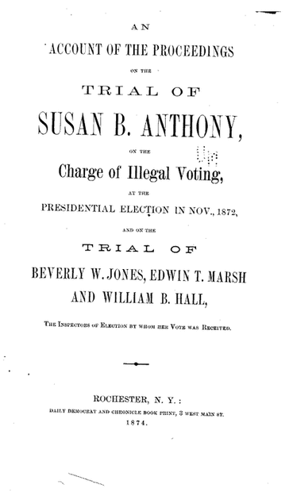
The cover for the record of the trial of Susan B. Anthony when she was arrested for secretly voting in the election of 1872.
1.) Based on this document describe the social climate of the United States of America in 1874?

2.) Based solely on this image how would you predict the trial ending?

3.) What information regarding the legislative approach to suffrage can you distinguish based on this document that may not be present in the other documents contained in the DBQ?

Document G
The actual statement of the 19th Amendment, which granted women the right to vote in elections in the United States of America.
"The right of citizens of the United States to vote shall not be denied or abridged by the United States or by any State on account of sex."
The 19th Amendment to the U.S. Constitution

- Judge the value of this statement in terms becoming a constitutional amendment. How did it change the views of many Americans during the mid-twentieth century?

- Identify at least one modern-day example of a law or Amendment that was made possible through the passage of this bill?

